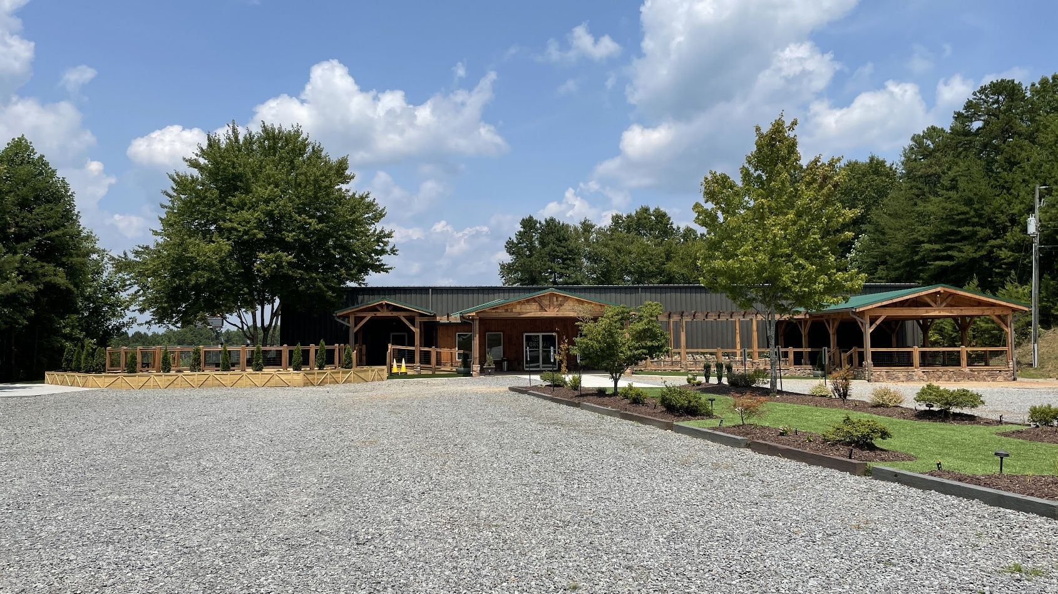 HIGHLIGHTS OF 7288 HWY 515

Current Church Buiding
- Metal Roof
- Parking and walkway
- Outside useable area-Decks
3800 square feet plus
- Fenced in back
- Storage sheds
- Sanctuary- holds 98-120
- Classrooms/ nursery
- Total inside square feet 9300.00
- Security in place
- Sanctuary Chairs – can stay
- Kitchen- with Sink, Oven and storage
- Shared well- on upper property ( by Mobiles)
- Easement guarnteed
- Septic- permited and cleaned (3 years ago)
- Retaining wall- installed for road saftey
- Fire codes met
Current Mobile Area
- Set up currently for office use with
5-6 offices, 2 bathrooms,1 reception area, 1 kitchen/ workspace, 2128 square feet
- Set up currently for a meeting area with 1 bathroom, 2 closets , 768 square feet
- Concrete basketball court 34x44
- Parking for 25-35 cars
- Septic -Permitted and Cleaned
- Roof- Metal
- HAVC- Serviced

