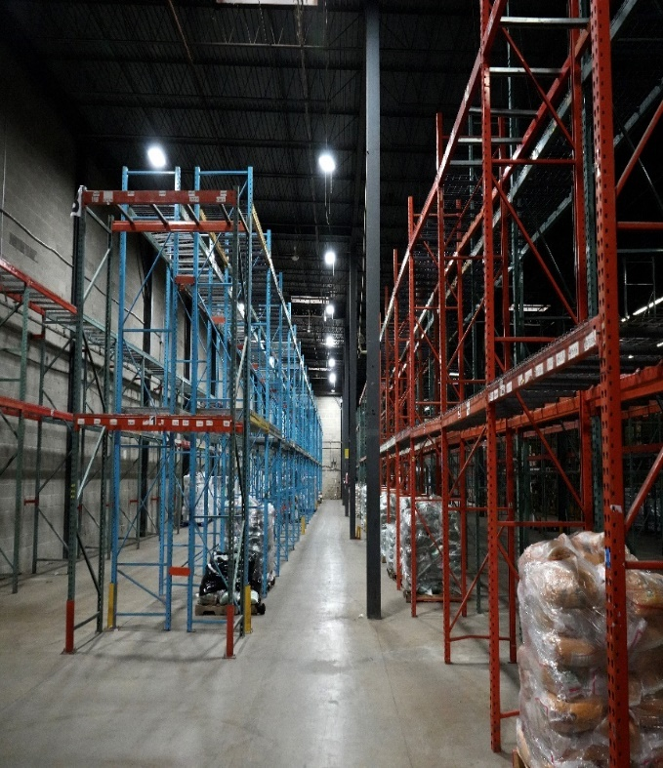
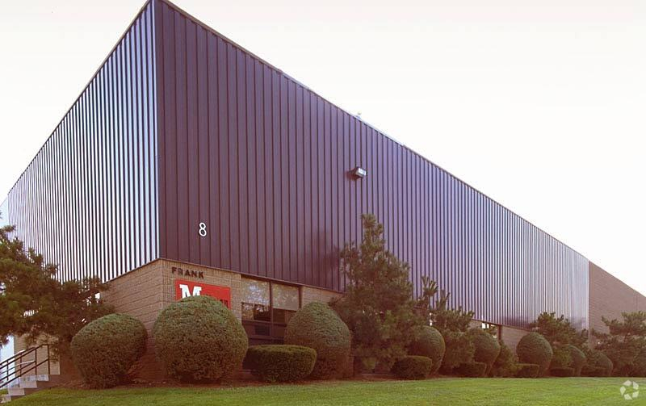

z
Warehouse for Sublease
8 Progress Street
Edison, New Jersey
08820

Exclusive Broker:
Dino Ganas
Director
908-358-7645
dganas@crpnj.com

Property Highlights

- Total Building Size: 67,000 SF
- Total Available: 67,000 SF
- 25’ Clear Ceiling Height
- 4 Loading Docks
- 1 Drive-In
- Taxes: $1.37/SF
- Racking Included
- 7,000SF Cooler/Freezer Box

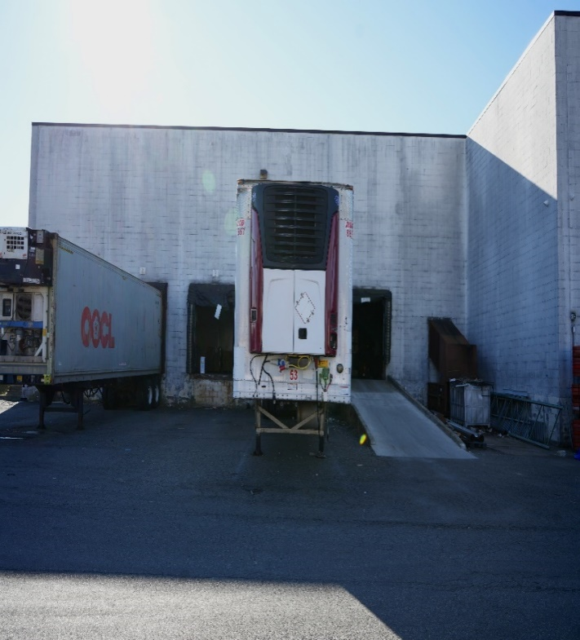
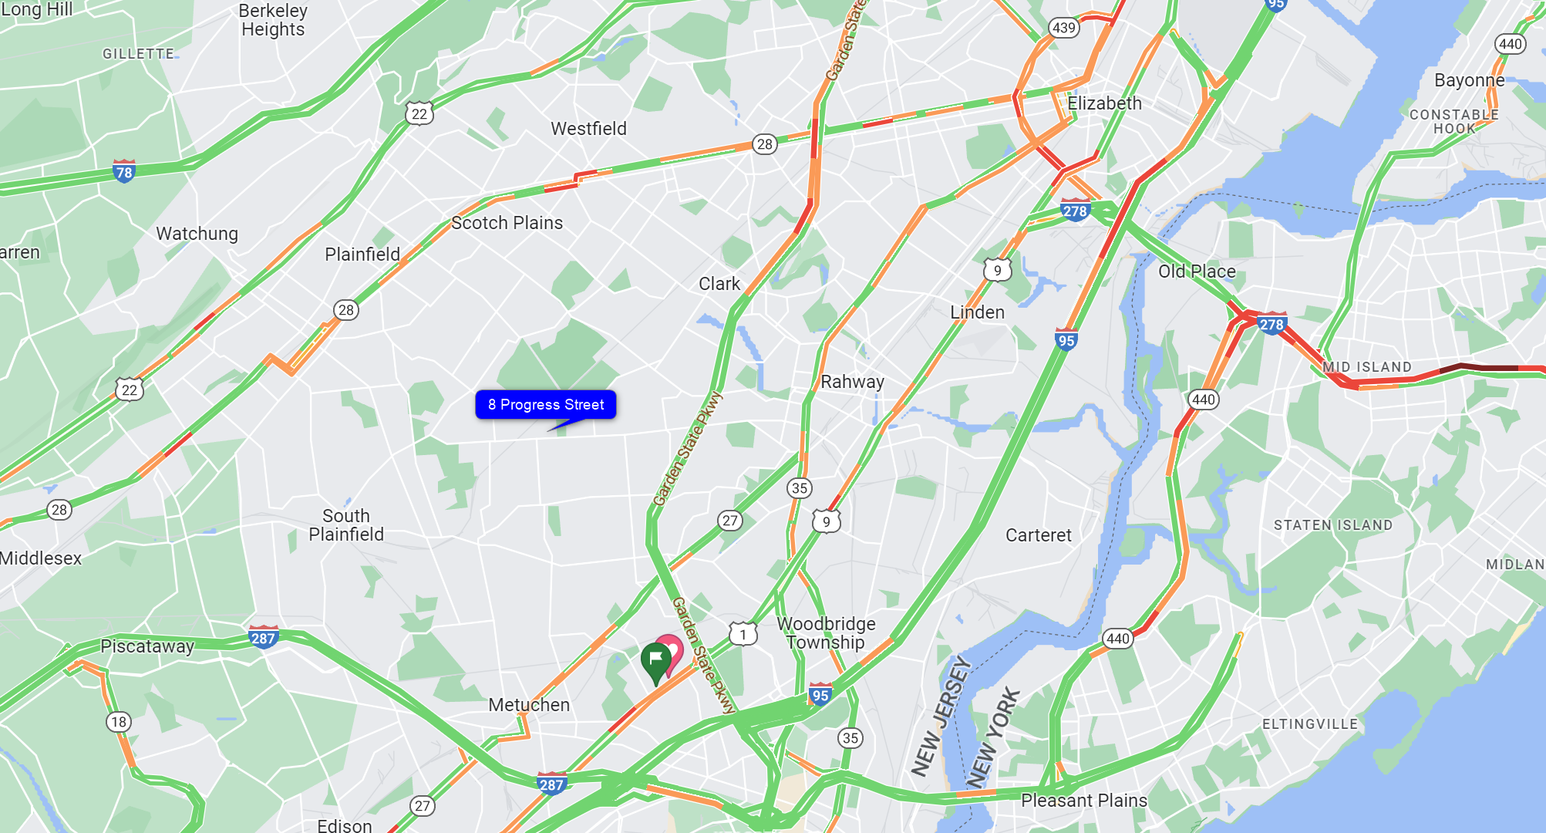
Warehouse for Sublease
8 Progress Street
Edison, New Jersey
08820

Property Highlights

- 5.5 miles mins to Route 287
- 11 miles to Port Elizabeth
- 19 miles to Port Newark

Exclusive Broker:
Dino Ganas
Director
908-358-7645
dganas@crpnj.com

Warehouse for Sublease
8 Progress Street
Edison, New Jersey
08820

