8625 Galena Road, Bristol Township, IL

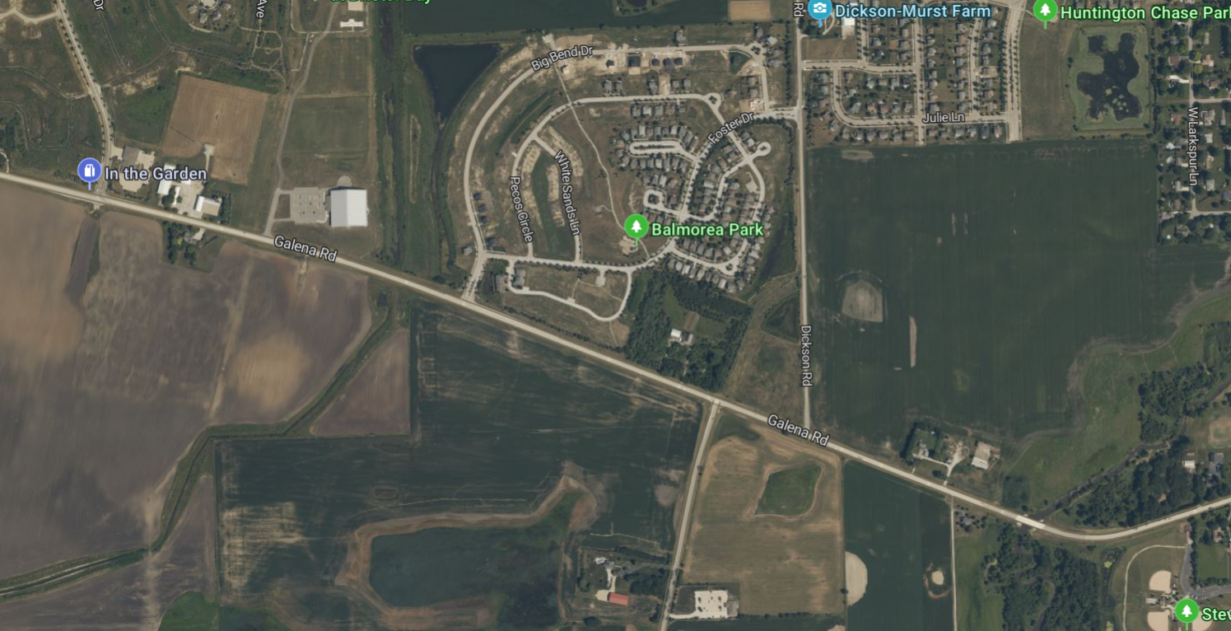

Property Overview:
Size: 8.63 Acres
Offering Price $1,650,000
Price per square foot $4.38
Zoning: Currently zoned Kendall County A-1. High Probability of B-1 upon annexation to the Village of Montgomery

Phase one of the Cannonball Trail and Dickson Road realignment project has been completed, creating a four-way stop.

PIN: 02-10-100-010 2024 taxes (payable 2025) $2080.66

Demographics
Radius Total Households Total Population Avg. HH Income
1 MILE 1230 3888 $115,212
5 MILES 28,413 84,767 $121,568
10 MILES 115.272 347,516 $126.693

Offered By Oakwood Development Corporation,
Scott G. Krafthefer Managing Broker, sgk65@yahoo.com
414 Plaza Drive, Suite 307 Westmont, IL 60559 (630)430-5635

