 |  | MLS#10356691
 |  | FOR RENT OR LEASE
SALES, LEASES, RESIDENTIAL, COMMERCIAL, FARMS & LANDS |  | OWNER: |  | James & Lisa Whitlock
14 JACKSON STREET  NEWNAN, GEORGIA 30263  SINCE 1948 | TELEPHONES:  NEWNAN - (770) 253-6990  FAX - (770) 253-6843  WEBSITE - www.LindseysRealtors.com | LOCATION: |  | 10 East Washington Street  Newnan, GA 30263
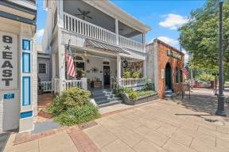  See the Virtual Tour at: https://listings.advantagehometours.com/sites/10-e-washington-st-newnan-ga-30263-11061127/branded |  | SALES PRICE: |  | $850,000
 |  | POSSESSION DATE: |  |  | Negotiable, subject to current lease terms
 |  | APPROX. SQ. FT. |  |  | 3,666+/-
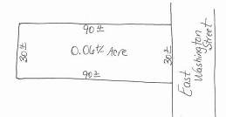 |  | WATER: | City |  | SEWER: | City
 |  | ZONING: | CBD – Central Business District
 |  | PROPERTY TAXES: |  |  | 2023 – 2,751.68
 |  | HOW TO SHOW: |  | Call/text Jess Barron – 678-857-9350 or Frank Barron – 770-231-9535
IMPROVEMENTS: | RARE OPPORTUNITY TO LIVE OFF THE COURT SQUARE IN DOWNTOWN NEWNAN! Beautifully renovated (in 2021) living space upstairs with a stunning kitchen, 2 bedrooms, 2 full baths and living area w/ fireplace and access to your very own private deck overlooking the court square. Kitchen features an island, ample cabinet space, solid-surface counters, stainless steel appliances. Incredible natural light. Full bath off kitchen & living area. Primary bedroom, w/ spacious walk-in closet. Lovely primary bathroom w/ clawfoot tub & custom separate shower. Beautiful original hardwood floors & masonry walls. Property has 6 total fireplaces. Long-time tenant in place on main level. Downstairs level has 2 half baths. Living on ground floor is possible w/ Central Business District Zoning. Inquire with the City of Newnan. Walk to the restaurants, shops & businesses around downtown Newnan.
TERMS: | Cash to seller or conventional financing. Property is presently leased and possession is subject to terms of the lease. Ask agent for lease details.
OTHER: | This property has a tenant that has a medical practice on the first level and lives on the upper level.
DIRECTIONS: | From historic court square in downtown Newnan, take East Washington Street to property on left.
NOTE: Although every effort has been made to provide accurate information, some of the above was supplied by others and therefore we do not guarantee or accept responsibility for the above. Price and terms subject to prior sale and change without notice.

