
Lincoln Real Estate
Commercial Listings for Northampton, Amherst & Hadley
Visit: www.AmherstLincolnRealty.com Call (413) 253-7879

Amherst
17 Kellogg 3rd Fl Office Available 12/1/2024
$1,000/mo. + electric/cable, (heat/water included) approximately 425 sq ft
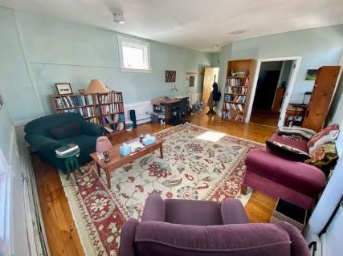
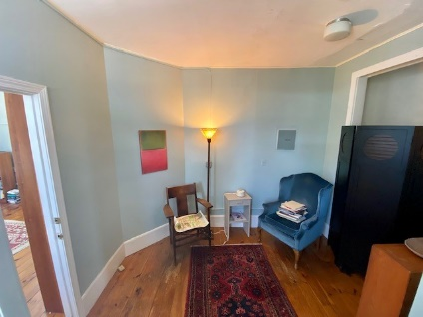
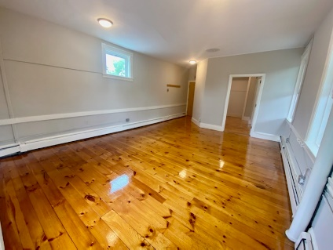

425 Sq Ft $1,000 + cable & electricity. This large open floor plan features an open studio, waiting room and separate exit for privacy for your clients. There is a dedicated bathroom for this office on the 2nd floor. The commercial building has high visibility and is located at 17 Kellogg Ave. in the center of Amherst.
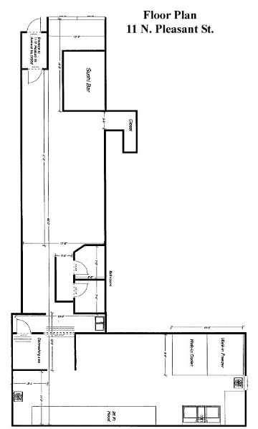
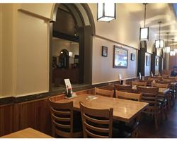
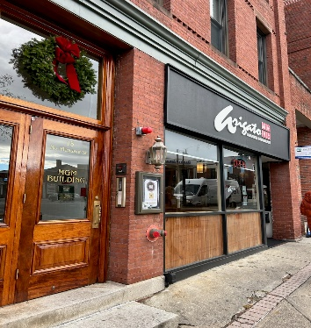

11 N. Pleasant St. (Restaurant) Available 8/1/2025 or sooner
$7,000/mo. + utilities +30% tax and Insurance. Average monthly taxes ($400/month) and monthly insurance ($220)
Location Location Location. This commercial restaurant is located in the center of Amherst on the sunny side of the street on the business intersection in the center of town. Recently remodeled, fully equipped restaurant with two accessible bathrooms, large kitchen with walk in cooler and freezer and large 26 Ft hood. There is a building wide fire alarm system. The space is approximately 2,010 SqFt. There is 1,150 on the main floor and 860 in the kitchen. Come make your restaurant/ cafe dreams come true! Benefit from the proximity of Amherst College, Umass Amherst, Hampshire college, Mt. Holyoke College, Smith College

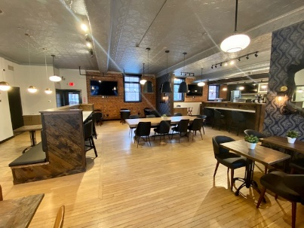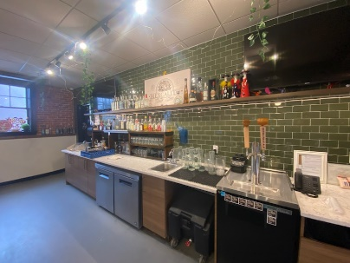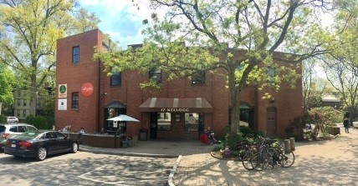
17 Kellogg Ave. (Restaurant) Available 1/1/2025
$7,000/mo. + utilities +40% tax and Insurance. Average monthly taxes ($460/month) and monthly insurance ($95)
17 Kellogg Ave. Entire 1st Floor 2,400 SqFt $7,000 NNN Available 1/1/2025 Includes 1,700 SqFt outdoor patio. Current occupancy allows for 89 people inside and an additional 100 people outside.
The first floor of 17 Kellogg Avenue has been a successful coffee cafe since the 1990’s. Our most recent tenant was a cafe/ restaurant. The space has received many upgrades throughout the years and is in beautiful condition. Upland Architects was contracted to completely renovate the space in January 2019 into a fully operational café/restaurant with outdoor dining and storage. Students, locals, and visitors know this address as a premier location in the center of Amherst. There are parking spaces in front of the space as well as behind the space and there is a parking garage steps away. There is approximately 2,400 square feet on the first floor including kitchen, four bathrooms, new mini split Fujitsu units for heat and air conditioning, central fire alarm, rewired for highest speed internet, approximately 1,700 square foot outdoor patio, and approximately 444 Sq.Ft. of storage in the basement.
Hadley
The Elmwood Shops
The Elmwood Shops are conveniently located on the North Side of Route 9/ Russell St. in Hadley MA. They are on the corner of West St. making it easy for traffic to flow in and out of both the front and rear parking lots. The PVTA bus stop out front lends to the convenience of the property. There are over 80 parking spaces for your clients and employees to utilize. Being located between Northampton and Amherst, off of I91 N Exit 19 makes visibility and commuting a dream. These buildings host a variety of tenants: from The Pilates Center, to Ascent Audiology, Massage Therapists, Hair Salons, Attorney offices and a variety of Therapists. Come make The Elmwood Shops your professional home. Call Lincoln Real Estate for more information. 413-253-789
102 Russell St. Unit B
$500/mo. + CAM Fee, approximately 820 sq ft
820 Sq Ft $500 + $75CAM Fee, this large open floor plan features separate entrance with ramp. Electric baseboard heat, 220 service panel, large windows, ½ bath featuring sink and toilet. The commercial building has high visibility located at 102-108 Russell St., Rte. 9, Hadley, MA. 102 B Russell St. is part of a commercial complex features approximately 80 parking space off street and it houses a variety of professional uses. There are the following mix of tenants: Attorneys, Therapists, Audiologists, Labs, Pilates Studio, and tutors. This space is on the lower level with 3 large windows which make it a bright space, separate entrance located on the side of building with ramp.
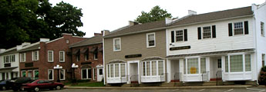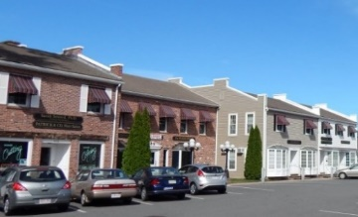
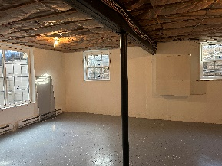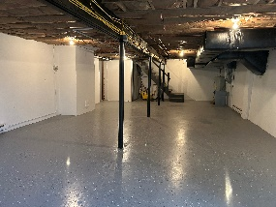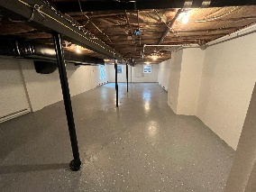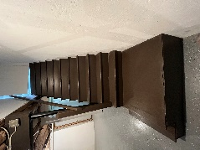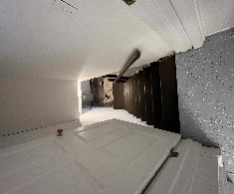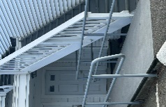
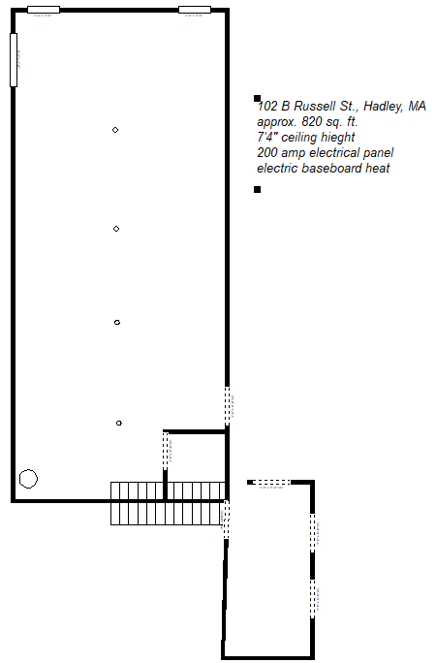
Contact Peter Grandonico or Kathryn Chiavaroli for more details.
Lincoln Real Estate 25 N. Pleasant St. Amherst MA 01002
(413) 253-7879 info@amherstlincolnrealty.com WWW.AMHERSTLINCOLNREALTY.COM

