If you are looking for a great investment property, this is it!
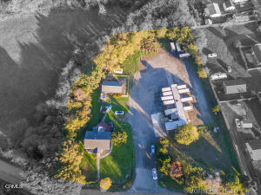

$689,950
- Two homes and UPS lease on the property | - Front home:  2 beds/1 bath  - Studio | - Built 1994
- Heat: basedboard; central; wood stove | - Appx Acre: 1.3 | - 4 parking spaces
If you are looking for a great investment property, this is it! Zoned commercial, this 1.3 acre property is located in a desirable area, near the Botanical Gardens a short distance to Belinda Point's lovely beach and the City of Fort Bragg.There are currently 2 homes and a UPS lease on the property. The 2 homes are currently rented to great tenants. Charming farm house style front home with 2 beds and 1 bath, for $1,100, the Studio with a full bath and kitchen for $1000. and UPS has a 5 year lease at $1500 a month, a substantial total of $3,600 a month income. Added to the charm is Digger Creek running through the back of the two homes. Seller may carry depending on the terms.

MLS#C1-10768
Presented by Century 21 Fort Bragg Realty & Seascape Realty
Susie Francis 707-964-2194
The Gold Standard
Information deemed reliable, but not guaranteed and subject to change.

