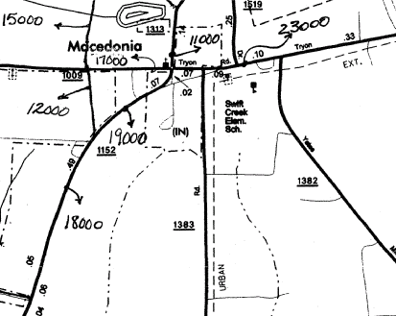
2003 AADT WAKE CO, RALEIGH URBAN, SHEET 7
Campbell Rd.

TRYON RD AND HOLLY SPRINGS RD

