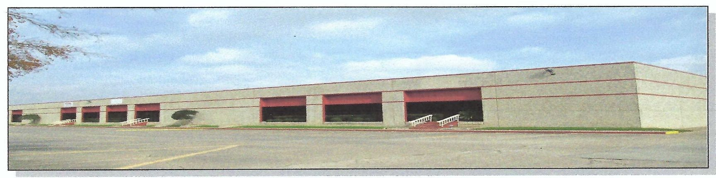
Located in master-planned Corporate Park, within 17 miles of Houston with access
oﬀ I-69, close proximity to Beltway 8. Large warehouse spaces with dock high
and ramp loading capabilities, ample public parking.
•
Suite 604-B: •Warehouse Space-9,240 SF •Loading Docks-4 •20’ Clear in
AVAILABLE SPACES-OPTIONS (See Attached Layouts)
Suite 600: •Warehouse Space-9,258 SF •Loading Docks-2 •Drive in Ramp-1
HIGHLIGHTS
•

FOR LEASE-OFFICE/WAREHOUSE
12701 EXECUTIVE DRIVE, STAFFORD, TEXAS 77477

FOR LEASE-OFFICE/WAREHOUSE
12701 Executive Drive, Stafford, TX 77477

20’ Clear in warehouse •Restrooms-M/W •Oﬃce-1
(Contact for Rental Rate)

Warehouse •Restroom-1 (Contact for Rental Rate)
Suite 604-A Offices/604-B Warehouse/600 Warehouse
Warehouse Space-18,498 SF •Office Space-2,787 SF •Reception Area-1
•Break Room-1 •Restroom-4 •Conference Room-1 •Offices-6
(Contact for Rental Rate)

RROD EVANS AMAR AMANCHARLA
Tel: 713-817-7674 Tel: 281-300-5353
Email: rod@recomproperties.com Email: ati952@yahoo.com

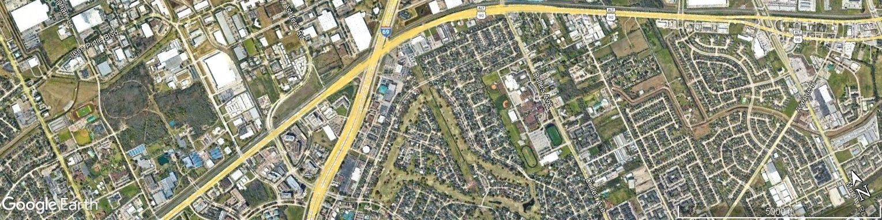
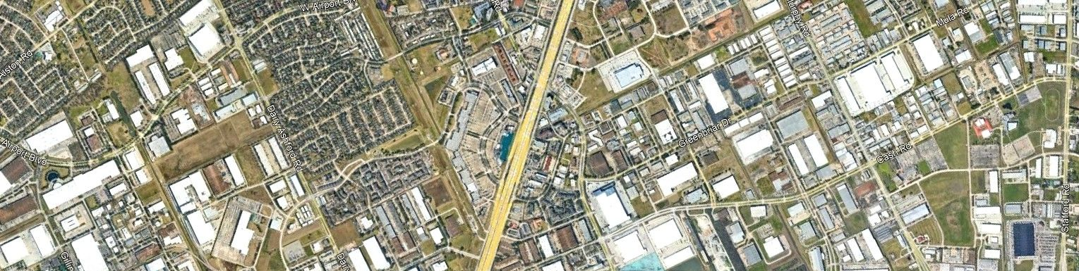



AERIAL LOCATION OF 12701 EXECUTIVE DRIVE, STAFFORD, TX 77477
3

SUBJECT

000.38
Miles to 69

Suite-604-B
RAMP

Suite-600

Suite 600 + Suite 604 Warehouse Only

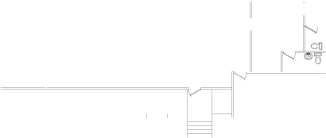
Suite-604-B
RAMP

Suite-600

Suite-604-A

Suite 600 + Suite 604 With Office

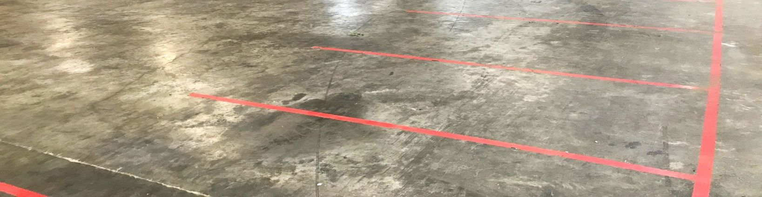
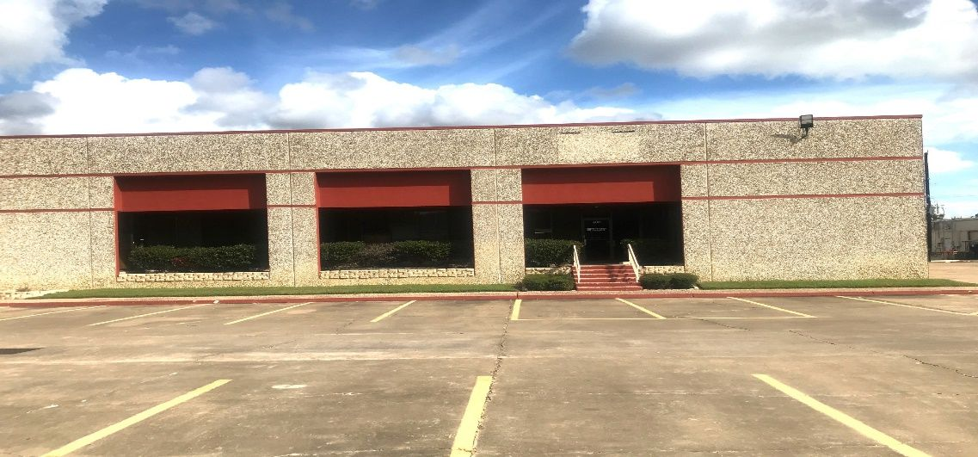
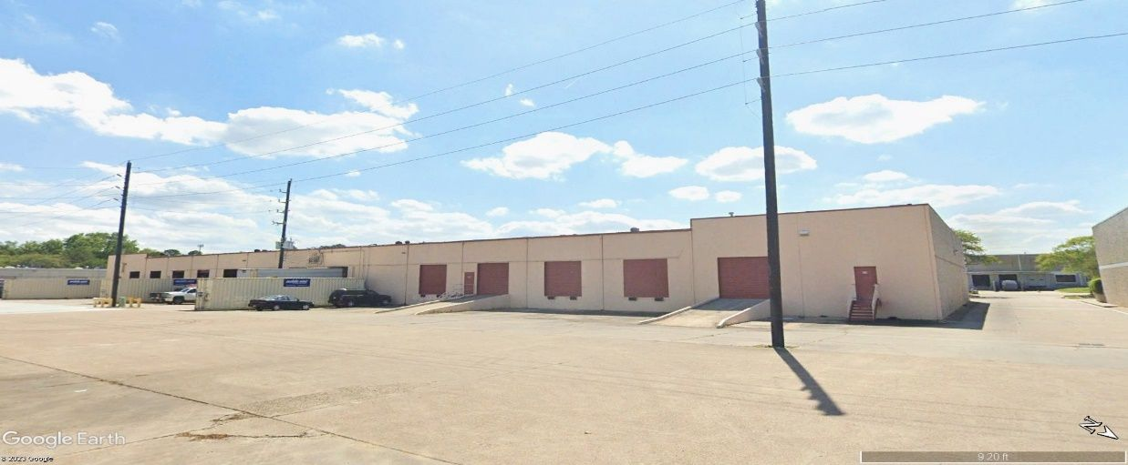
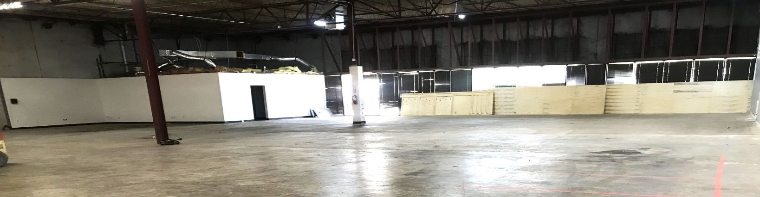
12701 Executive Drive-Suite 600 Photos

Suite 600 Front Elevation

12701 Executive Dr. Rear Elevation

Suite 600 Warehouse Area

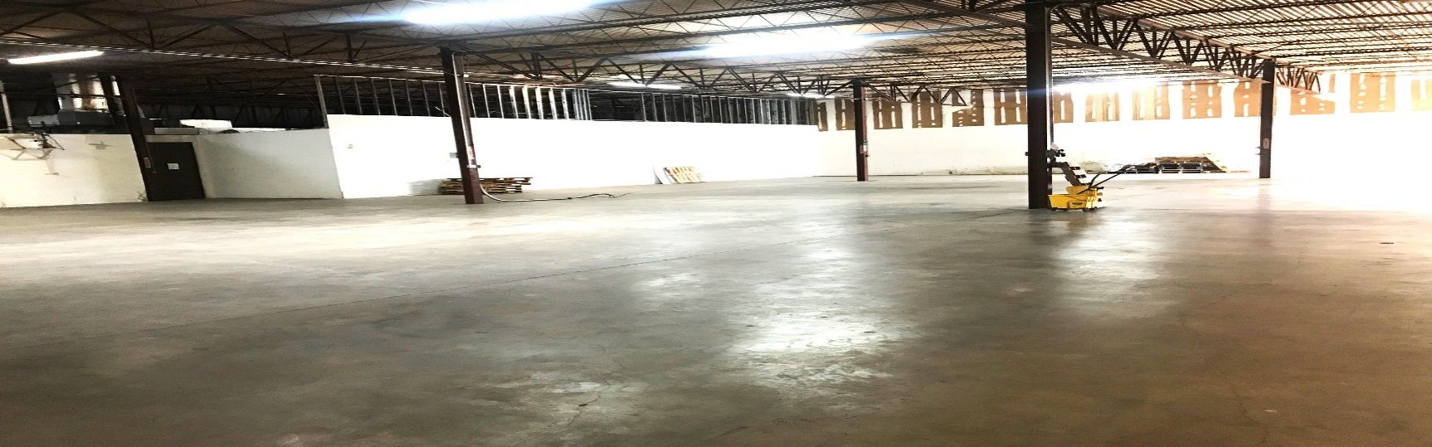
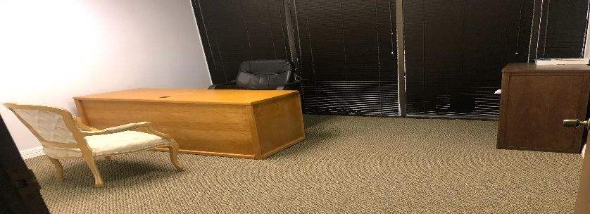
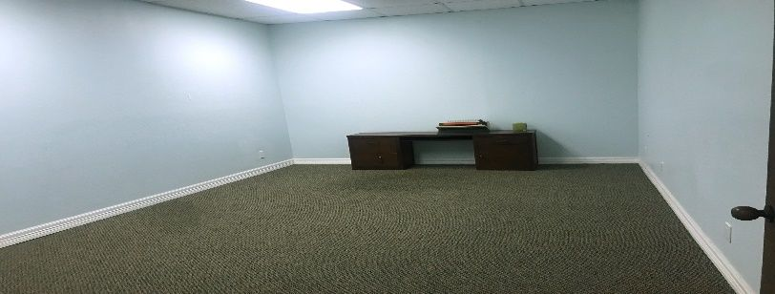
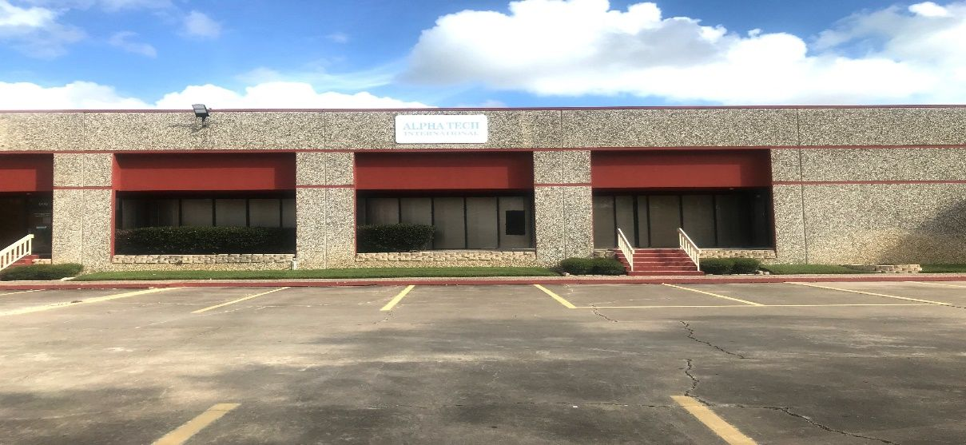
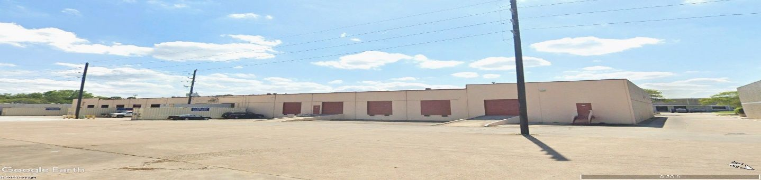
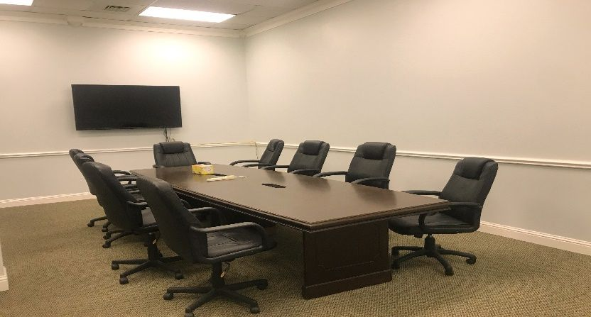
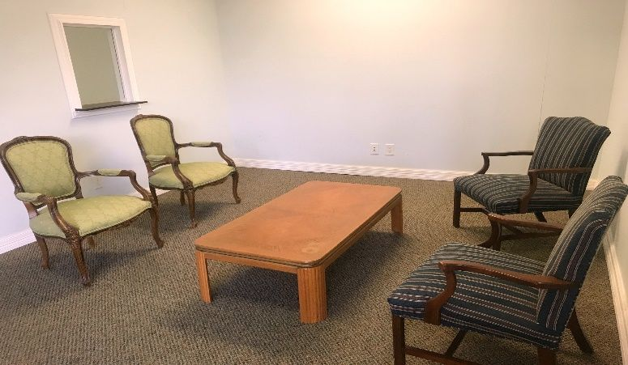
Suite 604 Front Elevation
12701 Executive Drive-Suite 604 Photos

12701 Executive Dr. Rear Elevation

Lobby Area

Conference Room

Large Oﬃces

Small Oﬃces

Suite 604 Warehouse Area

