Brochure

The building is under construction and tentative date for finish is March, 2025.
This property is also on MLS: 8067798

Rent
====
First Floor: $30 psf + $10 NNN with $40 TI
2nd Floor: $28 psf + $10 NNN with $40 TI

The measurement is from Architecture drawing.
First Floor:
- 101A (south) – 1,280 SF
- 101B – 860 SF
- 101C – 860 SF
- 101D – 860 SF
- 101E (north) – 1,050 SF

Figure 1: First floor
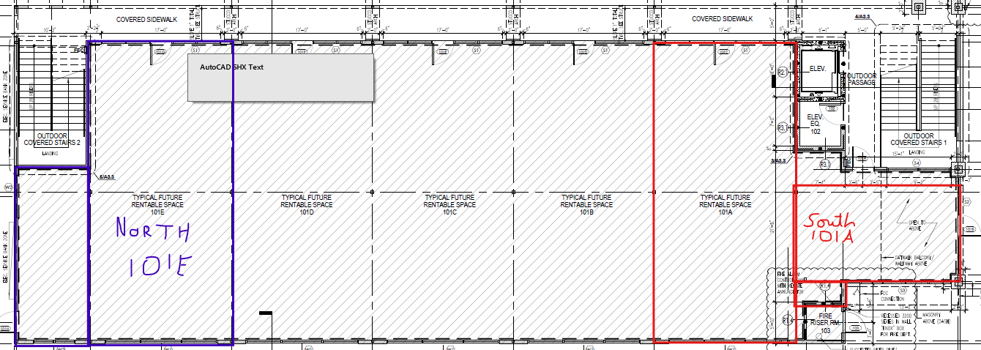
Second Floor => Looks good except commented below.
- 204A & B (south) – 860 SF => This will be little more as my office did not occupy 860 sq. ft. 860 + (860 – 615 – 65 [for corridor] ) = 1040 sq. ft.
- 204C – 860 SF
- 204D – 860 SF
- 204E (north) – 1,050 SF
Figure 2: Second floor with suites marking with office which will be excluded
