**GREENWAY CENTER**
RETAIL/ OFFICE SPACE FOR LEASE

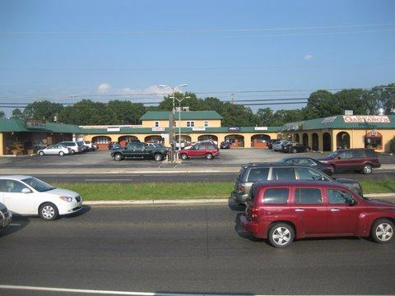

750 + SQUARE FEET AVAILABLE

LOCATION: Retail/Office Space is located within the GREENWAY SHOPPING CENTER on Route 73 North in West Berlin, New Jersey. Route 73 is the main artery that runs from Atlantic City to Philadelphia. This location is comprised of a variety of commercial uses including retail strip shopping centers, office buildings, and many restaurants.

SPACE AVAILABLE: 447 Route 73 North, West Berlin, New Jersey
750 * SQ FT: $1,625.00/month – Gross Lease (only other expenses: Utilities)
Security Deposit required: $2,440.00
3 year- Lease Term

TRAFFIC COUNT: According to the NJ Department of Transportation for the year 2019, 120,595 +
cars travel in both directions in an average 24-Hour period.

COMMENTS: Newly Renovated space with up to date listing. 2 ft X 4 ft sign ready for insert.
Unit faces Route 73 with great road visibility.

For More Information
CALL: (609) 654-5666
travis@prattconstructioninc.com

