John Tsavalos 143-07 Cherry Ave, Flushing NY 11355
Cell: (917)225-6494 e-mail: JTESRENTALS@gmail.com

Subject: LEASE OFFERING for 43-43 Bowne St Flushing NY 11355

The second floor of the school building (aka Kissena Jewish Center Inc) located at 43-43 Bowne St, Flushing NY 11355, is being offered for Lease. Zoning: R4-1.

Location: 12 minute walk from downtown Flushing, No. 7 train and LIRR (Main St stations). Q65 bus within 1 block from school. Two blocks from Kissena Blvd, 4 blocks from the Queens Botanical Gardens, within a 15 minute walk to Kissena Park.

Property Sub-type – 2 story brick building housing a school and house of worship, completely separated by hallway.
Space Use – School, office, non-retail. Tax exempt usage preferred because of existing building usage.
Space Available – Second floor of school building. Approx 3550 sq ft. Subject to actual measurements. 2 car on-site parking available with space. Small yard in rear of building by parking lot can be used. There is no elevator.

Description:

Second floor. Accessed by main entrance or rear of building. There are a total of 3 points of entry/egress by stairwells. No elevator. Baseboard heating. AC – window units. Some walls are non-bearing walls and can be removed, opened up accordingly.

Room 1 - Approx 400 sq ft inclusive of bathroom and kitchen area
Room 2 – Approx 400 sq ft
Room 3 - Approx 480 sq ft
Room 4 – Approx 480 sq ft

Rental Terms:
Base monthly rent – $5500
Annual escalations – TBD
Security Deposit – 3 months
Lease Term – TBD
Landlord work – None. Delivered as is.
Tenant Improvement Allowance (TIA) – 2 months upon lease execution date
Utilities (gas for heat and electricity) – 30% of net
Delivery Date – ASAP
Rent Commencement Date – Lease execution date.

If interested, please contact me as soon as possible.

Should you have any questions, please feel free to contact me.

Sincerely,
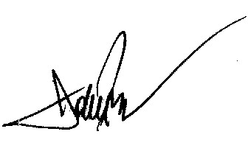

JOHN TSAVALOS
RE Broker
917-225-6494
Information based upon data available. Subject to change and market conditions and Owner Approval
Issued: March 15, 2024
Revised: March 19, 2024

GOOGLE MAPS VIEW:
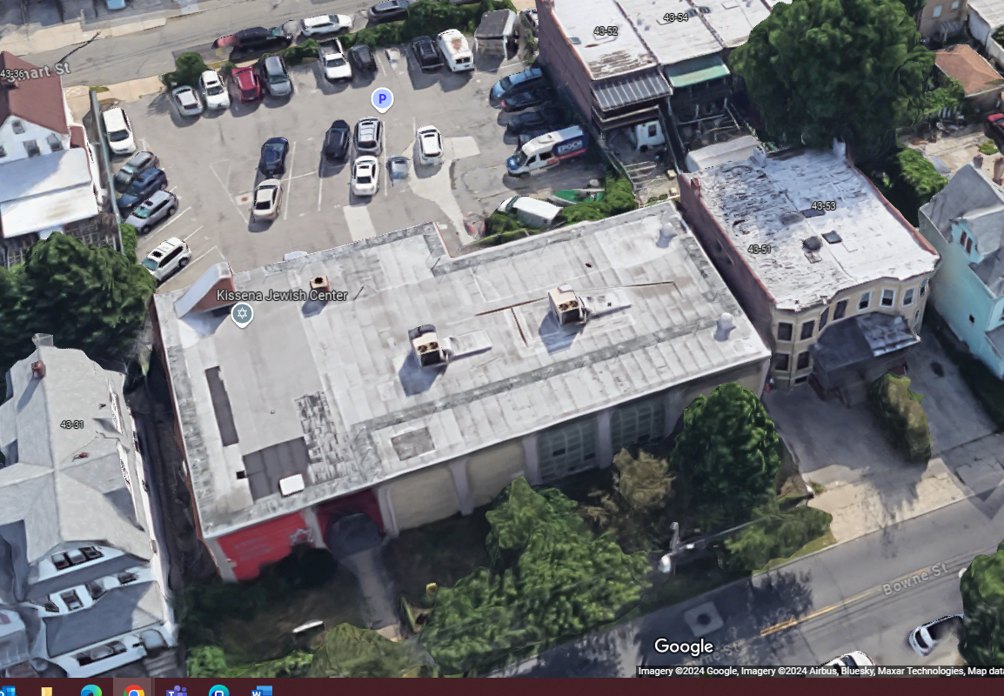
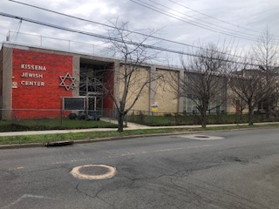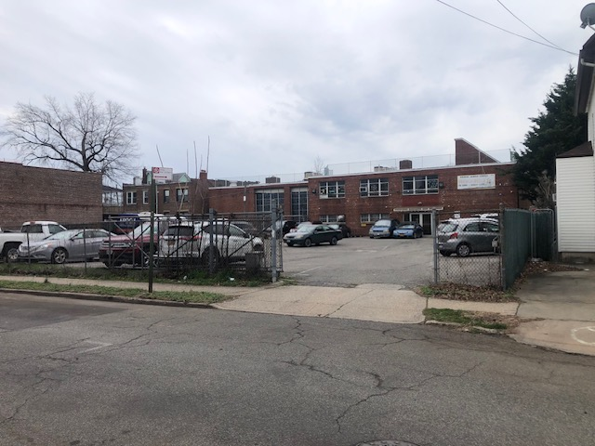

Main Building Hallway:
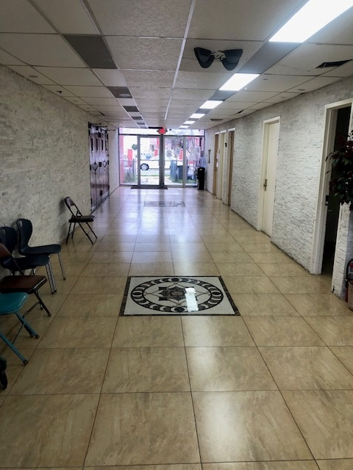

Room 1 (facing rear – Smart St):

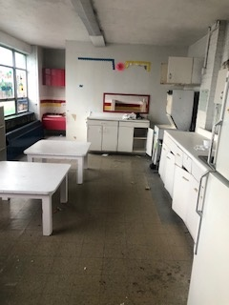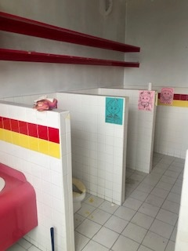

Room 2:

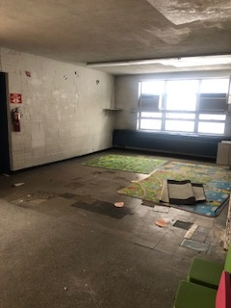

Room 3:

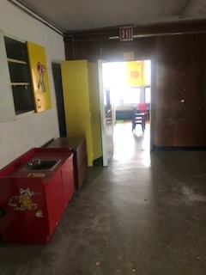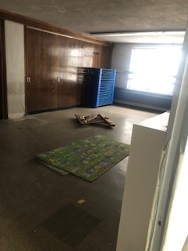

Room 4 (facing front – Bowne St) :

