786 Highway 441, Clayton, GA 30525

$680,000
12 Bo James St Checkers & Rally

Your own Fast Food Franchise at 7.1% Cap Rate
Broker/Agent of Record: Tim LE (License: 293555)

Tung Le
GA 293555
770.912.9684
Luis E. Hernandez 305.595.8166


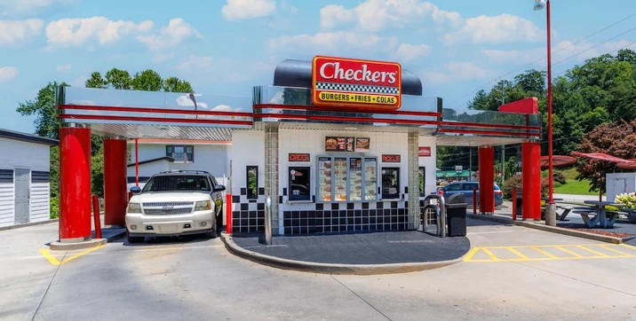


e

Listing Added: 08/03/2026 Listing Updated: Today

Details
Asking Price | $680,000 | Property Type | Retail
Sub Type | QSR/Fast Food, Restaurant | Lease Type | NN
Tenant Credit | Franchisee | Tenancy | Single
Brand/Tenant | Checkers | Lease Term | 5 years
Lease Commencement | 08/01/2026 | Lease Expiration | 07/31/2031
Remaining Term | 5 years | Square Footage | 810
Net Rentable (SqFt) | 810 | Price per SqFt | $839.51
Cap Rate | 7.10% | Occupancy | 100%
NOI | $48,200 | Units | 1
Year Built | 2008 | Year Renovated | 2008
Buildings | 1 | Stories | 1
Zoning | c2 | Lot Size (acres) | 0.25
Rent Bumps | 10% | Lease Options | 1 (5yrs)
Ground Lease | No | Ceiling Height | 8

Marketing Description

For Sale – Checkers & Rally's | Prime Highway 441 Investment Opportunity
786 Highway 441 South, Clayton, GA 30525

Established Quick-Service Restaurant in the Heart of Clayton
Rare opportunity to acquire a freestanding Checkers & Rally's restaurant strategically positioned along US Highway 441, the primary commercial corridor through Clayton, Georgia. This highly visible corner location benefits from exceptional traffic exposure, easy ingress and egress, and serves both the local community and the steady flow of tourists traveling to the North Georgia Mountains. Checkers

Property Highlights

Prime corner location on busy US Highway 441
Approximately 810 SF freestanding restaurant building situated on a commercial parcel. Strong visibility with excellent frontage
Convenient access from multiple directions Established operating Checkers & Rally's restaurant Ample on-site parking
Located within the City of Clayton, Georgia

Investment Opportunity
Two acquisition options are available: Option 1 – Owner/Operator
Purchase the real estate and acquire the operating business.
Ideal for an owner-operator seeking an established quick-service restaurant with an existing customer base.

Option 2 – Passive Investment
Seller will execute a 5-year leaseback at closing. Projected 7.10% capitalization rate.
Immediate, stable rental income with an experienced operator remaining in place.

Location Advantages

Situated on Clayton's primary retail corridor Excellent daily traffic counts on US Highway 441 Minutes from downtown Clayton
Gateway to North Georgia's premier mountain destinations
Surrounded by national retailers, restaurants, hotels, and local businesses Strong year-round tourism and local customer base
Whether you're looking to own and operate a successful restaurant or acquire a passive net-leased investment with attractive returns, this property offers flexibility, visibility, and long-term value in one of Northeast Georgia's most desirable mountain communities.

Contact Broker for pricing, financial information, and a confidential business package.

Investment Highlights

For Sale – Checkers & Rally's | Prime Highway 441 Investment Opportunity
786 Highway 441 South, Clayton, GA 30525

Established Quick-Service Restaurant in the Heart of Clayton

Property Highlights

Prime corner location on busy US Highway 441
Approximately 810 SF freestanding restaurant building situated on a commercial parcel. Strong visibility with excellent frontage
Convenient access from multiple directions Established operating Checkers & Rally's restaurant Ample on-site parking
Located within the City of Clayton, Georgia

Investment Opportunity
Two acquisition options are available: Option 1 – Owner/Operator
Purchase the real estate and acquire the operating business.
Ideal for an owner-operator seeking an established quick-service restaurant with an existing customer base.

Option 2 – Passive Investment
Seller will execute a 5-year leaseback at closing. Projected 7.10% capitalization rate.
Immediate, stable rental income with an experienced operator remaining in place.

Location Advantages

Situated on Clayton's primary retail corridor Excellent daily traffic counts on US Highway 441 Minutes from downtown Clayton
Gateway to North Georgia's premier mountain destinations
Surrounded by national retailers, restaurants, hotels, and local businesses Strong year-round tourism and local customer base
Whether you're looking to own and operate a successful restaurant or acquire a passive net-leased investment with attractive returns, this property offers flexibility, visibility, and long-term value in one of Northeast Georgia's most desirable mountain communities.

Contact Broker for pricing, financial information, and a confidential business package.

Location (1 Location)
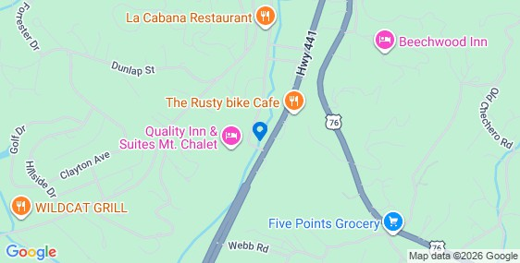

Property Photos (9 photos)
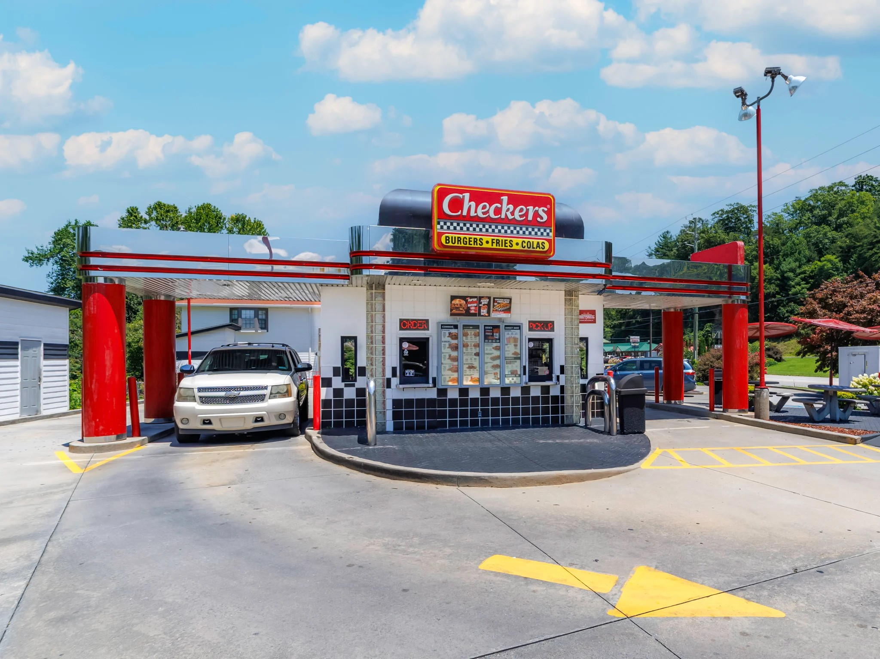
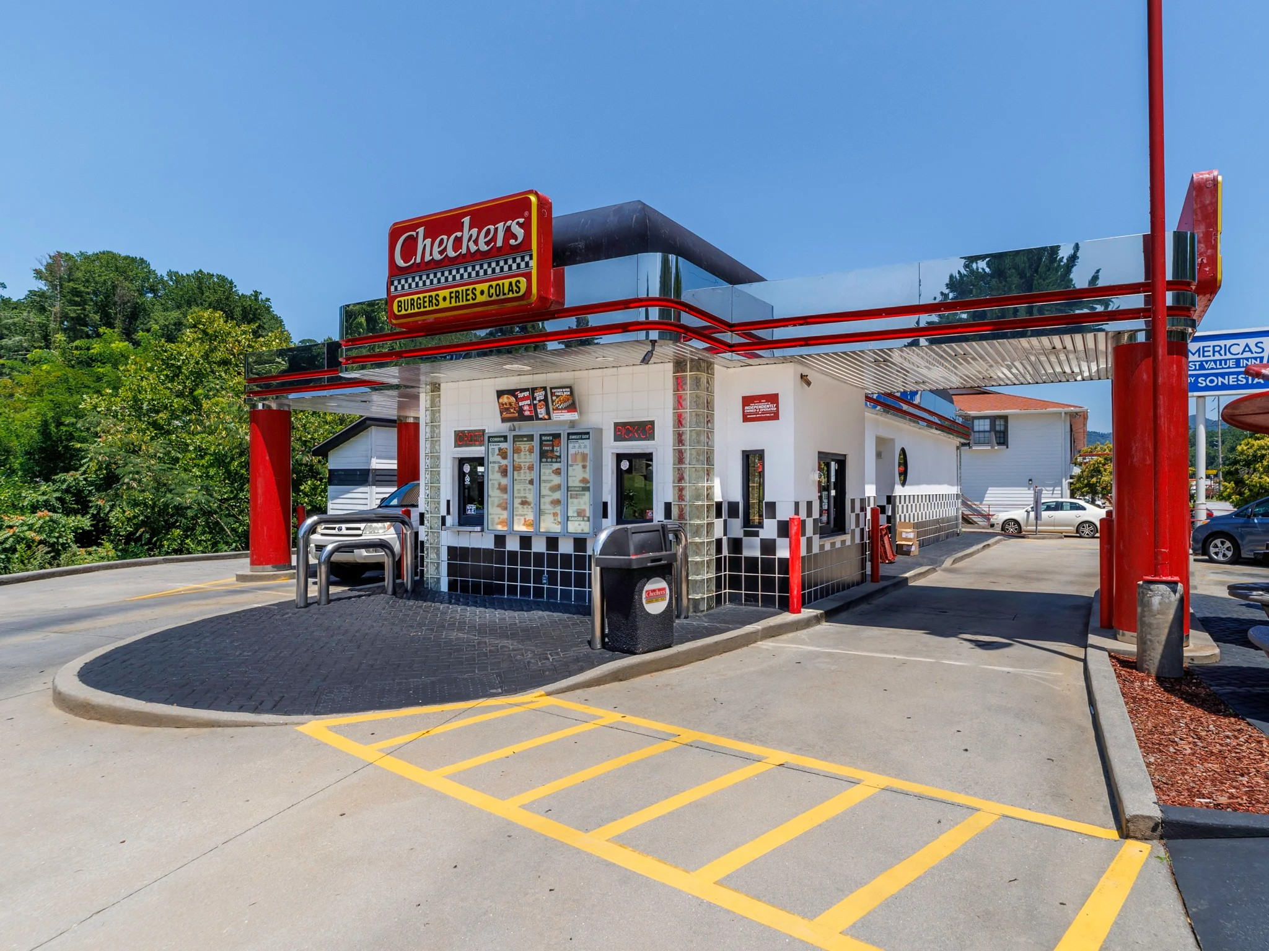
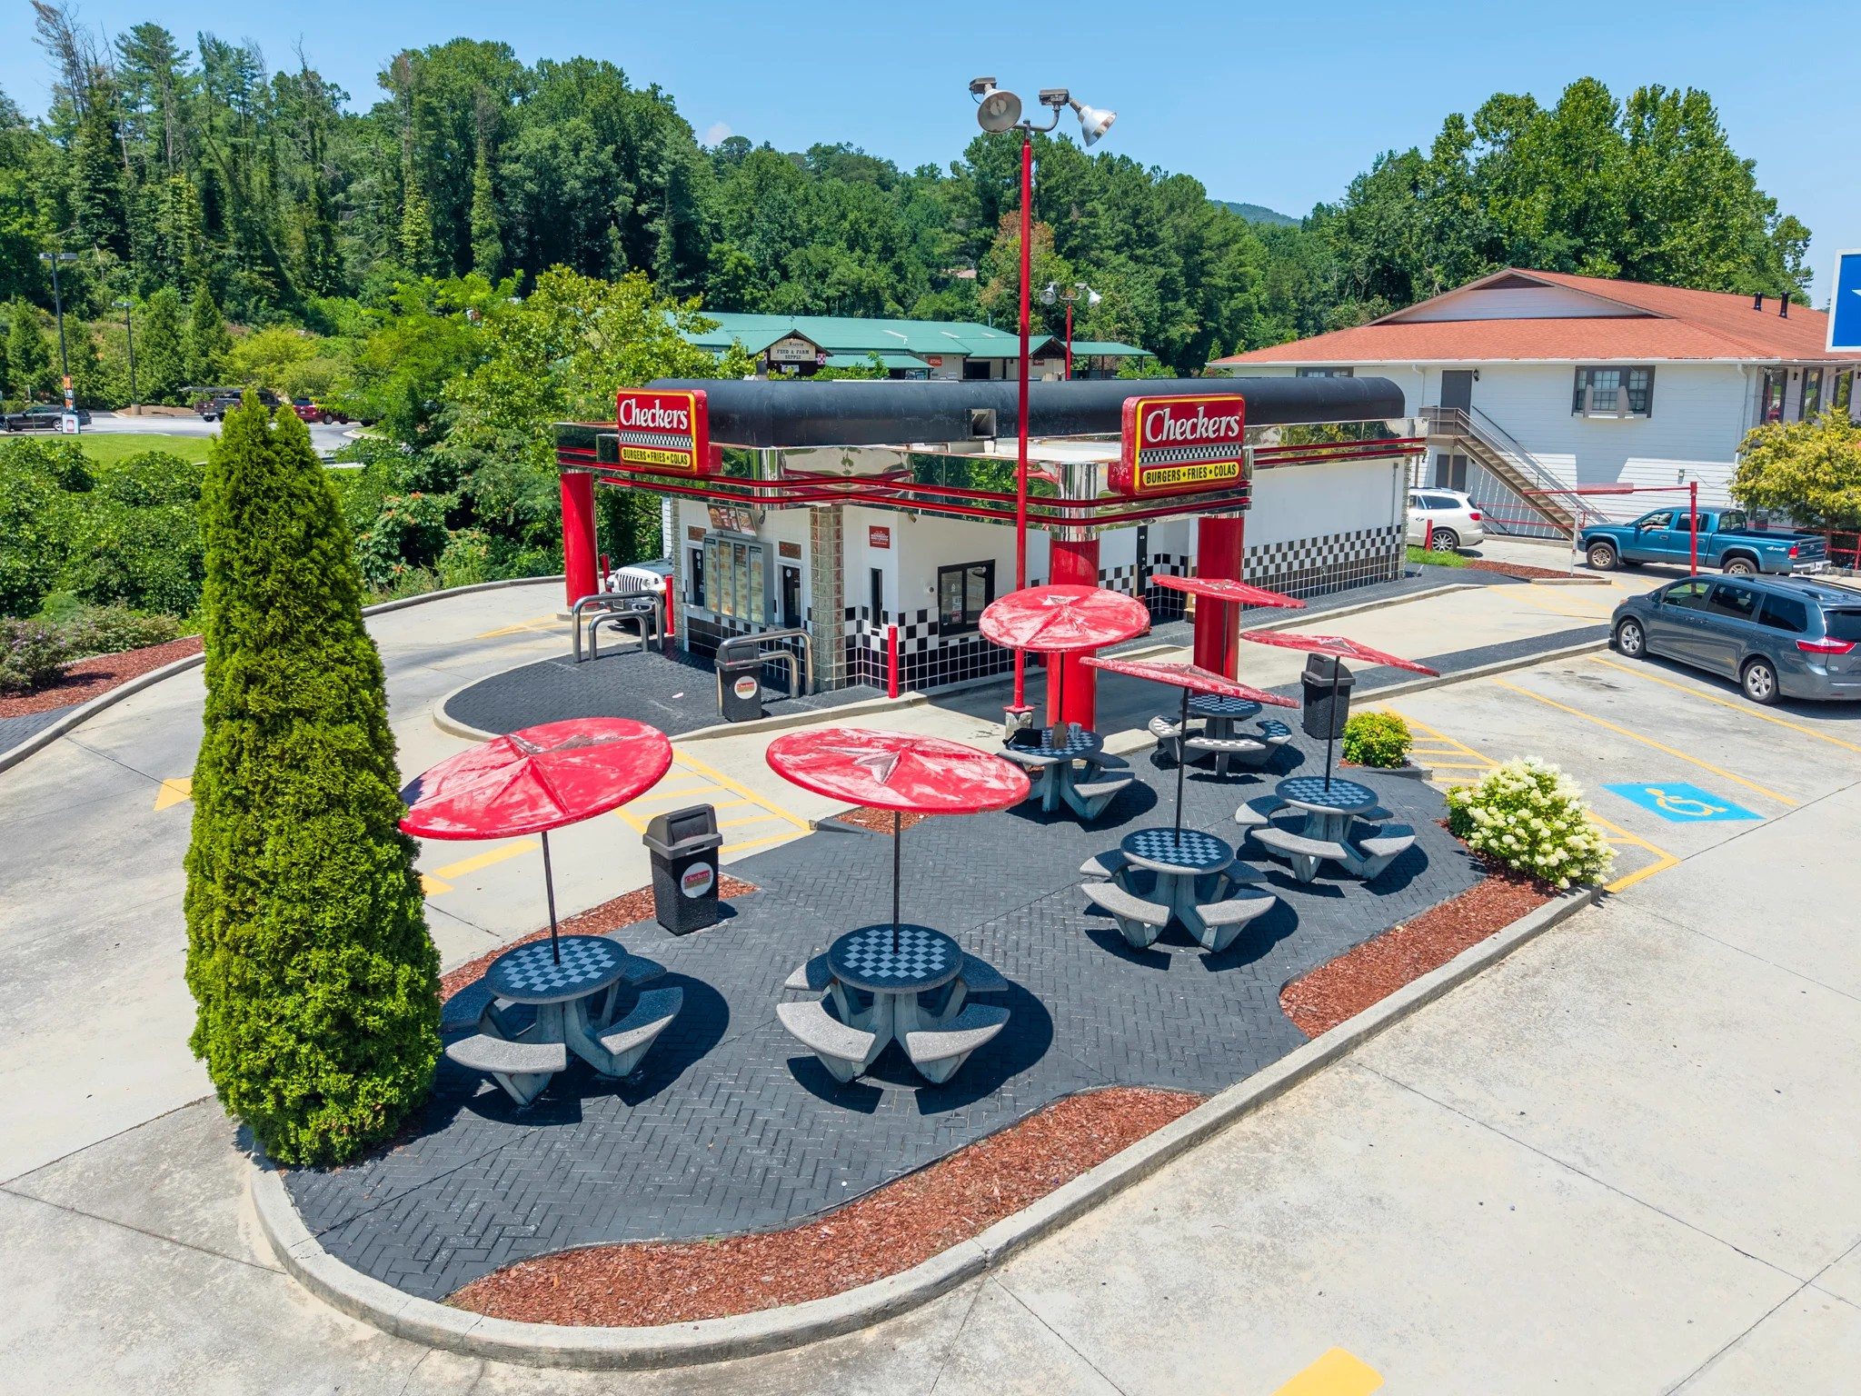
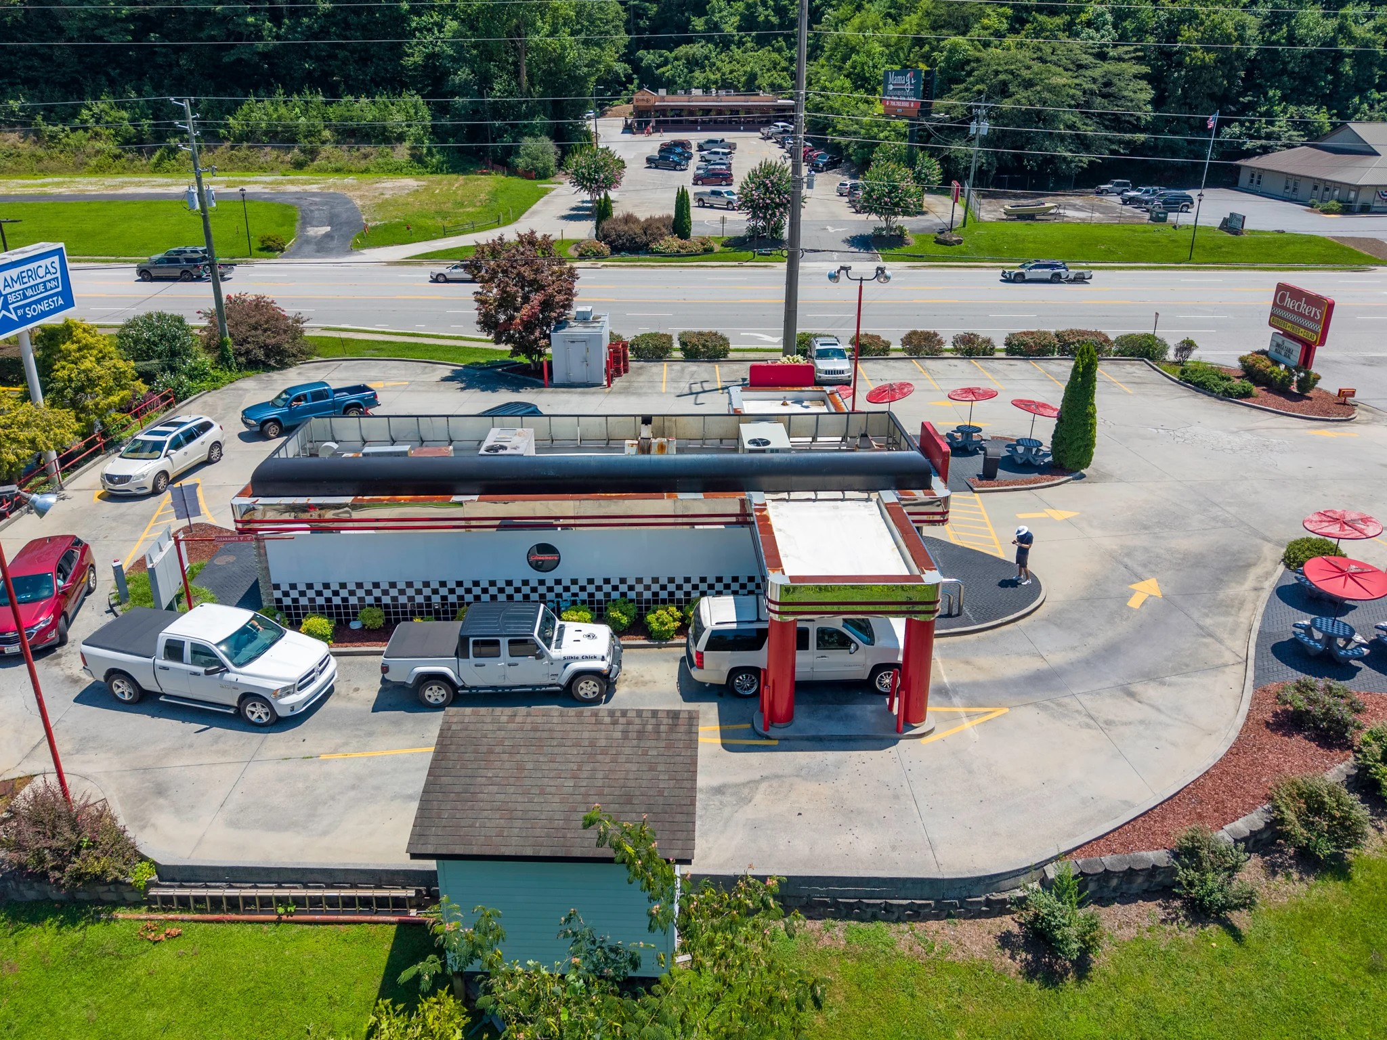
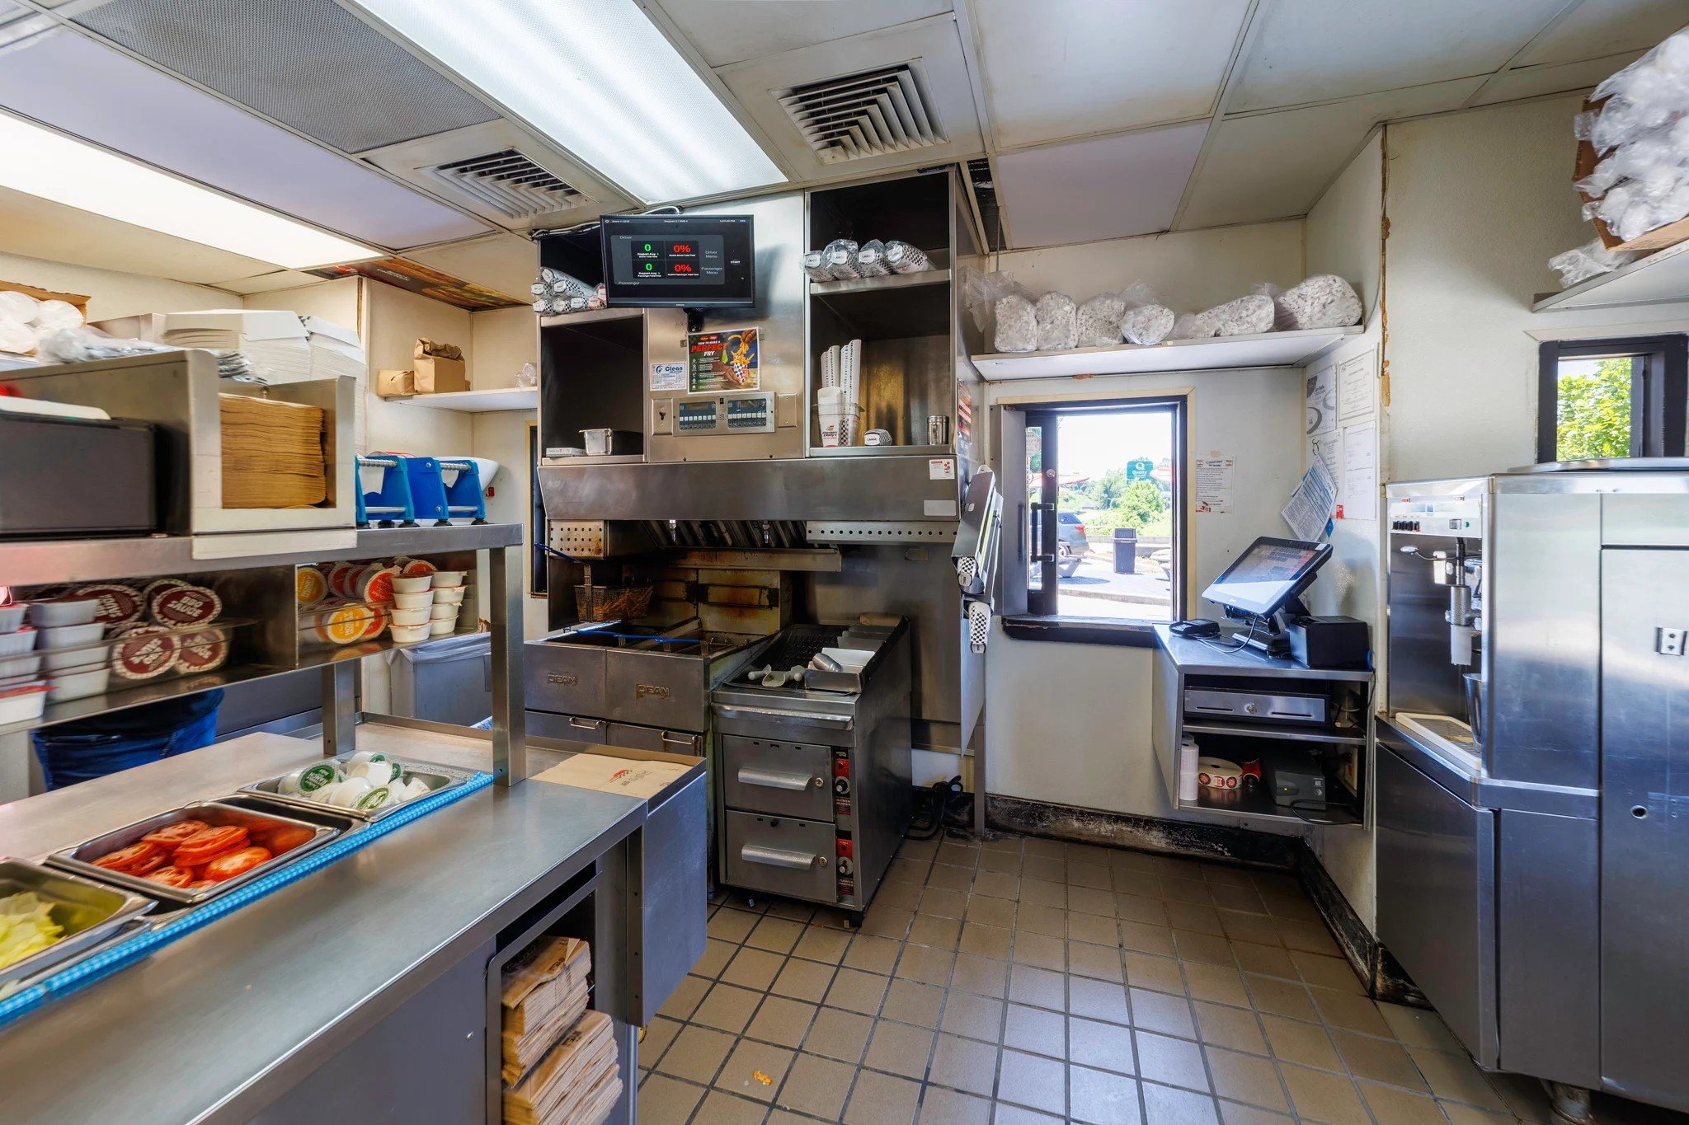
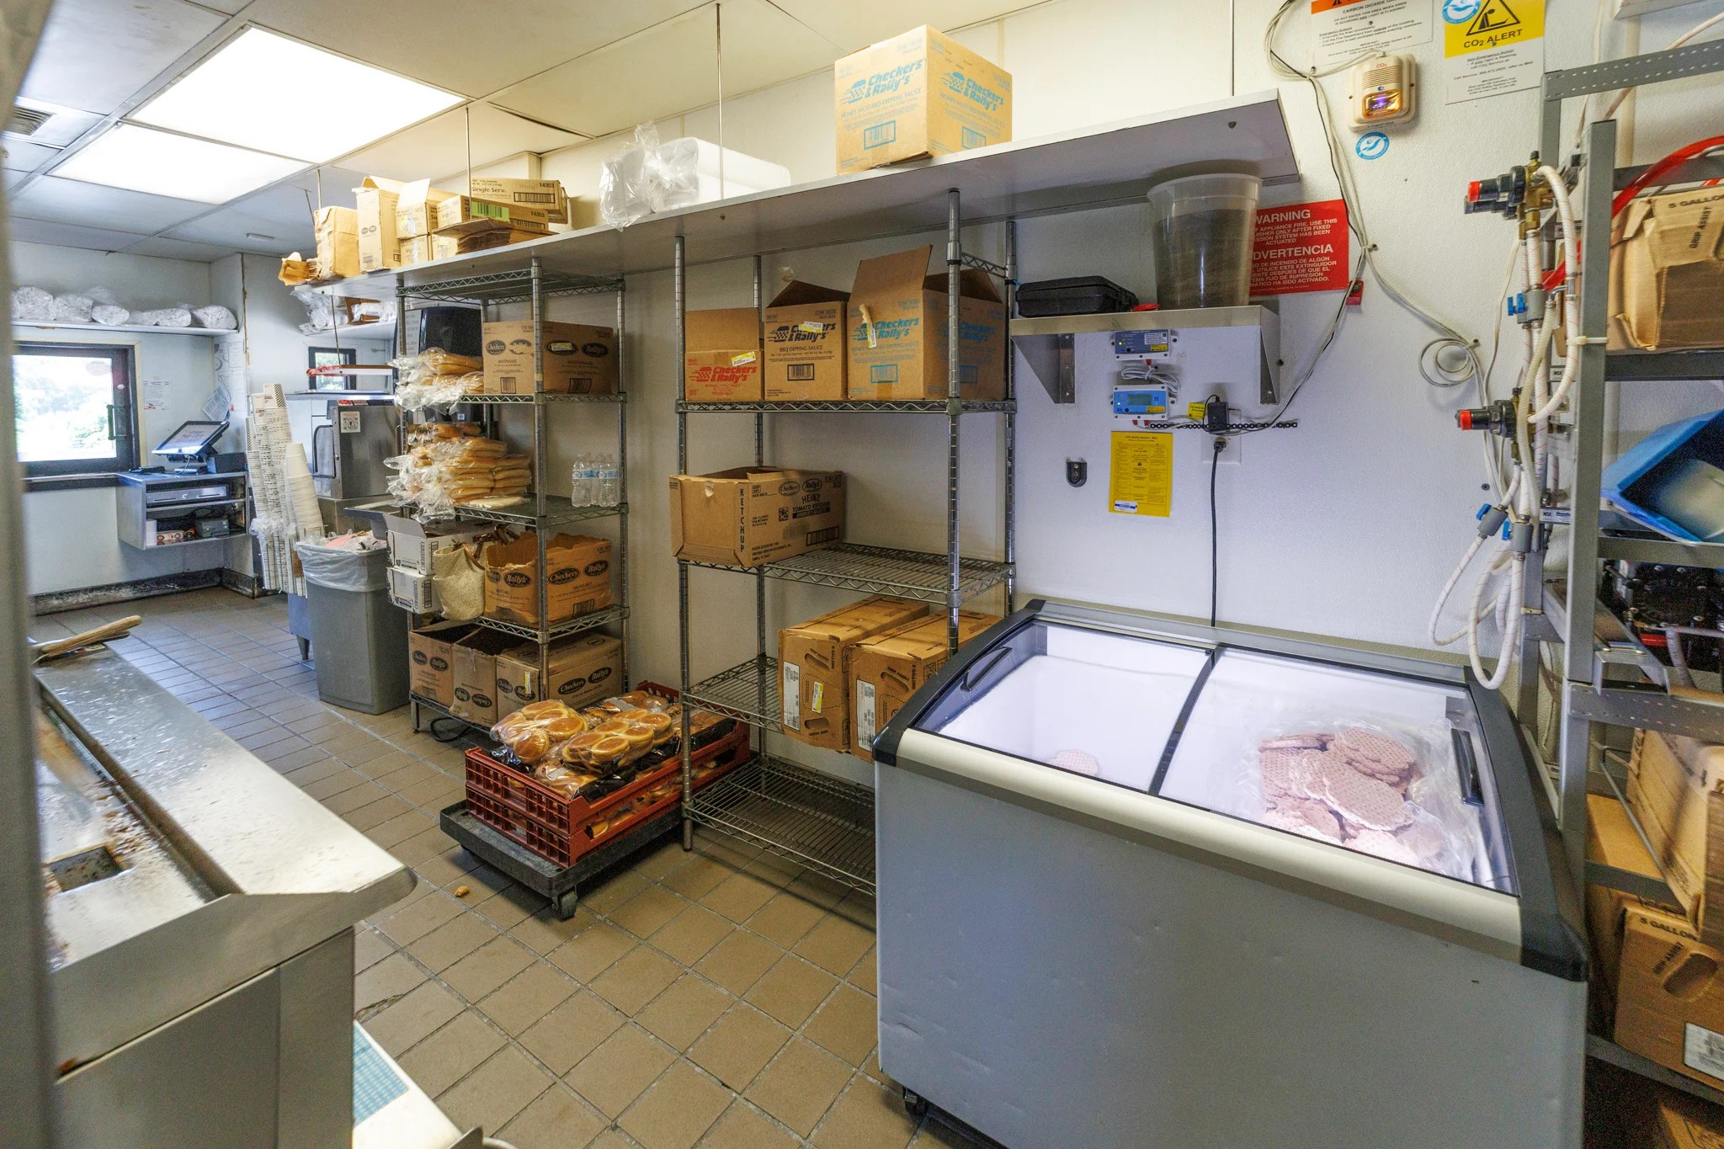
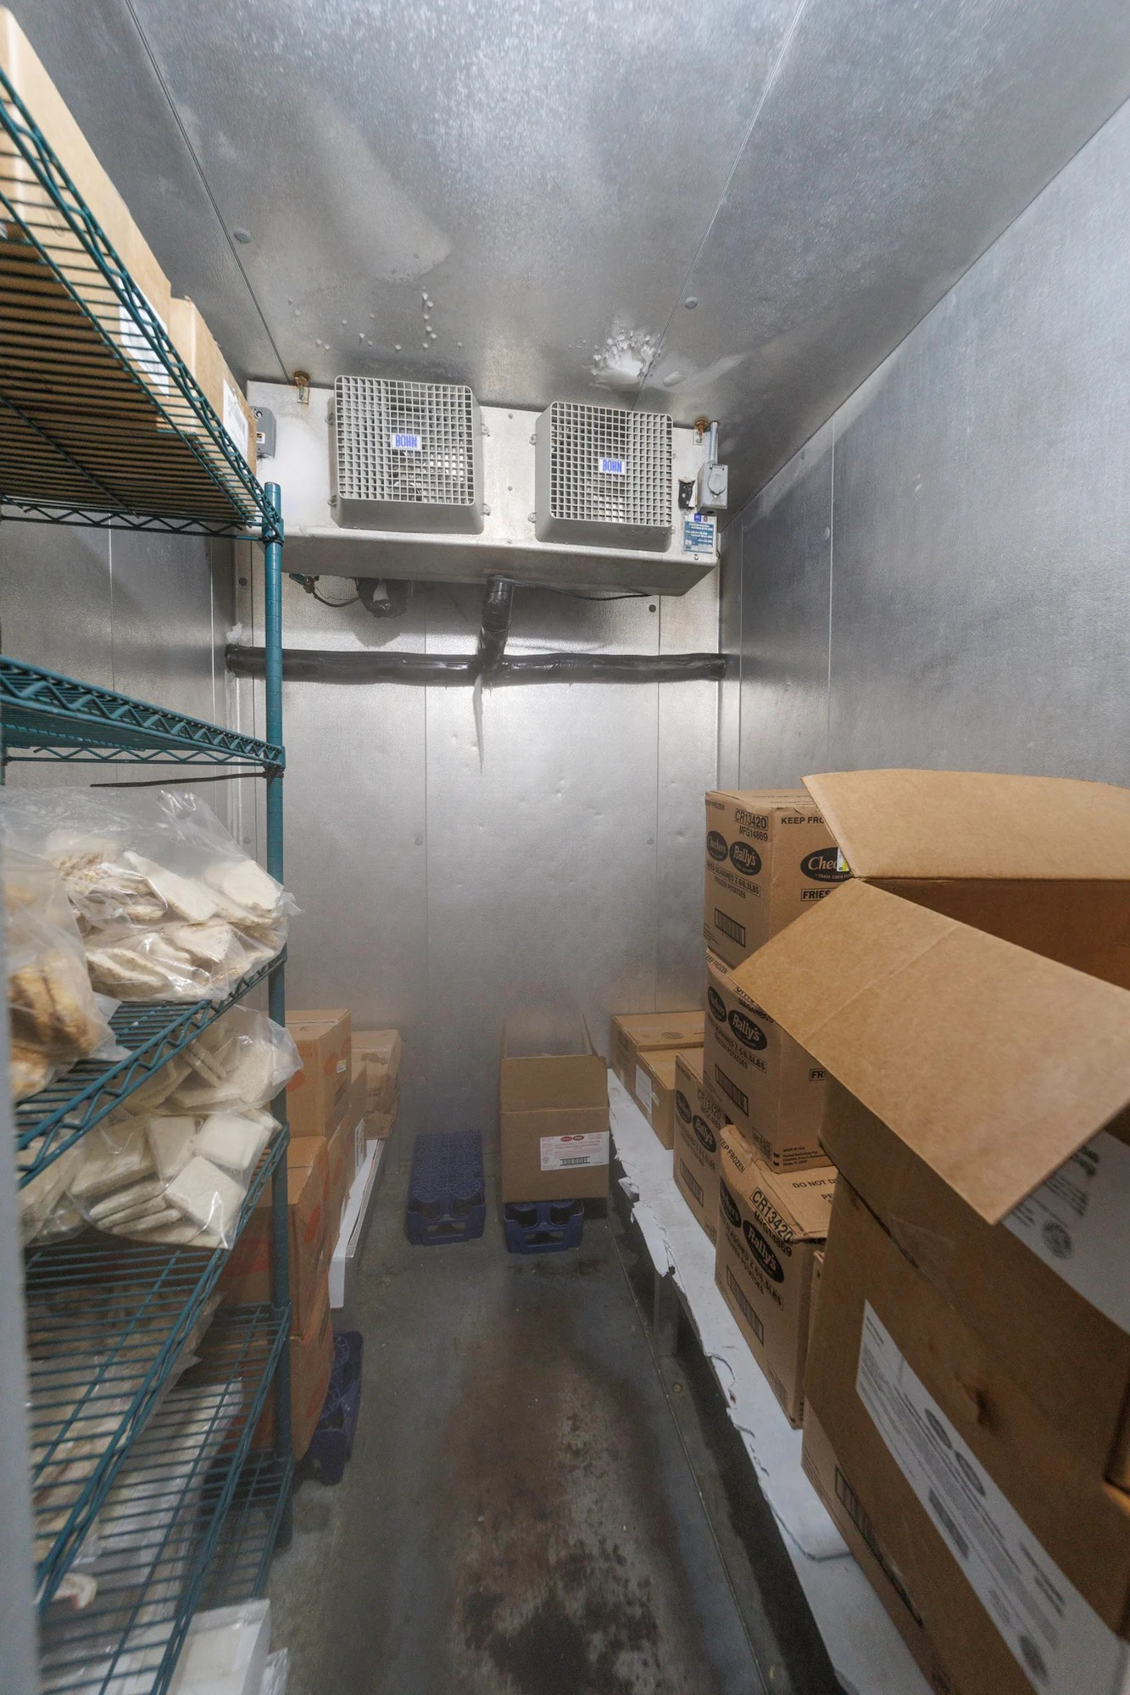
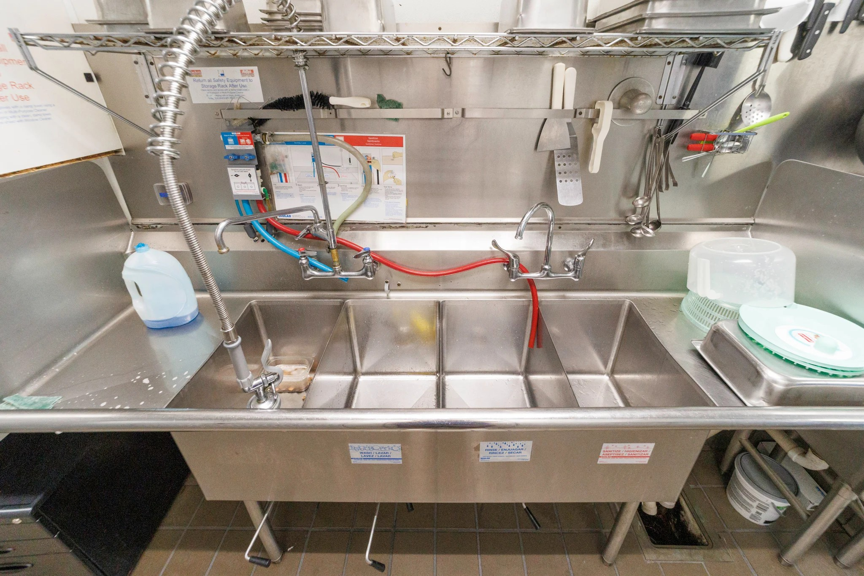
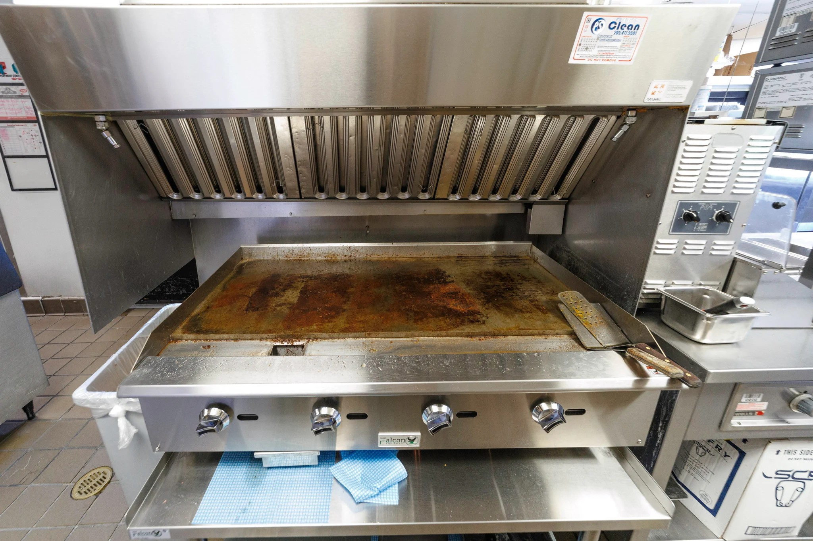

Demographic Insights

