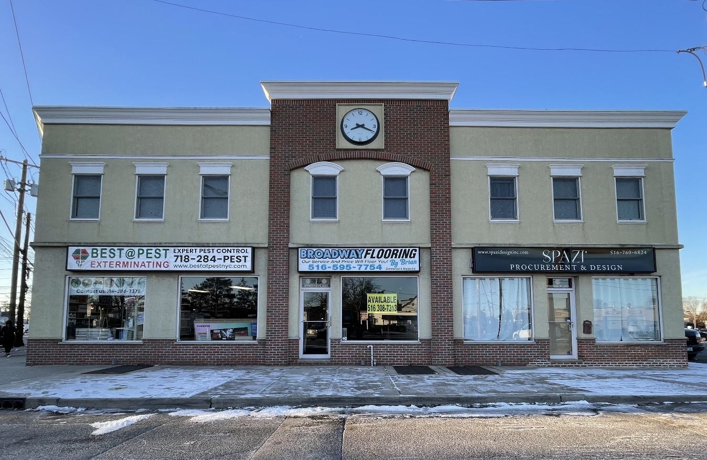
Rent too HIGH?... CAM Charges too HIGH?
Consider: 5 Station Plaza
In the Heart of Bethpage

- $1,950 Monthly
- TAXES Included in Base Year
- 672 Sf. Flexible Layout
- 14 Sf. Storefront
- Move In Condition
- Flexible Lease Terms
- NO CAM Charges
- Large Lighted Signage
- Great Location, Close to All
- Freshly Painted
- Directly Under Town Clock
Make an appointment to see this incredible opportunity.

For Rent by Owner
Contact
(516) 308-7313
rorentall@gmail.com

