10414 Main Street, City of Fairfax, Virginia 22030
Sale Price: $1,400,000
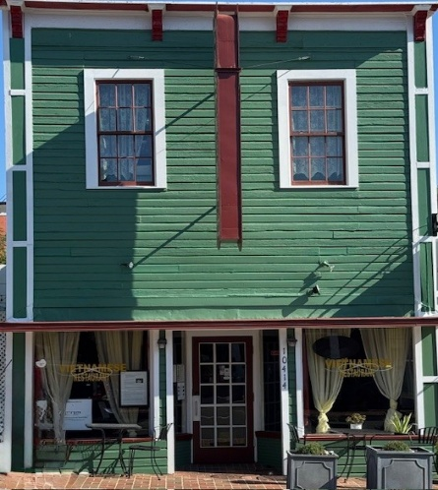
Parcel # 57 4 02 099
Zoning: Commercial-General
Land area: 0.06972 Acres
2025 City Assessment: $984,400.00 annual taxes for 2025 $10,385.42
Total above grade area (SF): approx..4,400 square feet
1st floor (restaurant): approx.. 3,000 square feet paying $6,000.00 per month Restaurant kitchen, two (2) ADA restrooms and open for restaurant seating
2nd floor (retail and two (2) artist) approx. 1,400 square feet paying $1,800.00 per month
Divided into two (2) office spaces. 1st office, Kitchenette, one private office and large open area 2nd office, 1 very large office and long wide hall ( both share restroom with shower).
Basement is usable and is currently storage for the restaurant
New roof on back half of building

