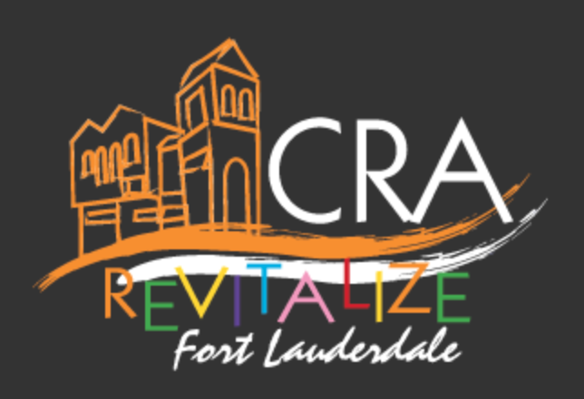

The Non-Residential Façade Improvements Program (NRFIP)

The Non-Residential Façade Improvements Program (NRFIP) is an incentive to assist commercial property owners with renovating existing structures in the NPF CRA. A forgivable loan up to $125,000 is available for capital improvements to the exterior of commercial properties. Exterior improvements include, but are not limited to: entry doors, windows, lighting, shade canopy, sidewalks, signage, and parking facilities.

GOALS/OBJECTIVES: Eliminate blight, remove deterioration; update exteriors of existing buildings in a manner that improves conditions of non-residential areas.
ELIGIBLE AREA: All properties within the NPF CRA area. There is a designated Focus Area defined as Sistrunk Boulevard between NW 24 Avenue and the FEC Railway, including one block north and south of Sistrunk Boulevard; as well as, 9th Avenue (between Sunrise Boulevard and Broward Boulevard), and 7th Avenue (between Sunrise Boulevard and Broward Boulevard).

ELIGIBLE PROPERTIES: Improvements to an existing building within the NFP CRA designed and used for:
a. Non-residential use, or
b. Mixture of uses containing a combination of residential dwelling units with commercial retail sales, service, office uses or combination thereof as permitted by the United Land Development Regulations, City of Fort Lauderdale.
The proposed project must comply with the CRA Redevelopment Plan, urban design guidelines, applicable land use regulations, and current code requirements.

ELIGIBLE PROJECT COSTS:
- All costs associated with exterior improvements which include, but are not limited to: entry doors, windows, lighting, shade canopy, sidewalks, signage, and parking facilities that further the objectives of this incentive.
- Cost of restoration, rehabilitation or both of exterior building are eligible for consideration.
- Costs associated with design and permitting of exterior improvements, restoration, or rehabilitation such as architectural, engineering, permit and application fees.

BASIS/LIMITS OF BENEFITS: A NRFIP award will provide a forgivable loan for up to 90% of the eligible project costs not to exceed $125,000. In the NPF CRA Focus Area, a NRFIP award will provide a forgivable loan for up to 100% of the eligible project costs not to exceed $75,000. Project costs that exceed the initial $75,000 may be funded if the owner provides a cash investment of 5% of the additional cost.

JOB CREATION AND RETENTION REQUIREMENTS: Job creation and/or job retention or another approved performance indicator may be a requirement for assistance provided through this program.
TERMS AND OBLIGATIONS: The program award will have ongoing obligations/covenants, which includes but is not limited to a lien on the applicant’s property.

SPECIAL CONDITIONS:
- Applicants shall propose a performance measure that demonstrates how the project contributes to the elimination or prevention of slum and blight. Job creation or job retention is an example of a performance indicator that may be required to fulfill this requirement.
- The program award will have ongoing obligations or covenants, which included but is not limited to a lien on the applicant’s property.
- In the case of multiple structures on a single property, the CRA Board ( and / or designee), at its sole discretion, may consider a forgivable loan application for each structure subject to the terms, conditions, and limits applicable to location of the subject property.

