Bill Brown Building – Second Floor Office – 7826 Leary Way, Redmond, WA 98052

SUITE 200
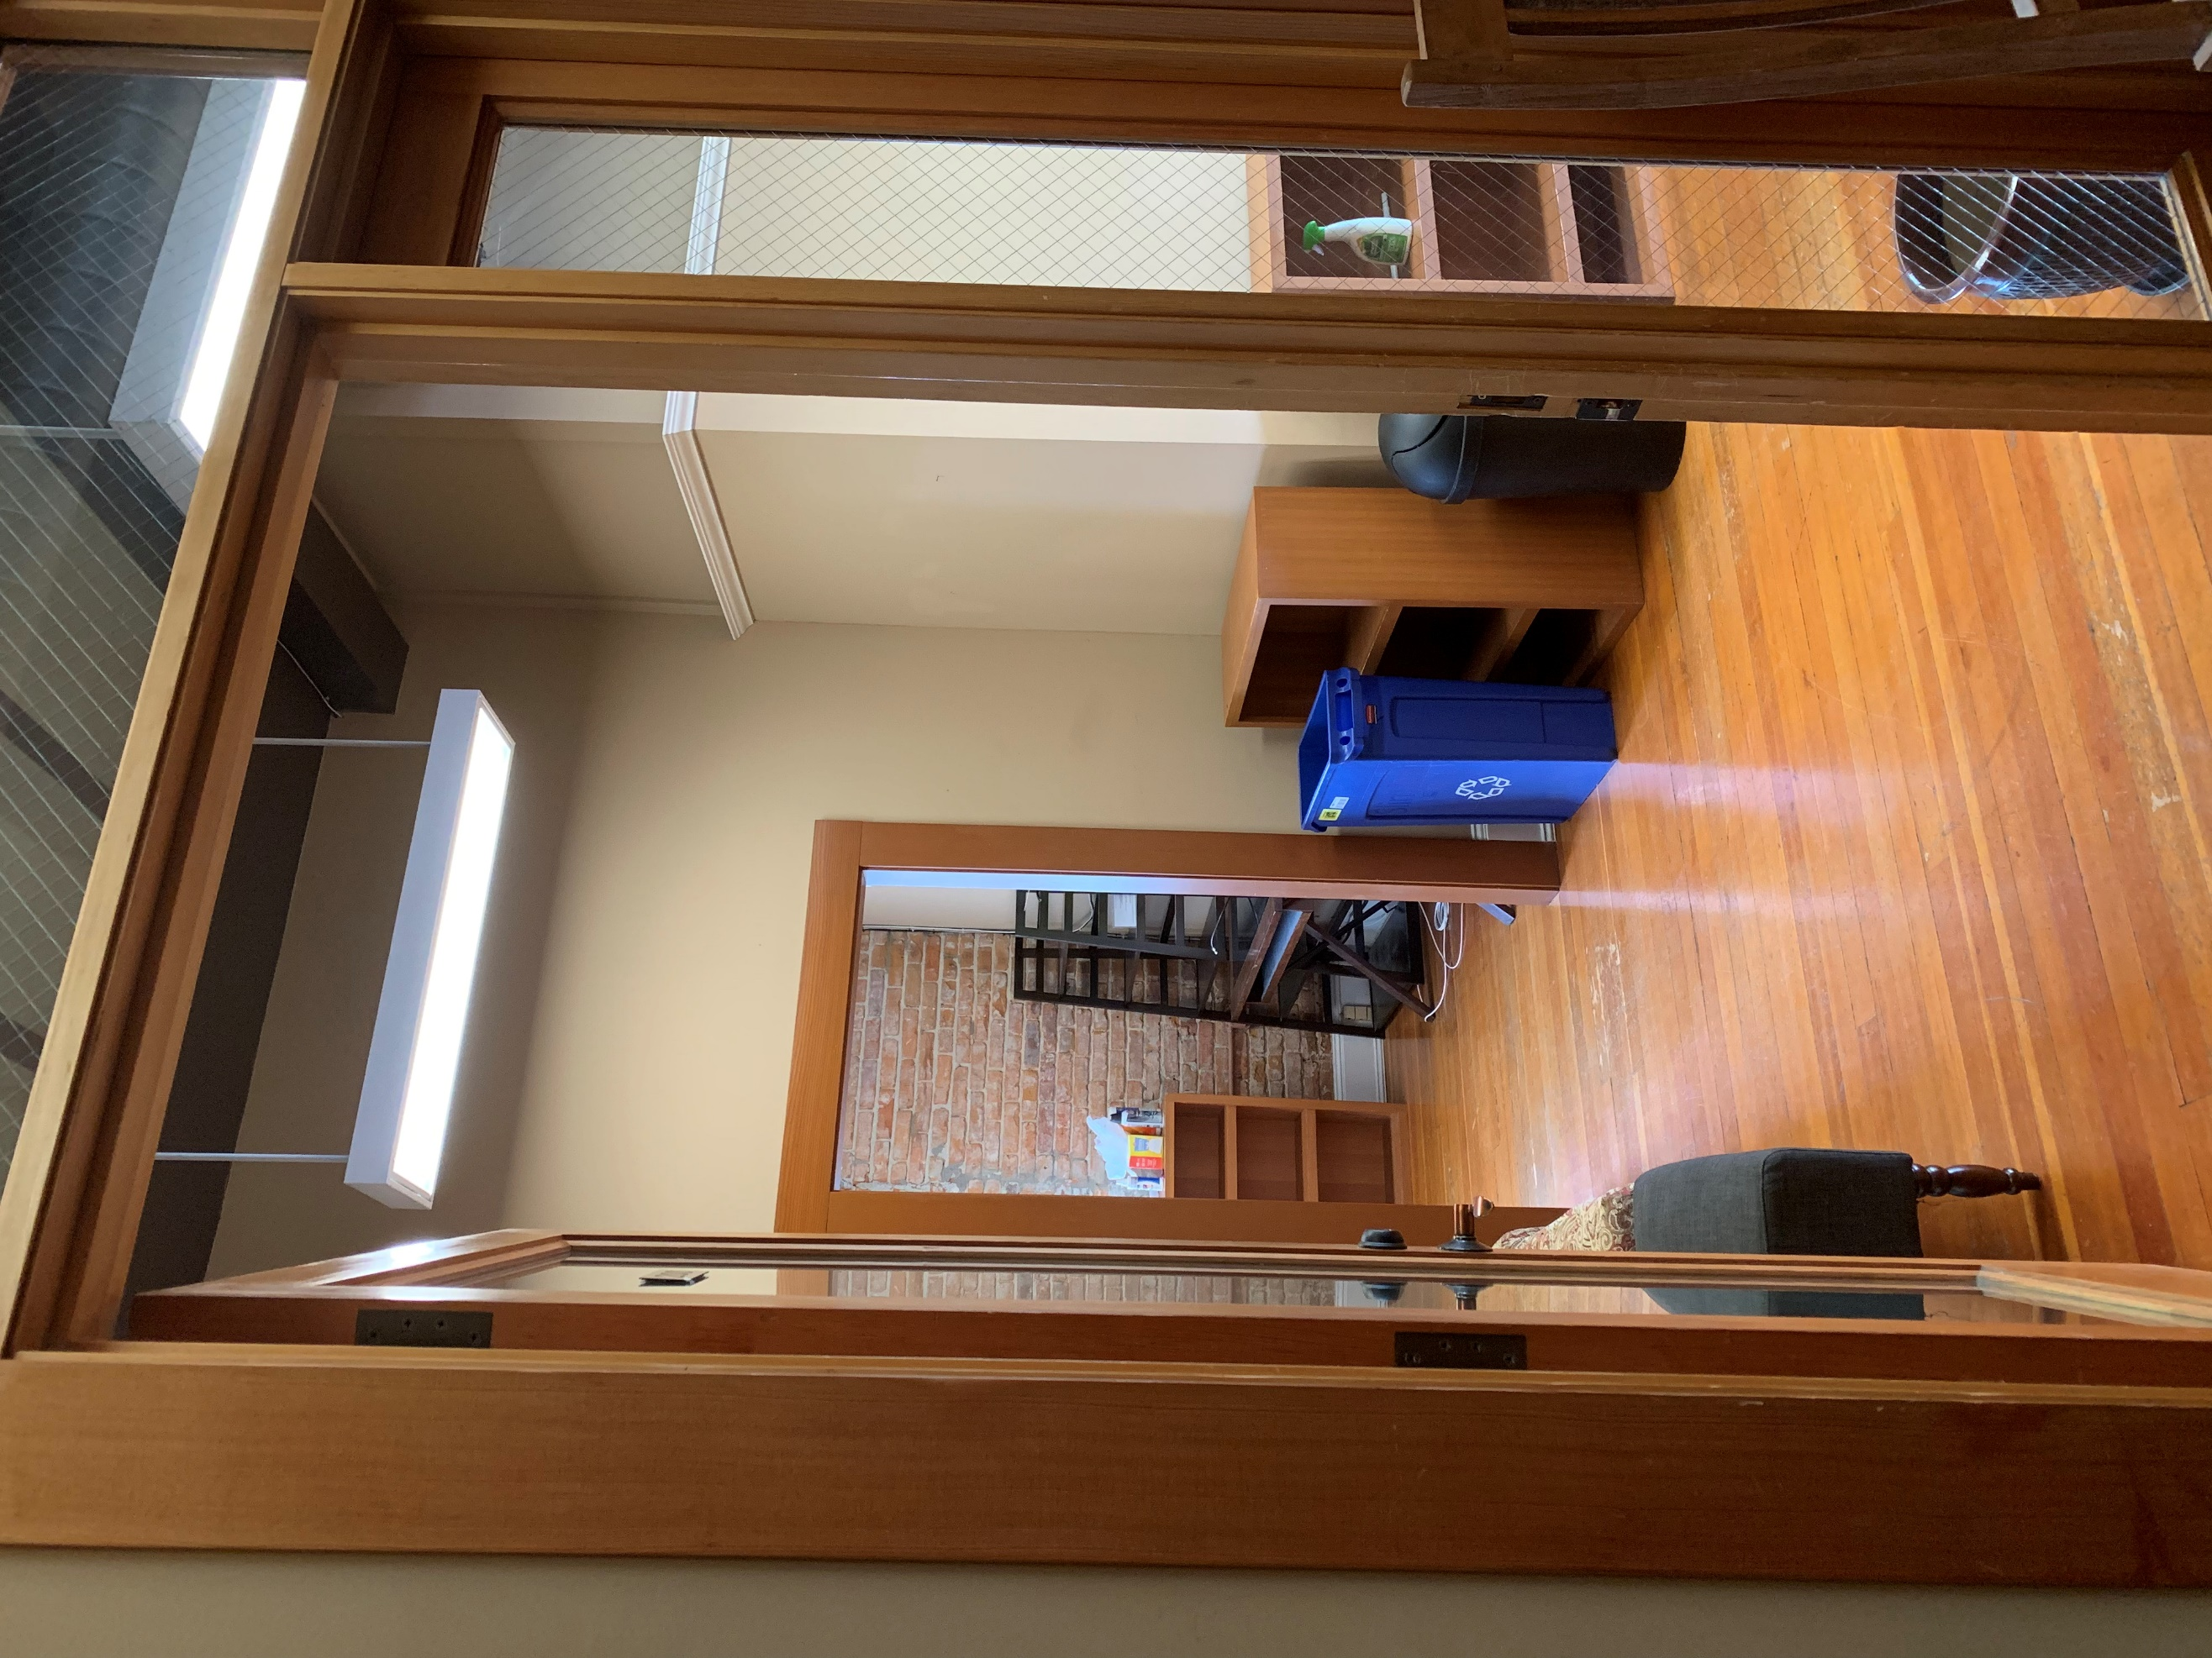
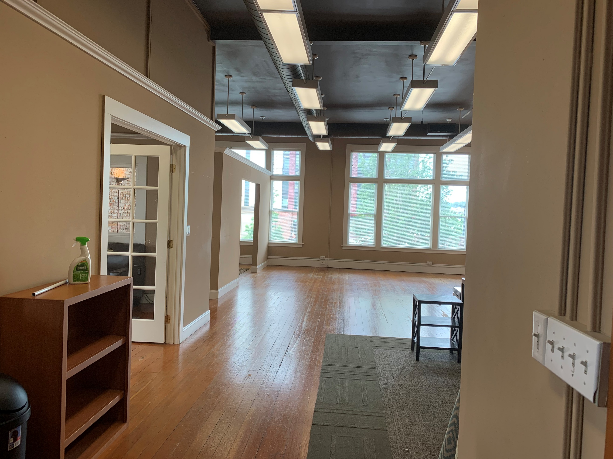
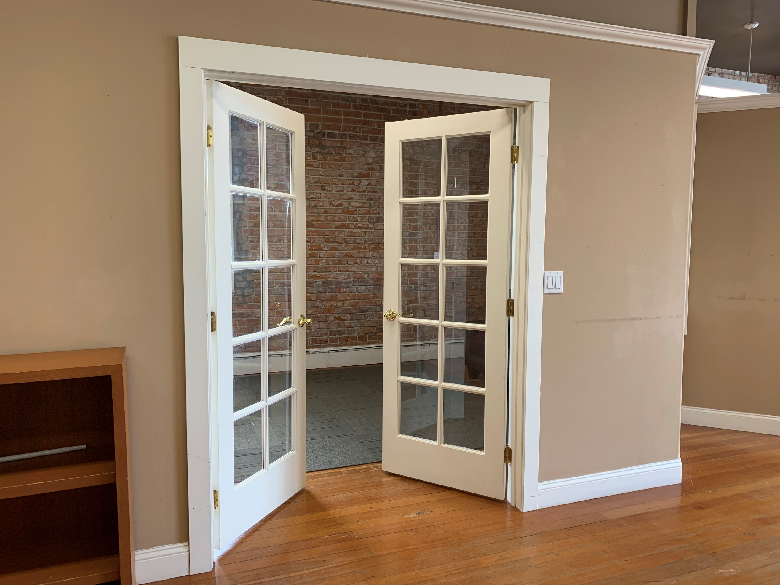

ENTRY FROM RECEPTION TO N. WINDOWS PRIVATE OFFICE / CONFERENCE
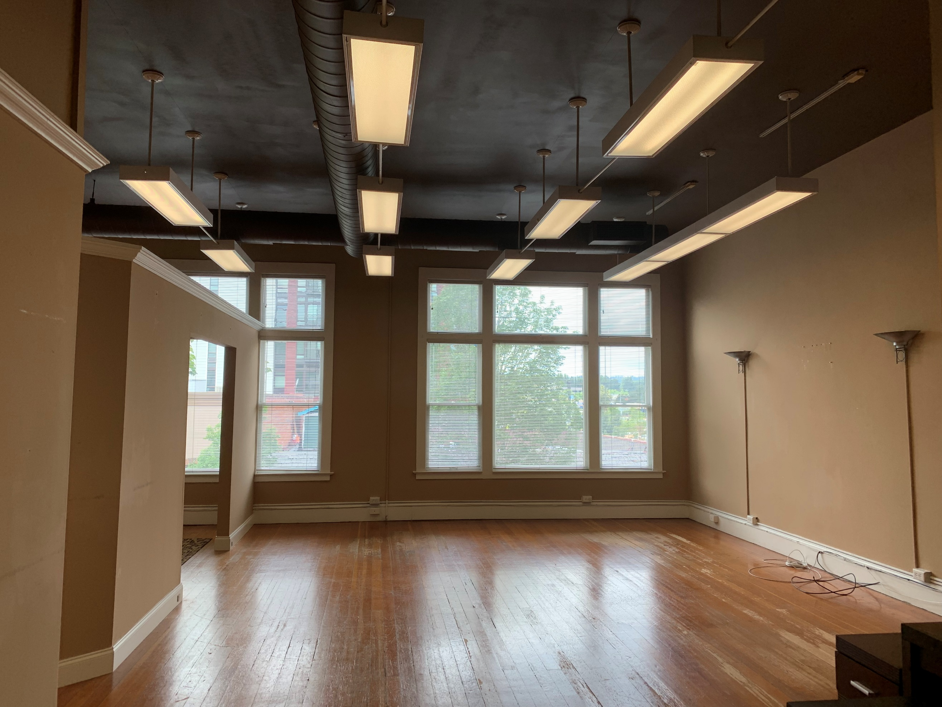
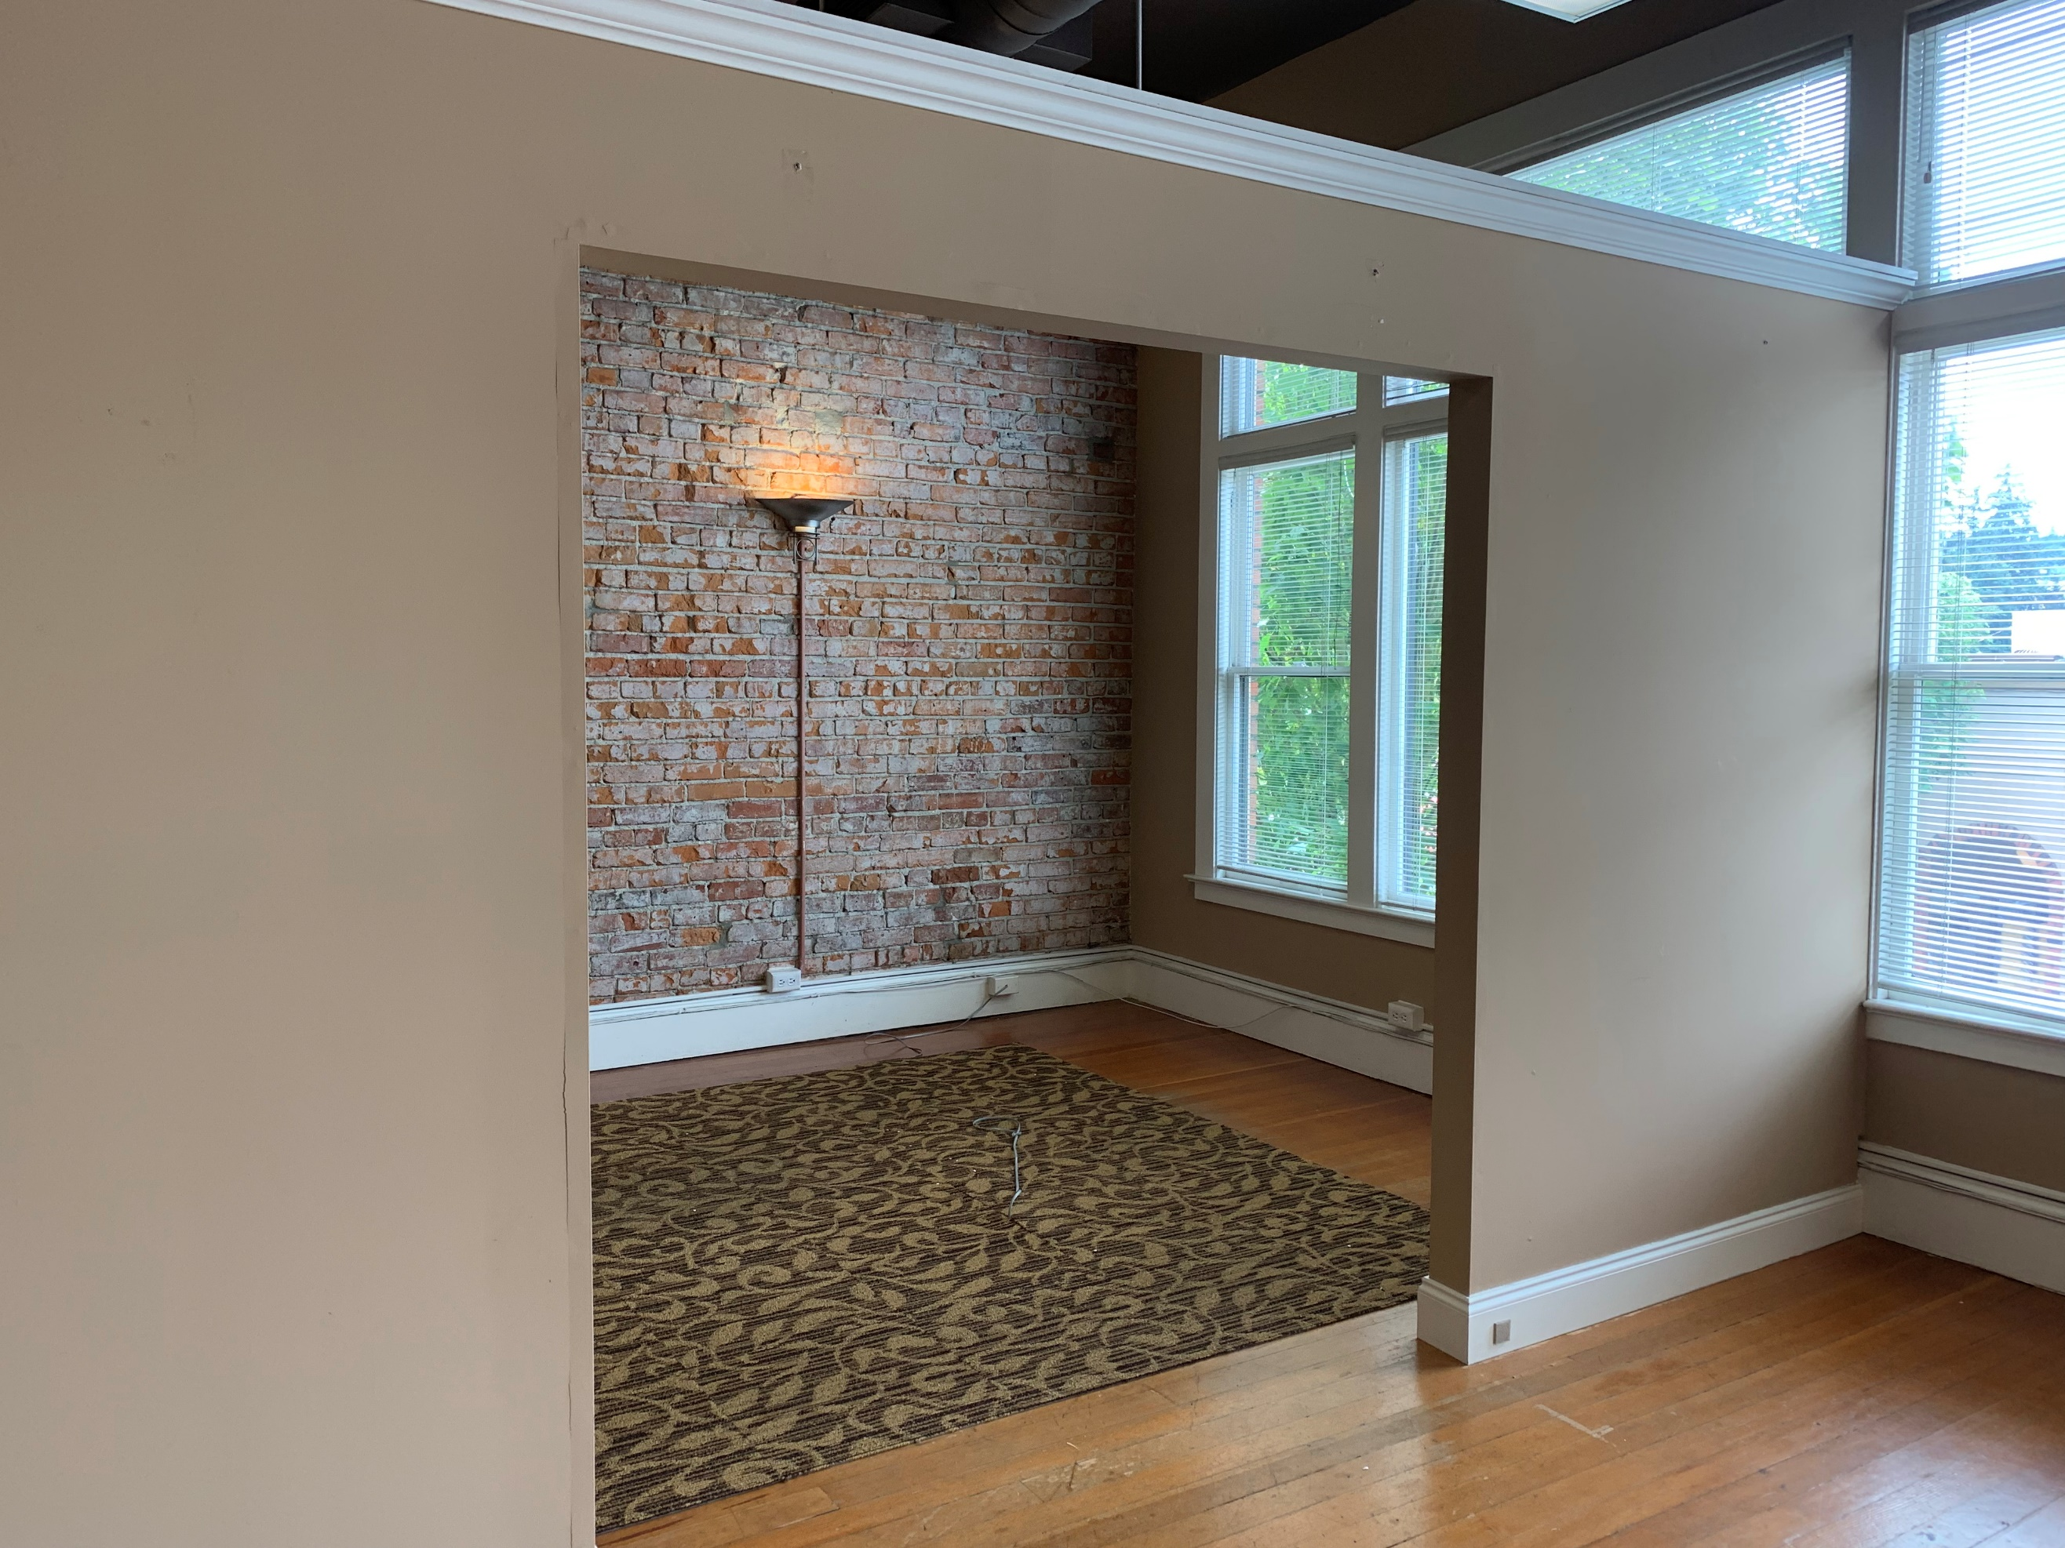
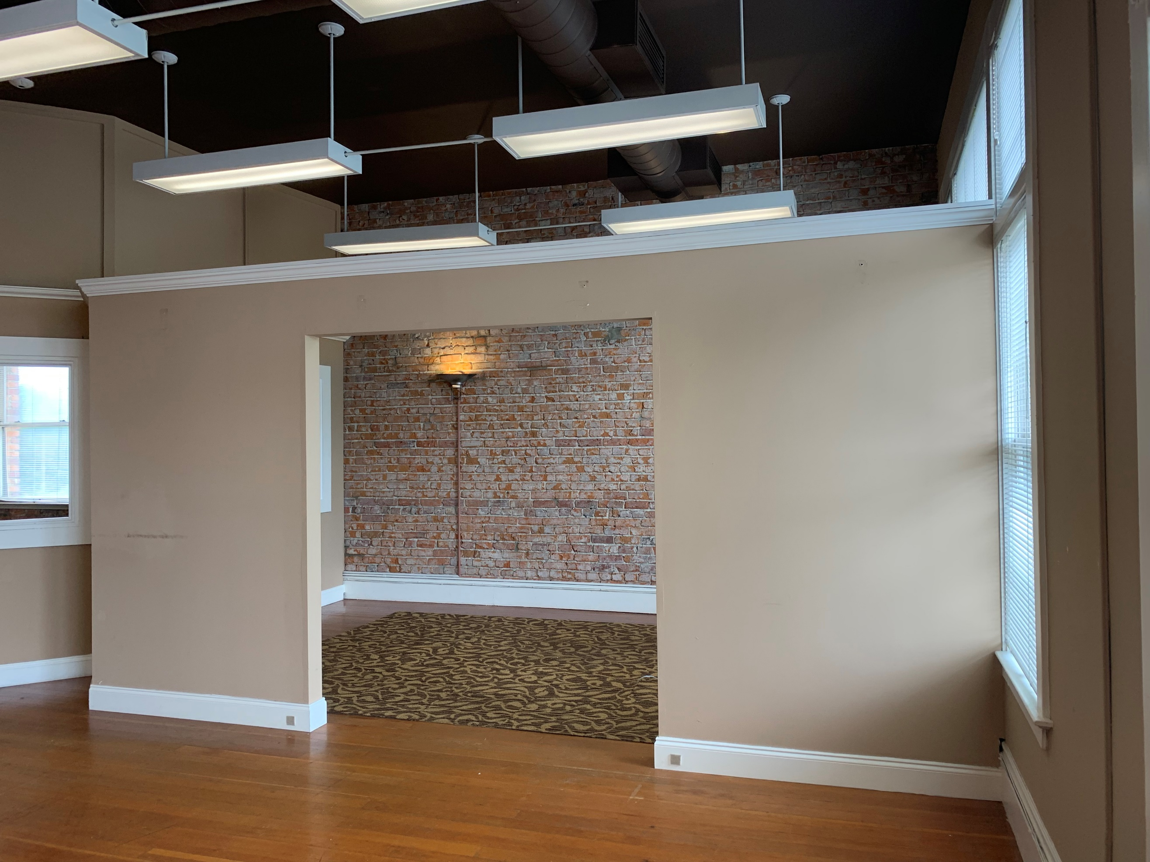

OPEN OFFICE AREA SEMI PRIVATE OFFICE AND ITS INTERIOR WINDOW WALL
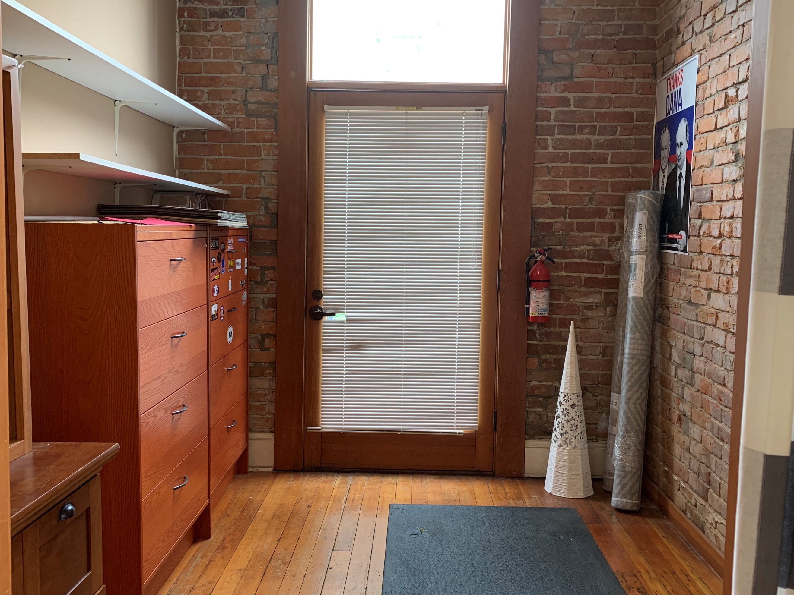
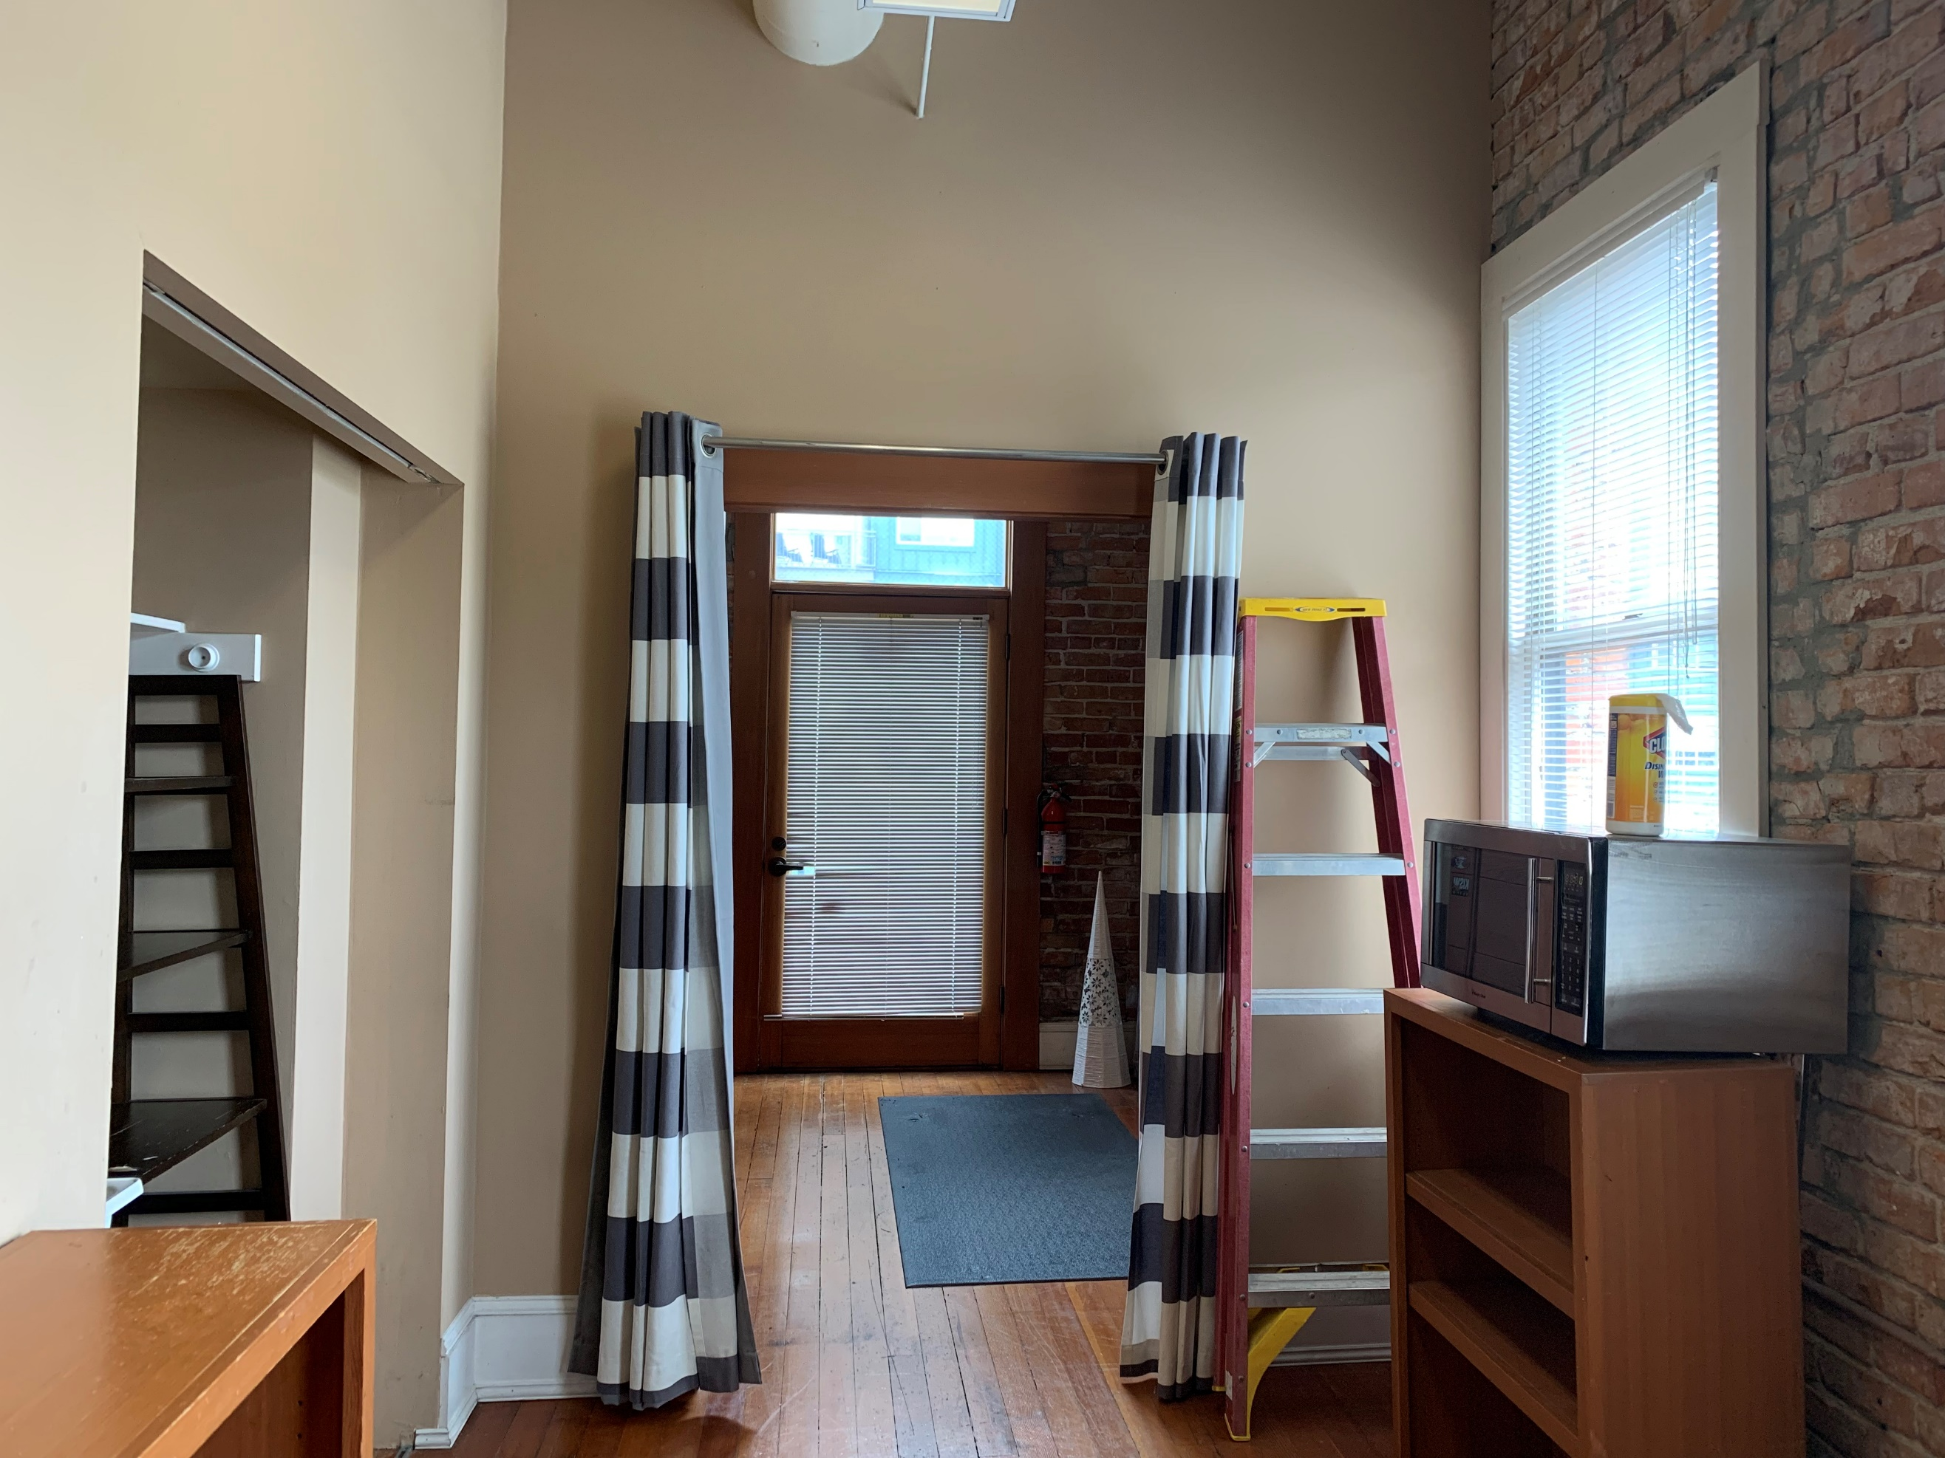
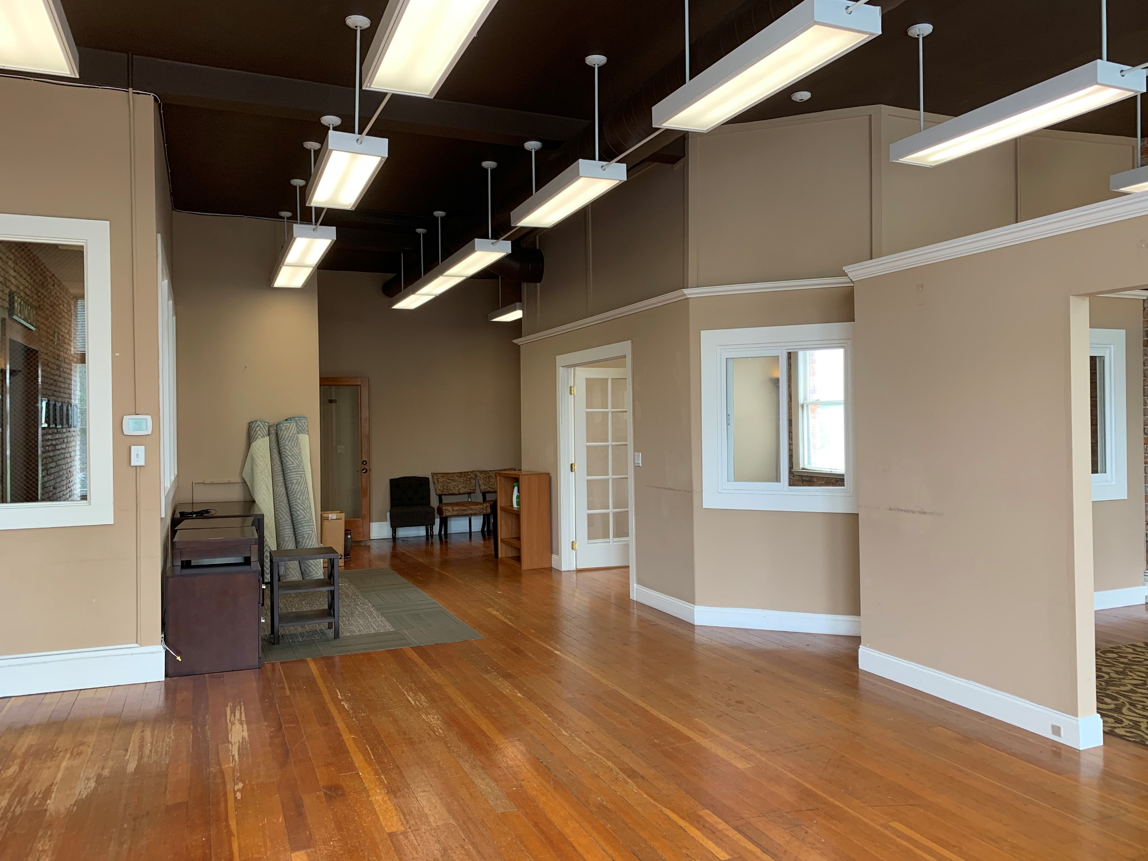

VIEW FROM N. WINDOWS TO ENTRANCE STORAGE / MOP SINK AREA STORAGE / REAR EXIT

