Office/Warehouse Space for Rent
at the Franklin County CDC Venture Center
The Venture Center sits within a 36,000 square foot industrial building and operates as a small-business incubator. It provides space, as well as office equipment and other resources, for start-up and growing businesses. This is an ideal way for businesses to keep their capital costs lower during their early years of operation. The facility is located in Greenfield, MA just one mile from downtown and within 2 miles from both Route 2 and Route 91.
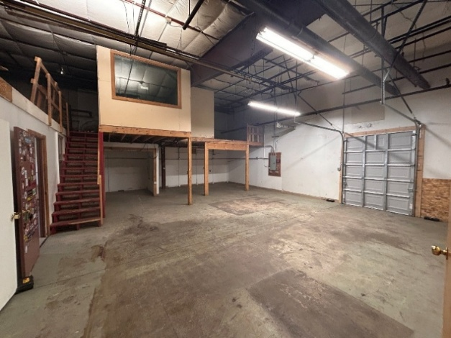
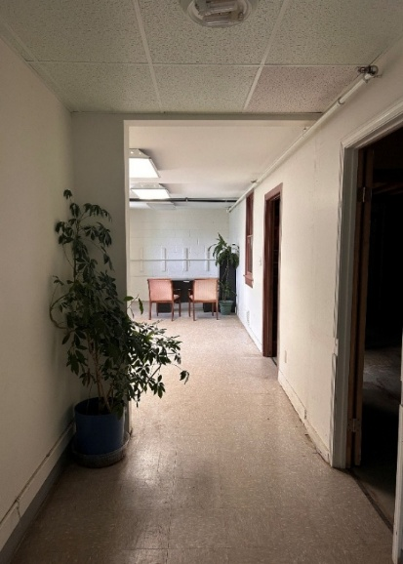
Space is available for rent, consisting of one main office area, 364 square feet, and a secondary warehouse space, 995 square feet, with additional loft storage space.
The space has a private entrance from the parking lot and comes with 4 parking spaces.
Rent is $1,550/month (spaces may be split but prefer to rent together).

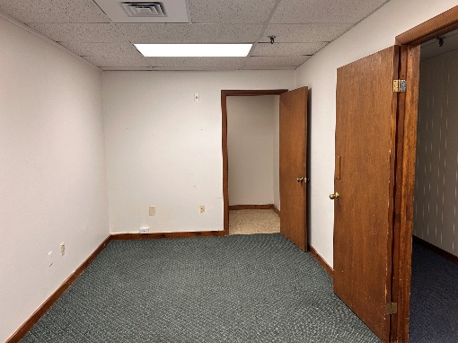
One office in the main area, 152 square feet. The space has a storage closet and comes with two parking spaces. Rent is $385/month.

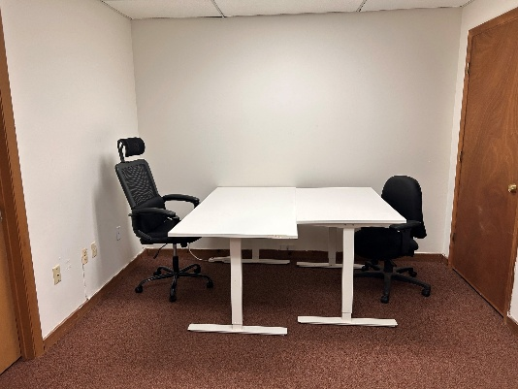
One office in the main area, 120 square feet. The space comes with two parking spaces. Rent is $340/month.

*All rental spaces come with use of the Venture Center’s common areas (kitchen, break area, restrooms, and conference room). If you are interested in renting space at the Venture Center, email hello@fccdc.org, or call (413) 774-7204 x100. County l Opportunity Provider, Lender, and Employer

