PAY-O-MATIC CORPORATE HEADQUARTERS
Located at 160 Oak Drive, Syosset NY 11791 (Nassau County)
Available For Sale By Owner
Parcel#: 2489-15-G-00-0033-0 / Block & Lot#: G / 33
Building Size: 14,888 Square Feet
Lot Size: 30,056 Square Feet / 0.69 Acres
40 Space Parking Lot
Zoning: Light Industry (LI), Industrial Zone
Year Built / Renovated: 1978
Type of Ownership: Fee Simple
1 Tenant: Double Net Leased Property, Landlord Responsible for Real Estate Taxes Only
PAY-O-MATIC has a long operating history (over 15 years) at this location
Lease Commencement: December 1, 2024
Lease Expiration: November 30, 2027
The lease is double net NN at $323,131.56 annually.
At the commencement of lease beginning on December 1, 2024, the landlord will pay for all of the real estate taxes on the property, which is currently at approximately $138,000 annually. Also, as part of the new lease, the landlord and tenant will have a 6-month cancellation clause as part of the new agreement.
Rent Escalations: 3% Annually
Tenant is responsible for Insurance, Common Area, Roof & Structure, HVAC and Utilities

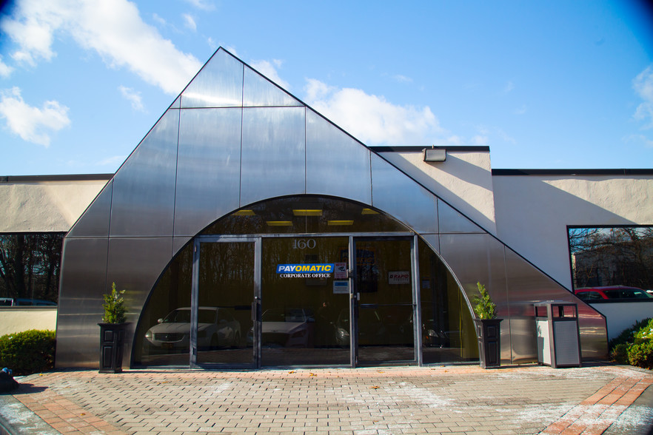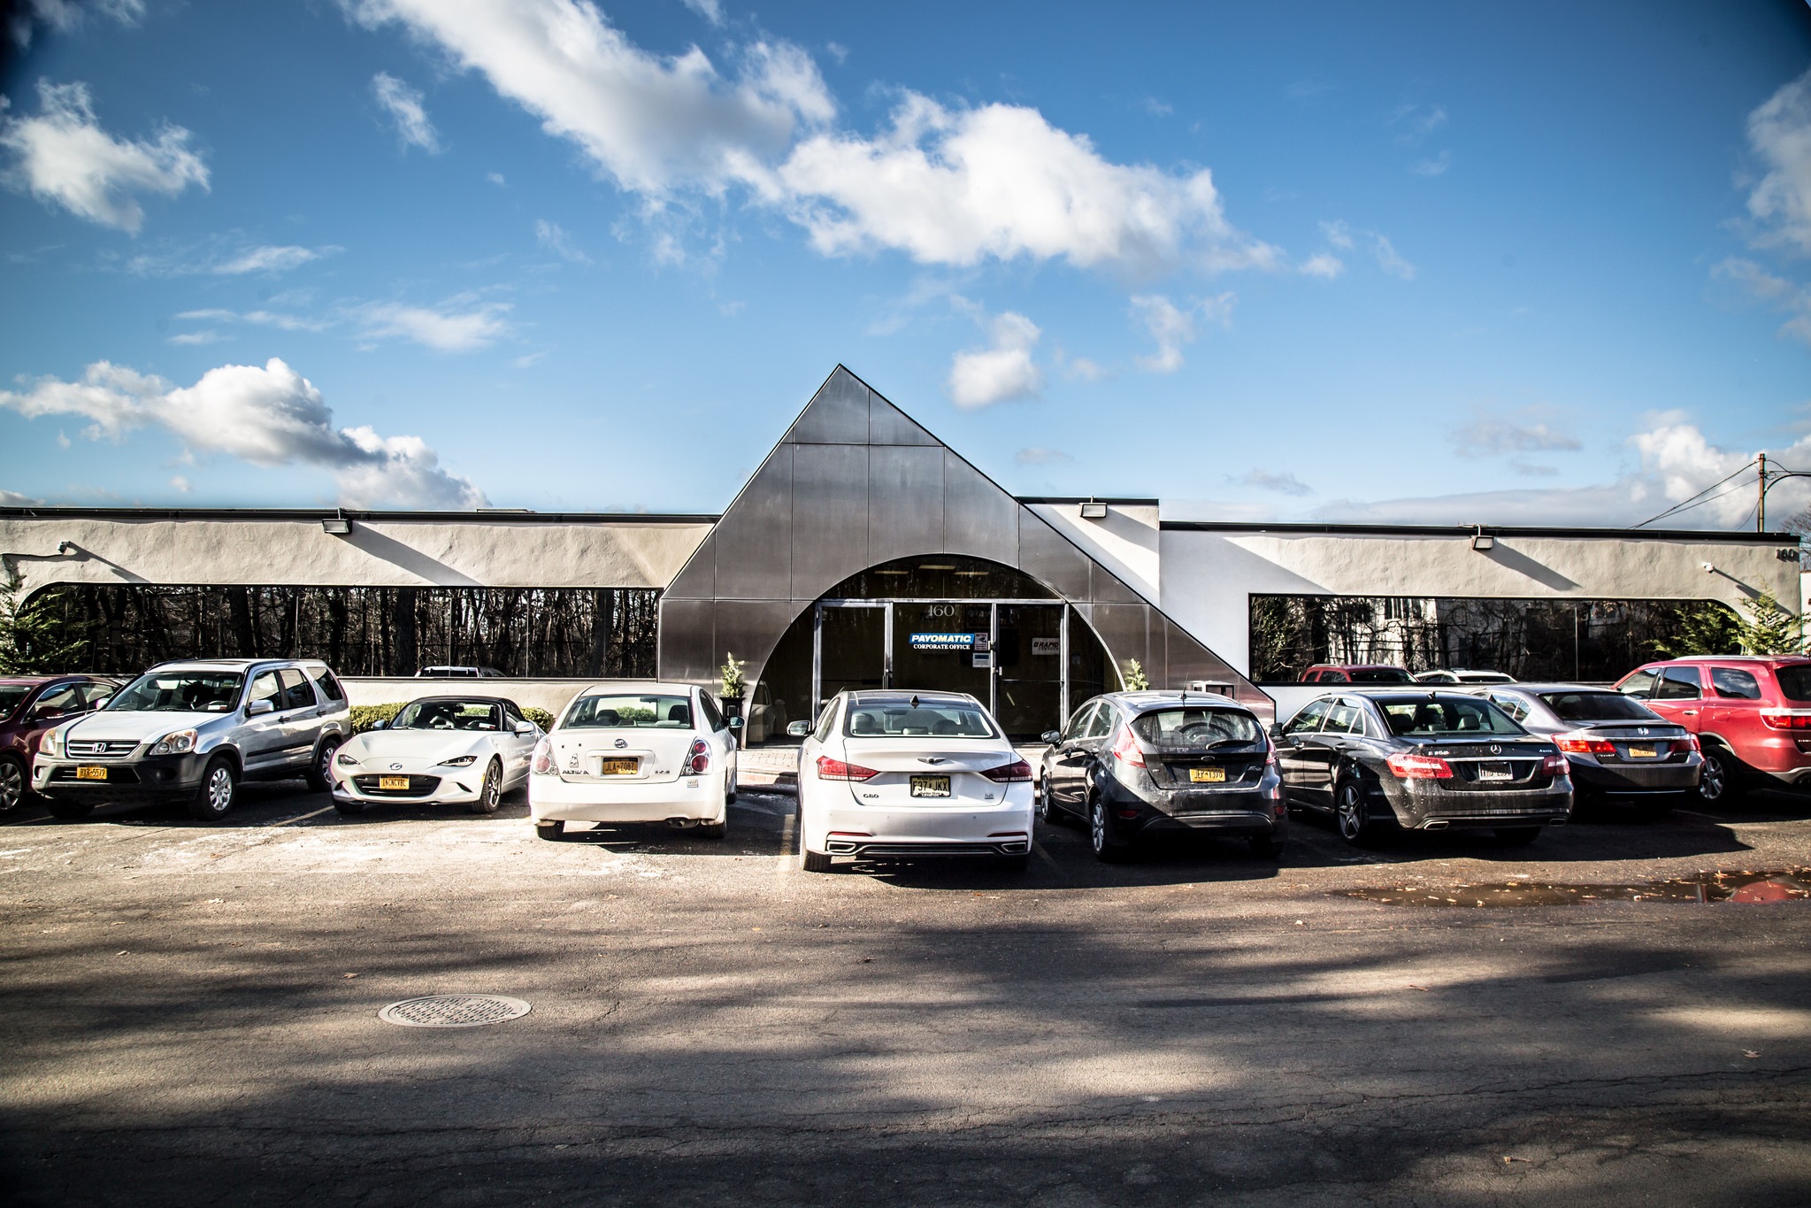

Asking Price: $2,700,000
PAY-O-MATIC is New York’s largest provider of check cashing and financial services, handling nearly 20 million transactions annually. Founded in 1958, PAY-O-MATIC has grown to 148 stores throughout the New York metropolitan area in neighborhoods throughout Manhattan, Bronx, Brooklyn, Queens, Long Island and the NYC area.

