COMMERCIAL LAND FOR SALE
FAYETTEVILLE, ARKANSAS
ADDRESS: 15th Street, Fayetteville
LAND SIZE: 3.86 acres
ZONING: Main Street Center (MSC)
Price: $1,100,000 ($6.51/sf)
PROPERTY DESCRIPTION:
- Land is located less than 200’ east of the intersection of S. School Street (US 71 Bus) and 15th Street (St Hwy `16)
- The land has a gentle south-facing slope from the street.
- The MSC zoning allows for a myriad of uses, including but not limited to: single family homes, multiple family dwellings, shopping goods, eating places, drive-thru restaurants, commercial recreation sites, hotels and motels, offices, liquor stores, shopping goods, transportation services, dance halls, & outdoor music establishments. (further definition and expansion of these use types can be found in the Fayetteville zoning ordinance, section 161.27.)
- Entrance to the 36 mile-long Razorback Greenway (hard-surface) Trail that connects south Fayetteville to Bella Vista and the many miles of connecting trails in Fayetteville can be accessed about 200’ east of the property on 15th St.
- Approx. 1.82 acre lies in multiple flood zonesk, as follows:
  - Far south end: Floodway - .45 acres
  - Middle section: 100 yr flood plain (1% change of an annual flood) - .78 acres
  - Last section: 500 yr flood plain (.2% chance of an annual flood) - .59 acres
    - Map attached
LOCATION:
- 15th Street is a major arterial in South Fayetteville with a connection between I49 and US Hwy 62 to the west and southeast Fayetteville and Hwy 16 to the east.
- Within minutes of the property lies Downtown Fayetteville, the Arkansas Research and Technology Park, the world class Fayetteville Public Library, the University of Arkansas flagship campus and its athletic facilities (some of the best in the U.S,), the Fayetteville Industrial Park.
- Across the street and slightly east is Walker Park, the major, 74 acre, city park in southeast Fayetteville, with facilities including 4 baseball/softball parks, soccer fields, a skateboard facility, a Senior Citizens Center, and woods and trails. The park is embarking on a $27 million improvement plan, details of which are attached.
- The areas to the north and east of park has seen substantial new, upscale residential construction and renovation over the last 5 years, and commercial development including hotels, eating establishment, retail shops, etc.
- Both east and west along 15th St, large scale housing single family and multiple family projects have been built and other large acreages are under lot development. The development in this area has grown to the point that the entire area is now known as SoFay (South Fayetteville).
CONTACT:
George Faucette, CCIM
Mobile phone: 479-530-1548
Coldwell Banker Harris McHaney & Faucette, 3593 N. College Ave, Fayetteville, AR 72703

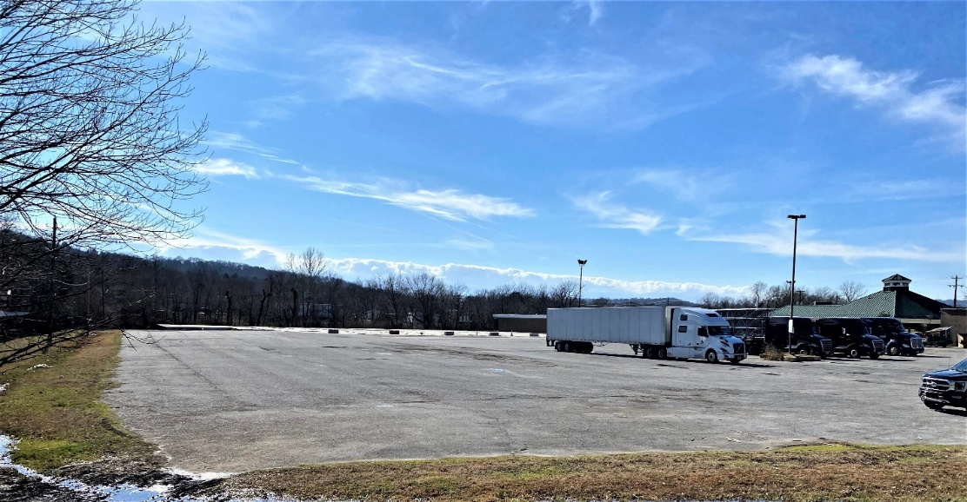
FROM FRONT
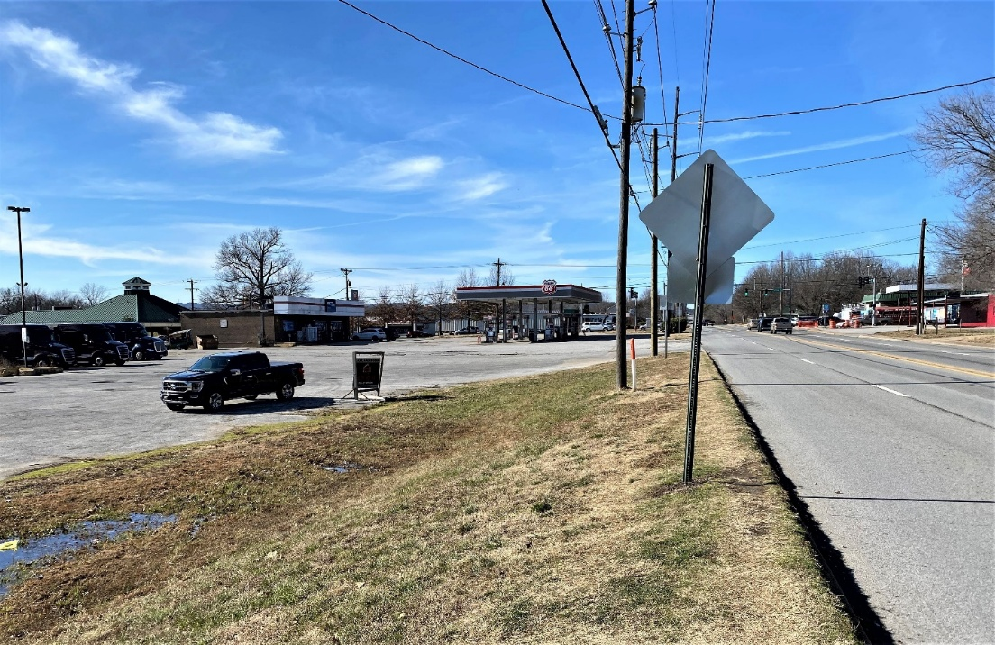
FRONT – LOOKING TOWARD CORNER STOPLIGHT



