Sec. 4.2.14. Manufactured Housing Park (P-MH) zoning classification.
A. Intent of Classification. The Manufactured Housing Park Zoning Classification is intended to provide tracts of land designed to create a sense of community and maintained or used for the purpose of renting individual sites for manufactured homes.
B. Residential Zoning Classification Permitted and Special Uses. See table 4.2-3 below.
C. Property Development Regulations. See table 4.2-4, and figures 4.2-2 and 4.2-3 below.
Table 4.2-3 Residential Zoning Classification Permitted and Special Uses Table
Permitted/Special Uses | RR-1 | R-E | R-1 | R-2 | R-3 | R-4 | MH | P-MH
Accessory uses on non-contiguous vacant lot | S | S | S | S | S | S | S | S
Art gallery |  | S | S | S | S | S | S | S
Cemetery, crematory, mausoleum |  | S | S | S | S | S | S | S
Church, Places of worship | S | P | P | P | P | P | P | P
Community and/or personal use garden |  |  | P |  |  | P | P
Community or personal use garden | P | P |  | P | P |  |  | P
Community residential home with six or less residents | P | P | P | P | P | P
Community residential home with seven or more residents |  | S | S | S | S | S
Convalescent home, adult congregate living facility |  |  |  |  | P | P
Daycare, child, adult |  |  |  |  | S | P
Gas meter facility and supply lines, high-pressure, except where such permits are pre-empted by state and federal regulations |  | S | S | S | S | S | S | S
Horses or cattle for personal use [See special lot area and number requirements in Sec. 4.2.6.F] | P | P | S | S | S | S | S | S
Library |  | S | S | S | S | S | S | S
Low-power radio station |  |  | S
Manufactured buildings (DCA approved residential units) | P | P | P | P | P | P | P | P
Manufactured homes | P | S |  | S |  | P | P | P
Multiple-family dwellings |  |  |  |  | P
Museum |  | P | P/S
Museums |  |  |  | S | S | S | S | S
Orphanage |  |  |  |  |  | P
Parking of commercial vehicles [see Sec. 4.3.21] | S | S | S | S | S | S | P
Pigeon lofts meeting the requirements of Sec. 4.3.20, on lots one acre or larger |  |  |  |  |  |  | S | S
Plant nursery, wholesale |  | S | S | S | S | S | S | S
Pot-bellied pigs as pets | S | S | S | S | S | S | S | S
Private clubs and community centers |  | S |  |  | S | S
Private greenhouse or non-commercial (no retail sales) conservatory for plants or flowers | P | P
Professional office |  | S | S | S | S | S | S | S
Public lodging establishments including resort condominium, non-transient apartment, transient apartment, rooming house, bed and breakfast inn, or resort dwelling | S | S | S | S | P | S | S | S
Public or private golf course or tennis facility, which may include a country club or clubhouse |  | P | P | P | P | S | P | P
Public Park, playground or other public recreational use | P | P | P | P | P | P | P | P
Recreation building |  | S |  | S | S |  |  | S
Rehabilitation center, physical |  |  |  |  | S | S
School, accredited public, private, parochial |  | S | S | S | P | P | S | S
Sewage treatment plants with an inflow exceeding 5,000 gallons per day |  | S | S | S | S | S | S | S
Silviculture
Single family, guest cottage, apartment. Refer to Sec. 4.3.18 | P | P | P
Single-family dwelling | P | P | P | P | P | P | P
Sprayfields (or other type of effluent disposal area when application rate exceeds 5,000 gallons per day, if allowed by law) |  | S | S | S | S | S | S | S
Sprayfields or other type of effluent disposal area when application rate exceeds 10,000 gallons per day, if allowed by law | S
Two-family dwelling (when consistent with land use) |  |  |  | P | P | P
Water wellfields |  | S | S | S | S | S | S | S

Table 4.2-4 Residential Classification Property Development Regulations Table
 | Special  Notes or  Regulations | RR-1 | R-E | R-1 | R-2 | R-3 | R-4 | MH | P-MH
Maximum Permitted Density [Vested or underlying land use designation, unless qualifies for the density exceptions provisions in Sec. 4.3.2.]
Single-  family |  | 1 du/acre | 1 du/acre | 1 du/1 acre | 4 du/acre | 4 du/acre | 4 du/acre | 4 du/acre | 4 du/acre
Two-family |  |  |  |  | 6 du/acre | 6 du/acre | 6 du/acre |  | 6 du/acre
Multiple-family |  |  |  |  |  | 8 du/acre | 8 du/acre
High-Urban Density |  |  |  |  |  | 8-16 du/acre | 8-16 du/acre
Minimum Lot Area | See Note(s) |  |  |  |  | Note¹ | Note²
without central water and central sewer service
Single-  family |  |  | 32,670 SF | 10,000 SF | 10,000 SF | 7,500 SF | 7,500 SF | 10,000 SF
Two-  family |  |  |  |  | 12,500 SF | 12,500 SF | 12,500 SF
3< family |  |  |  |  |  | 12,500 SF
For new residential subdivision development where central water and central sewer services are utilized
Single-  family |  |  | 32,670 SF | 7,700 SF | 10,000 SF | 7,500 SF | 5,000 SF | 10,000 SF
Two-  family |  |  |  |  | 12,500 SF | 7,700 SF | 7,700 SF
3< family |  |  |  |  |  | 7,700 SF
Minimum Lot Width
without central water and central sewer service (feet)
Single-  family |  | Existing | 150 | 85 | 85 | 85 | 75 | 85 | 85
Two-  family |  |  |  |  | 100 | 100 | 100 |  | 100
3< family |  |  |  |  |  | 100
For new residential subdivision development where central water and central sewer services are utilized (feet)
Single-  family |  | Existing | 150 | 70 | 85 | 70 | 70 | 85 | 85
Two-  family |  |  |  |  | 100 | 70 | 100 |  | 100
3< family |  |  |  |  |  | 70
Maximum Floor Area Ratio |  | None | None | None | None | None | None | None | None
Setbacks, Principal Structure without central water and central sewer service (feet)
without central water and central sewer service (feet)
Front |  | 25 | 25 | 25 | 25 | 25 | 25 | 25 | 25
Side |  | 25 | 25 | 8 | 8 | 8 | 8 | 8 | 15
Rear |  | 8 | 25 | 25 | 15 | 25 | 25 | 25 | 25
For new residential subdivision development where central water and central sewer services are utilized (feet)
Front |  | 25 | 25 | 20 | 25 | 20 | 20 | 25 | 25
Side |  | 25 | 25 | 8 | 8 | 8 | 8 | 8 | 15
Rear |  | 8 | 25 | 20 | 15 | 20 | 20 | 25 | 25
Setbacks, General Accessory (feet) [refer to placement requirement s in Sec. 4.2.6.C.(8)] |  |  | Refer to Sec. 4.2.6.  C.(8)
Front |  | 25 | 25 | 25 | 25 | 25 | 25 | 25 | 25
Side |  | 8 | 25 | 8 | 8 | 8 | 8 | 8 | 8
Rear |  | 8 | 25 | 8 | 8 | 8 | 8 | 8 | 8
Maximum Building Height (feet)
Primary Structure |  | 40 | 40 | 40 | 40 | 40 | 40 | 40 | 40
Accessory Structure [refer to placement requirement s in Sec. 4.2.6.C.(8)] |  |  |  | 20 | 20 | 20 | 20 | 20 | 20

¹ Smaller lots sizes may be approved administratively through the waiver process in Article 2, Division 10 including DRC, Development Review Committee, recommendation and approval by the Board.
² Smaller lots sizes may be approved administratively through the waiver process in Article 2, Division 10 including DRC, Development Review Committee, recommendation and approval by the Board.
Figure 4.2-2 Residential Classification Property Development Regulations Diagram
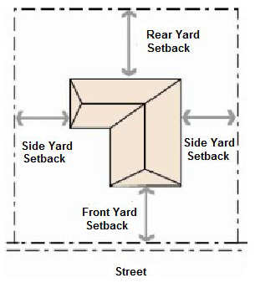
Figure 4.2-3 Mobile Home Park Classification Property Development Regulations Diagram
Diagramed Setbacks for Manufactured Home Parks Established on or prior to June 11, 1992
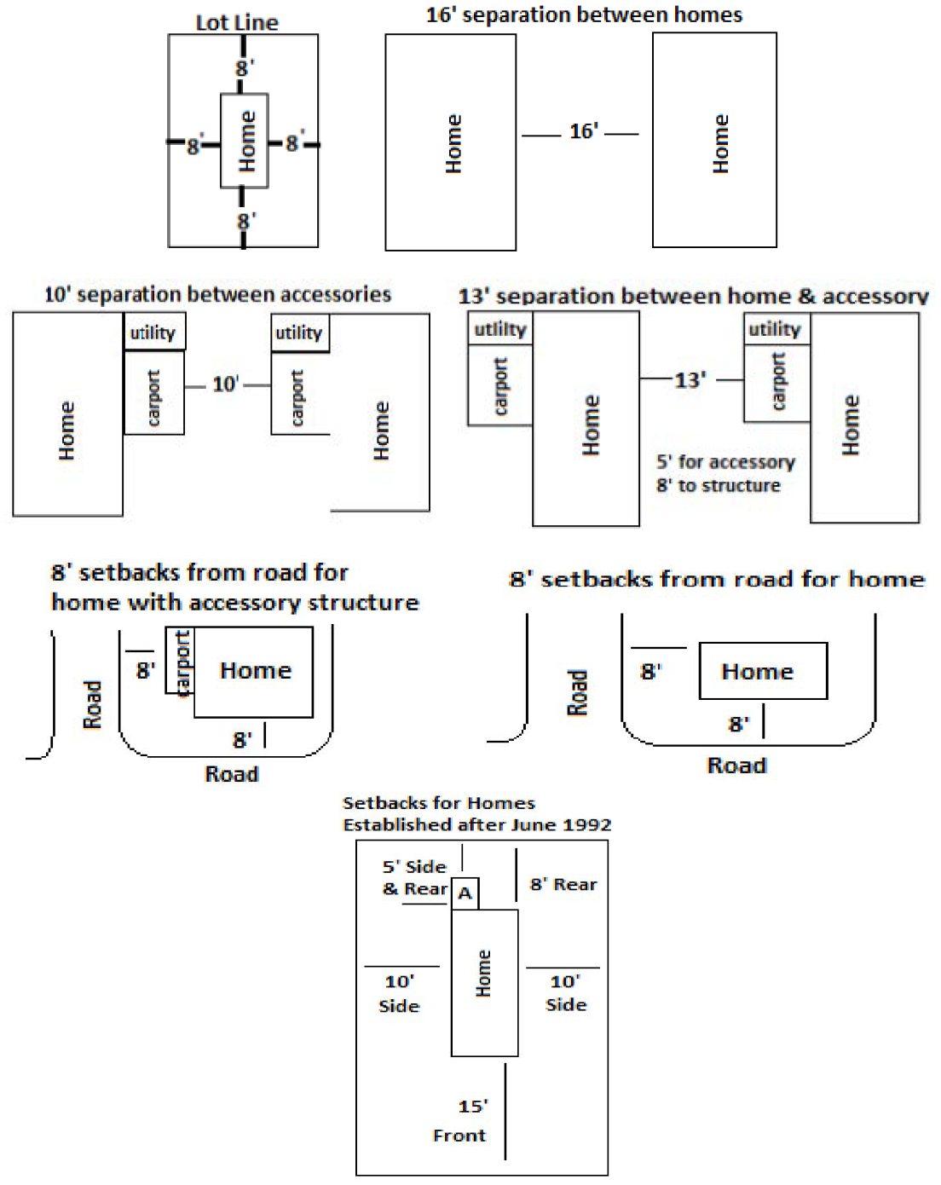
(Ord. No. 17-08, § 2(Exh. A), 4-11-2017; Ord. No. 24-08, § 1(Att. 1), 4-16-2024)

