1836 Church Street, The Trolley Garage
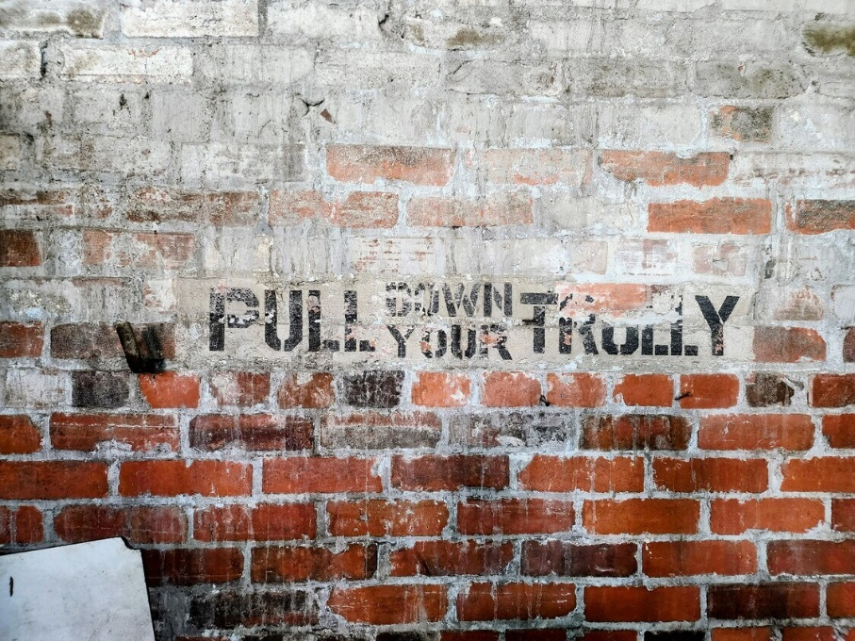
Additional Support Information
The new owner can take advantage of Federal, State, and Local Opportunity & Enterprise Zone tax credits and grants as well as the use flexibility offered by the Railroad District Overlay.
1836 Church Street is a contributing resources to the Norfolk & Western Railroad Historic District, which is listed in the National Register of Historic Places and the Virginia Landmarks Register. The former trolley car storage/warehouse building contributes to the district. That status likely makes the propertiy eligible for historic rehabilitation tax credits, a process that is managed by Virginia Department of Historic Resources. You can contact Chris Novelli at Chris.Novelli@dhr.virginia.gov or at 804-482-6097 with any questions about the process to apply for the tax credit and what type of work qualifies.
Additionally, as the property is located in the Norfolk & Western Railroad Historic District, it is also eligible to be rezoned into the Norfolk & Western Railroad Historic Overlay District. This is a local zoning overlay that seeks to preserve the historic character of the district by encouraging adaptive reuse of existing structures. While properties that are rezoned into this district are required to receive approval from the Norfolk Architectural Review Board for certain changes to the building’s exterior and site, the overlay permits residential and commercial uses otherwise not available in the industrial districts, a process that involves a specific historic district designation application and review by ARB and the City Planning Commission.
Aside from the historic rehabilitation tax credit, there are limited funding opportunities to assist with brick-and-mortar preservation. Competition for preservation funds is very high these days given changes and uncertainty with typical sources, but the Commonwealth History Fund, established by the Virginia Museum of History & Culture, does accept applications for restoration, rehabilitation, and other related building and construction projects; however, it is only open to nonprofit organizations, 501(c)(3)s, state and federally recognized American Indian tribes, and local government agencies. I do not recall if this would apply to your potential client. Given the property’s association with railroad history, you could look for grants like this one from the National Railway Historical Society. Engineering societies sometimes have grants available to assist industrial sites. I would also reach out to the City’s Department of Economic Development to see if there are any local incentives that might be applicable for the property, if the property would be eligible to apply for a façade improvement grant, or if it might be eligible for the Tax Abatement Program.

