PROPERTY INFORMATION PACKAGE



1077 RYDAL ROAD

SUITE 303
RYDAL, PENNSYLVANIA 19046
(215) 784-9100 FAX (215) 784-9540

PROPERTY ADDRESS

119 S. EASTON ROAD
GLENSIDE, PA

MUTUAL REAL ESTATE CONTACT:

LOUIS J. SYRKUS

Summary of Pertinent Information

ADDRESS: 119 S. Easton Road
Glenside, PA 19038

TOWNSHIP: Cheltenham

COUNTY: Montgomery

STATE: Pennsylvania

BUILDING SIZE: 8,395 Square Feet

PROPERTY DESCRIPTION: Two Story multi- tenant office building with lower level, attractive exterior, ample side and rear off street parking, plenty of on street parking, multiple perimeter windows.

ZONING: MU1 – Mixed Use

SPACE AVAILABLE: Suite 200: 3,500 RSF of Offices
Suite 201: 1,500 RSF of offices

BUILDING ACCESS: Entrance can be made either from Easton Road in the Front of the Building or directly from the Rear Parking Lot.

HVAC SYSTEM: 100% Heated & Air Conditioned.

REST ROOM FACILITIES: Both a Mens Room and a Ladies Room are located on the Second Floor.

PUBLIC TRANSPORTATION: Easy access to SEPTA 22 and 77 Buses and
R 1 and R 5 Regional Rail Lines (at the Glenside Station).

MISCELLANEOUS: Conveniently located in the heart of Glenside’s Shopping and Business District. This property is on Easton Road and is close proximity to Limekiln Pike (Rt. 152), Cheltenham Avenue, Old York Road (Rt. 611), and minutes to Rt. 309 and the Pennsylvania Turnpike.

RENTAL RATE: $18.50/RSF

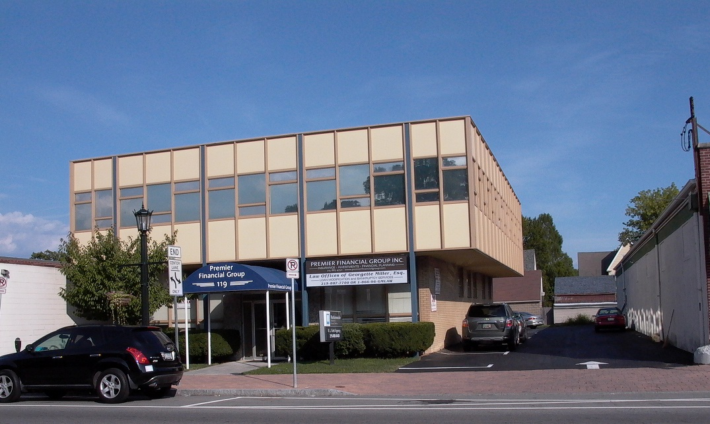

119 S. Easton Road

(Showing the Front Entrance, Side off Street Parking, Access to Rear Parking, and off-Street Parking)
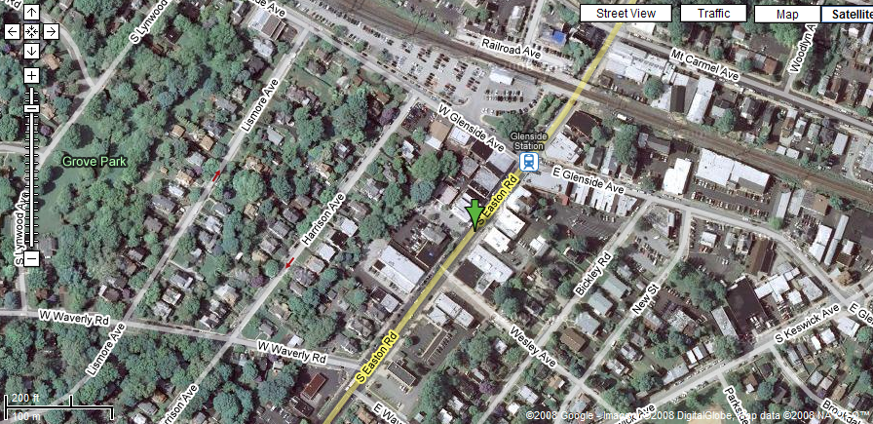

AERIAL VIEW
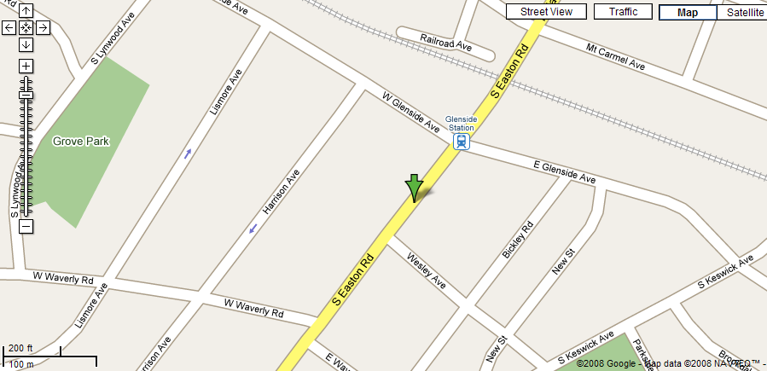

LOCAL MAP

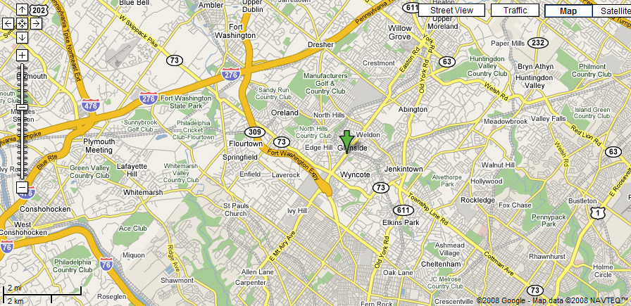

REGIONAL MAP

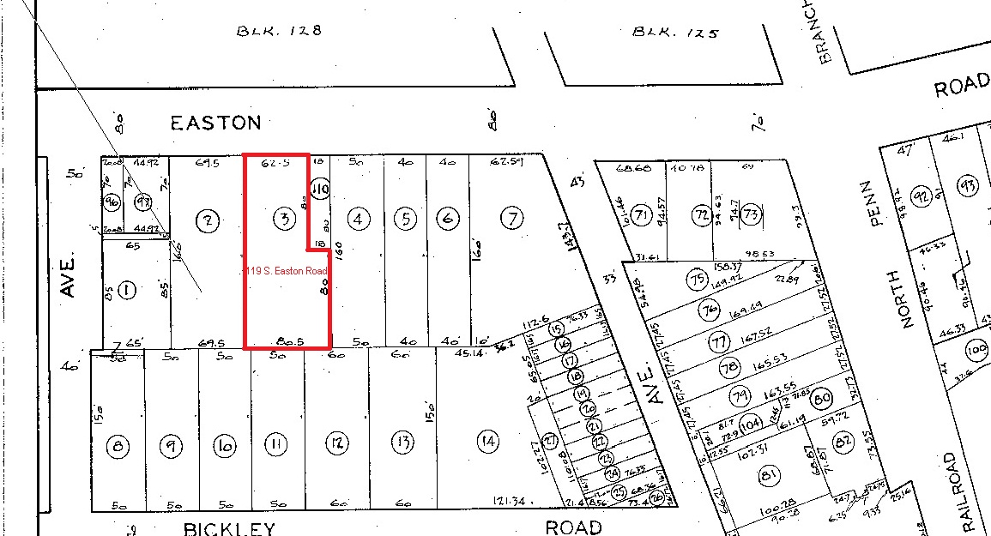

TAX MAP

