Mountain Spirit Inn
308 South Main Street (Highway 93)
Darby, MT 59829
Tel: (406) 821-3405
E-mail: info@mountainspiritinn.com
www.mountainspiritinn.com
Reservations are recommended.
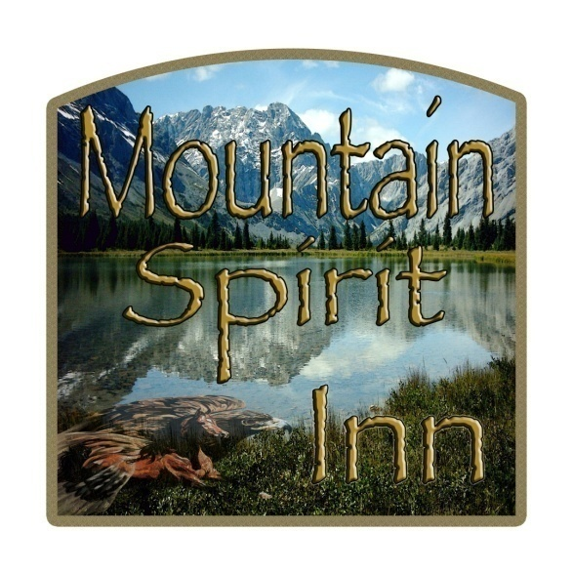
The Mountain Spirit Inn is a clean and comfortable, independently-owned motel in Darby, Montana.

The Inn’s comfort and style will provide you with a pleasing stay. Everything is nice and fresh. The remodeled, apartment-sized guest rooms are unique, all have satellite TV, and nine are equipped with kitchenettes, including dishware and utensils. Excellent Internet access is available. Check-in services are open from 9:30 am – 9:30 pm. Comfort for our clients is our highest priority.

The Mountain Spirit Inn is in a prime location in downtown Darby, Montana. Here, you have access to nearly every outdoor recreational activity for every season of the year.

Come enjoy your visit in this beautiful and majestic area.
Mountain Spirit Inn
The Mountain Spirit Inn is located on Highway 93, which constitutes part of the Lewis and Clark Trail. This scenic highway goes all the way from Canada to Mexico, and it is part of the TransAmerica Bicycle Path, and close to the Continental Divide Hiking Trail and Lost Trail Powder Mountain Ski Resort.

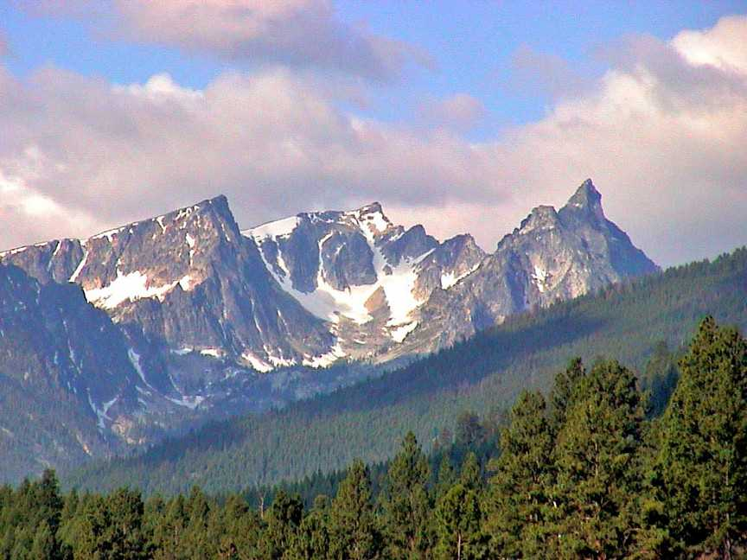

Darby is located at the southern end of the Bitterroot Valley, between the spectacular Bitterroot Mountains and the Sapphire Mountains of southwestern Montana. Close to Alta Ranger Station, Lake Como Recreation Area, Painted Rocks Lake, Skalkaho Falls, and 3.5 million acres of untouched wilderness. This is a great place to visit for families, four-wheelers, hikers, bicyclists, motorcyclists, fishers, hunters, nature lovers, photographers, rafters, skiers, and sightseers. The incredible scenery in western Montana will revitalize
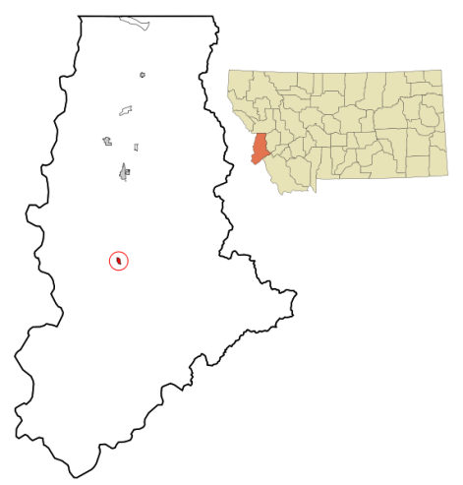
you.

