 FOR LEASE

PROPERTY: 941 S. Governor Williams Hwy, Unit # 1, Darlington, SC 29532
BUILDING: 9,014 SF Clear-Span Pre-Engineered Metal Building with Glass and Split-Block Store Front (vacant Dollar General)
LAND AREA: +/- 1.4 acres
YEAR BUILT: November 2008
PARKING: 36 spaces
LEASE PRICE: $12/sf NNN

Kathryn Roberts 919-961-7951
Broker / Owner sregllcnc@gmail.com

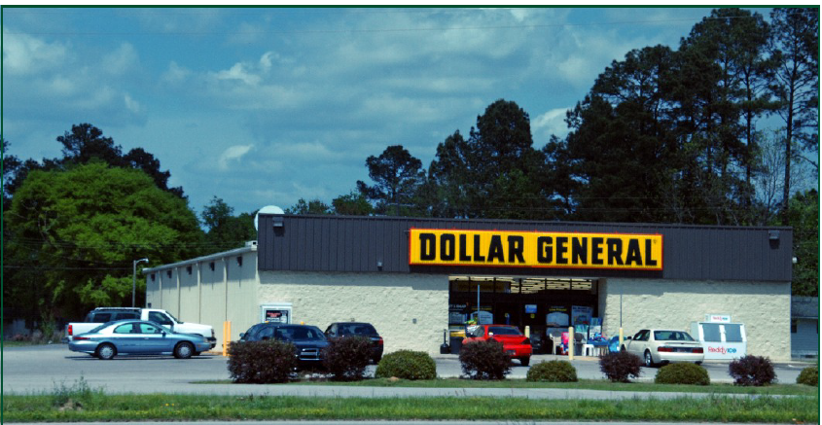

DARLINGTON, SC

The town of Darlington is a town located in the northeastern part of South Carolina near I-20 and I-95. The town of Darlington is the county seat for Darlington County. There is a large mixture of agriculture and manufacturing. Darlington is also home to the world-famous Darlington International Speedway and the Southern 500.

This Building is located on S. Governor Williams Highway (Hwy 52 By-Pass), which is a four-lane highway near the intersection with South Main Street (Hwy 52). This area is one of the main commercial areas of Darlington. Within a quarter of a mile of the store there are numerous retail stores and restaurants including Wendy’s, KFC, McDonalds, Pizza Hut, Bojangles, Food Lion, Walgreens and three convenience stores.

