BLACKFORK BISTRO
Turnkey Restaurant + Real Estate Opportunity
Located in Loudonville – Gateway to the Mohican State Park Tourism Region 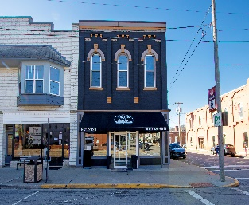
Asking Price: $1,600,000
(Includes Real Estate + Business + FF&E + Liquor License)

Investment Snapshot
Metric Amount
2025 Net Sales $1,801,694
Gross Profit $554,979
Operating Income (NOI) $158,157
Estimated SDE $125,000 – $180,000
Cap Rate (at $1.6M) ~9.9%

Property Details
• 4,532 SF restaurant building
• 1,600 SF paved parking area
• Fully renovated building
• Updated electrical service
• Updated HVAC systems
• Updated kitchen equipment
• Liquor license included
• All furniture, fixtures & equipment included

Business Highlights
Black Fork Bistro has become a destination dining experience serving both locals and visitors to the Mohican tourism region.
Highlights include:
• Loyal local customer base
• High tourism traffic year-round
• Strong social media exposure
• TikTok food influencer visits
• Celebrity and notable guest visits
• Turnkey operation with trained staff

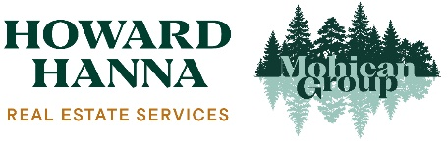

Tracy Kauffman - 330-231-4044 / TracyKauffman@HowardHanna.com
Howard Hanna Real Estate – Mohican Group

