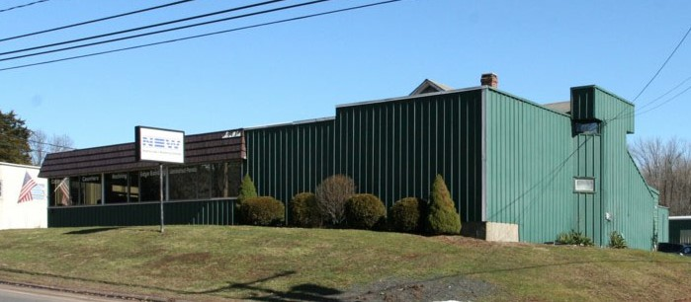
BUILDING SIZE: 11,264 SF POWER: 3 Phase/400 Amps/480 Volts
FOR LEASE
912 OLD COLONY ROAD, MERIDEN, CT
OFFICE SPACE: 1,500 SF
YEAR BUILT 1977 UTILITIES: Gas Heating
CONSTRUCTION: Metal Structure City Water
Metal Roof City Sewer
LAND AREA: 1.58 Acres Fluorescent Lighting
ZONING: M-3 PARKING: 3.26/1,000 SF
LOAD DOCKS: 1 Exterior
DRIVE -IN: 1 10 x 10 LEASE RATE: $5.50 SF NNN
CEILING HEIGHT: 9 – 16 FT CAM/TAXES: $2.32 SF

LOCATION: Exit 48 off I-91 and Exit 65 off CT-15

Chris O’Hara Coldwell Banker Commercial, Realty
Sr. Vice President 355 Riverside Avenue
203-257-0032 C / 203-831-4187 O Westport, CT 06880
cohara@coldwellbanker.com

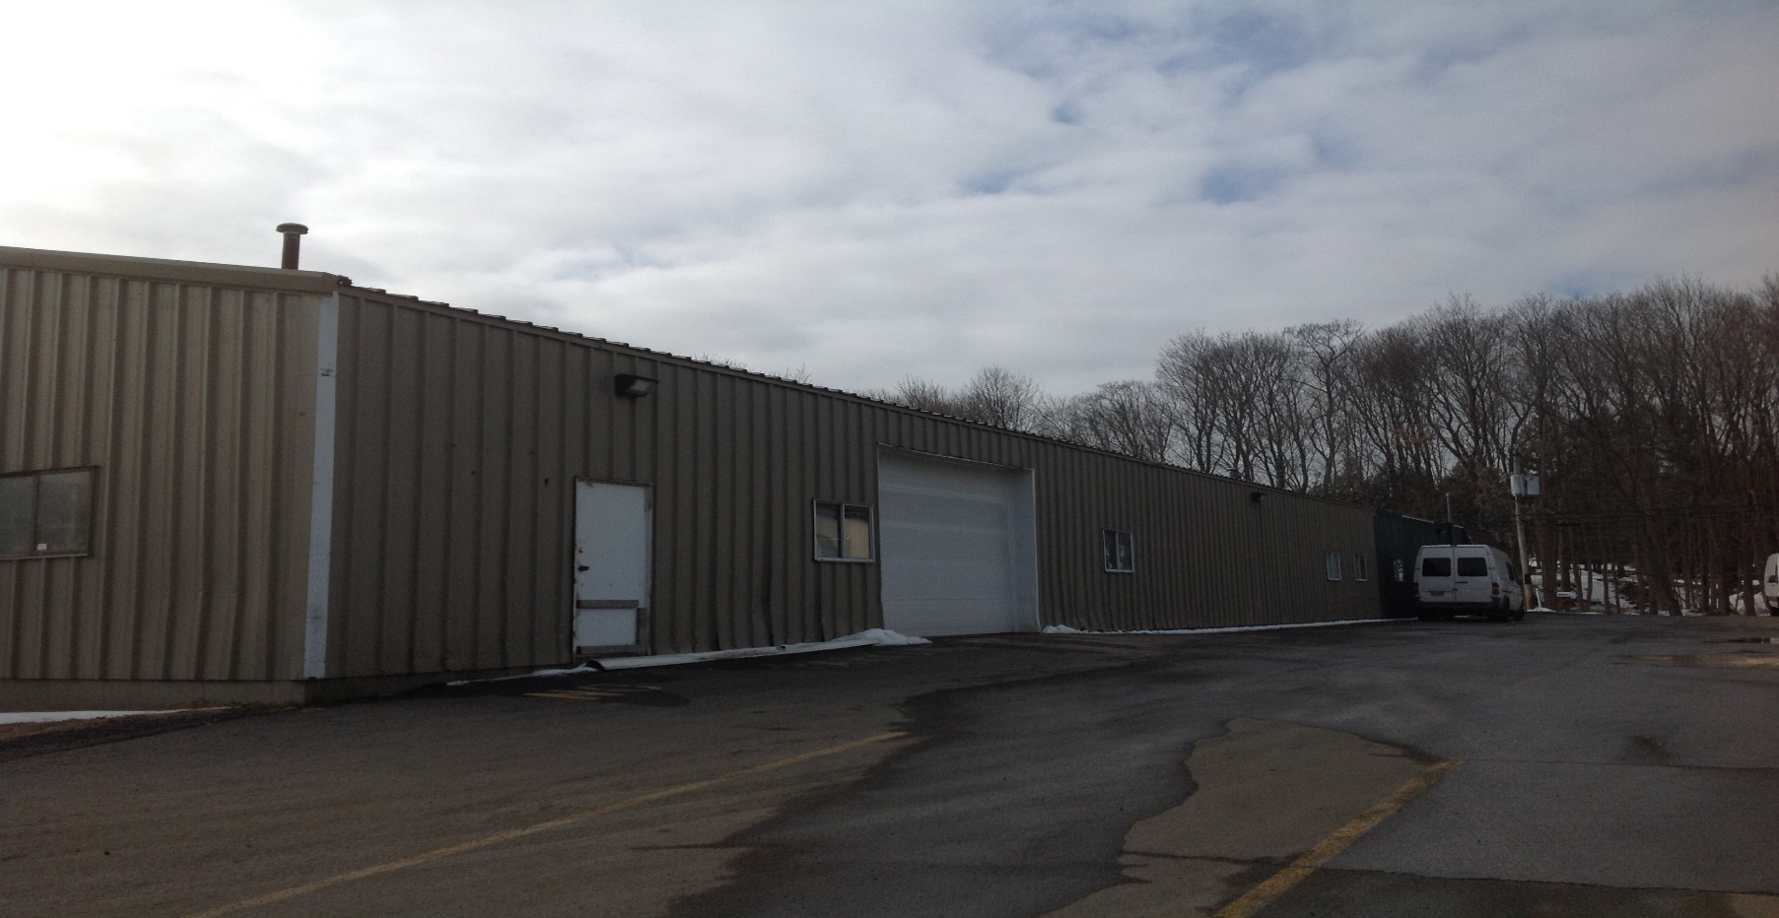
912 OLD COLONY ROAD, MERIDEN, CT
APPROXIMATELY 4.5 MILES OFF EXIT 65 – ROUTE 15
32 MINUTE DRIVE TO TWEED AIRPORT IN NEW HAVEN
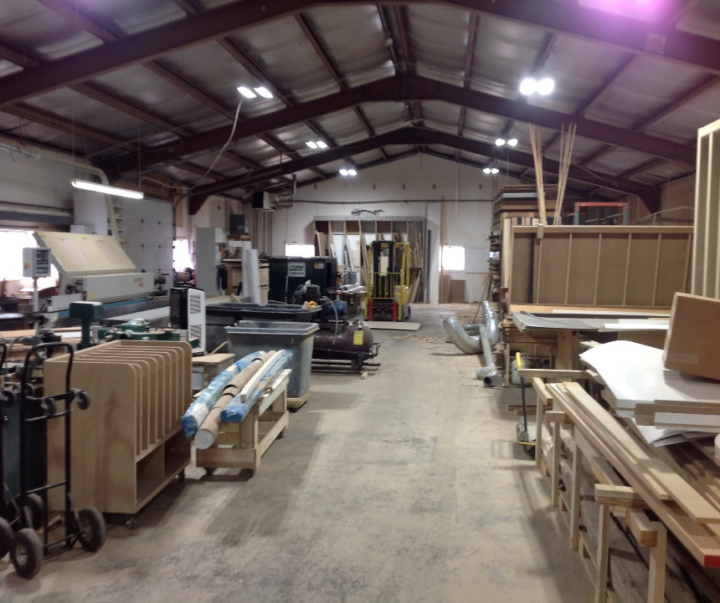
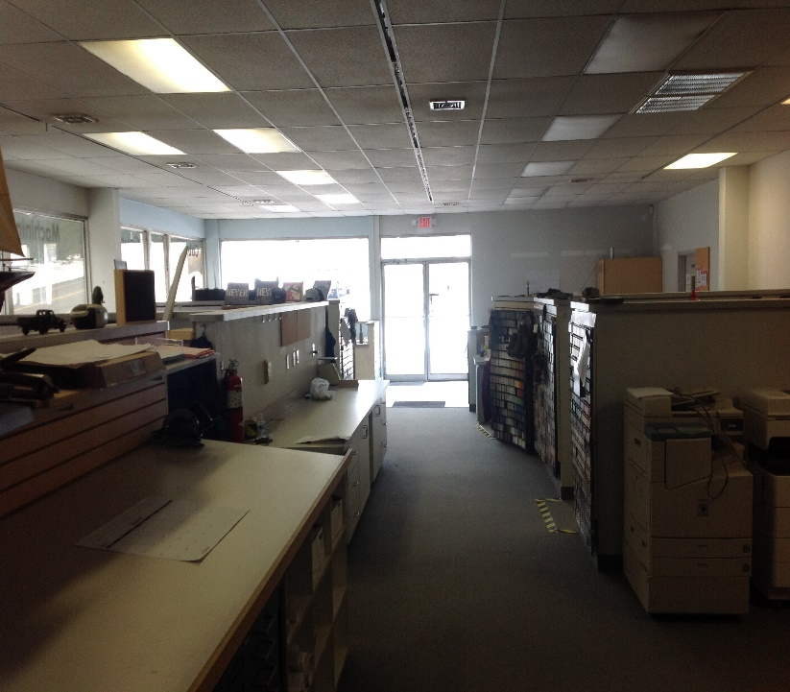
Chris O’Hara Coldwell Banker Commercial, Realty
Sr. Vice President 355 Riverside Avenue
203-257-0032 C / 203-831-4187 O Westport, CT 06880
cohara@coldwellbanker.com

