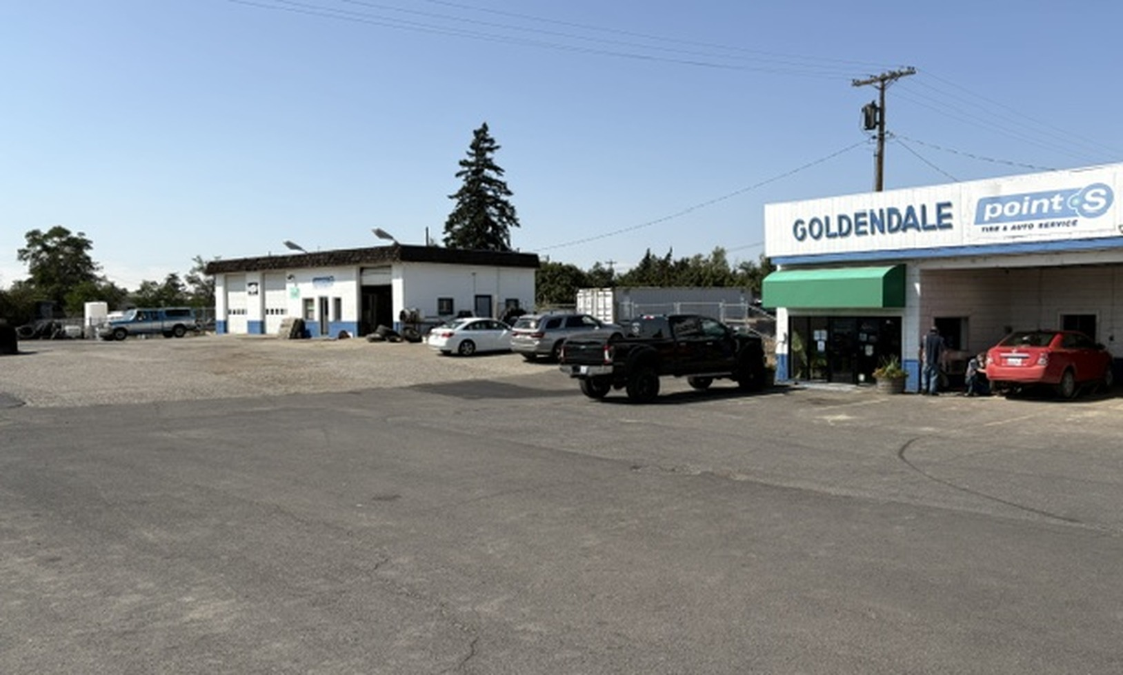
765 E Broadway
Goldendale Washington
OFFERING PRICE  $460,000 | SITE AREA  1.6 Acres | IMPROVEMENTS  Two Buildings
Automotive and Service Property
Sale includes existing equipment. Call broker for equipment list.
Presented by Venture Commercial Real Estate
Lyle Stratton and Jeff Crumbaker | 360.718.8787

Property Overview
This 1.6-acre commercial property is currently operated as a tire store and includes two separate buildings on two tax lots. The offering combines substantial service-shop space, additional covered improvements, a large paved operating area, and the existing business equipment included with the real estate.
PROPERTY DETAIL | DESCRIPTION
Address | 765 E Broadway, Goldendale, Washington
Offering Price | $460,000
Site Area | Approximately 1.6 acres
Building 1 | Approximately 1,920 square feet
Building 2 | Approximately 7,058 square feet
Attached Pole Building | Approximately 1,160 square feet
Attached Canopy | Approximately 720 square feet
Tax Lots | Two separate tax lots
Current Use | Tire store and automotive service
Equipment | Existing equipment included; call broker for list
Property Highlights
• Established automotive-service configuration
• Multiple shop bays and vehicle-lift capacity
• Office and customer reception area
• Large paved yard with maneuvering and parking area
• Two-building layout provides operating flexibility
• Equipment package supports continued tire and service use

Exterior Improvements
The property offers two separate buildings, a broad paved operating area, multiple overhead doors, and attached covered improvements suited to automotive or service-commercial operations.
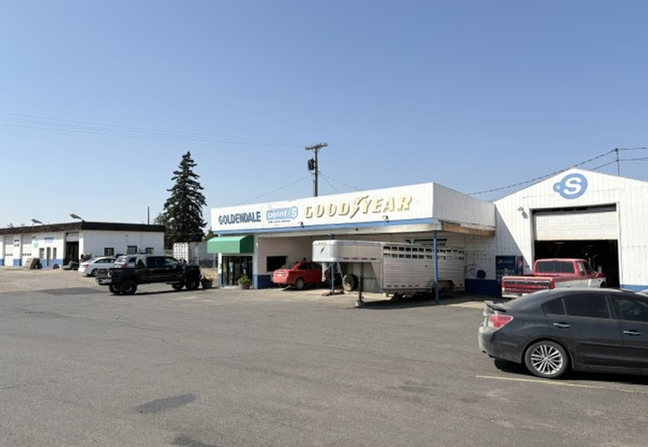  Main service building | 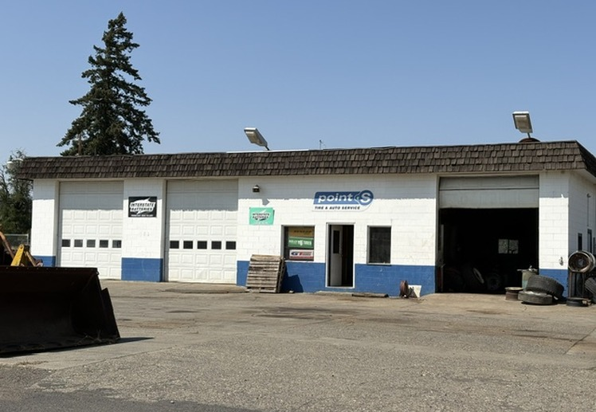  Separate shop building
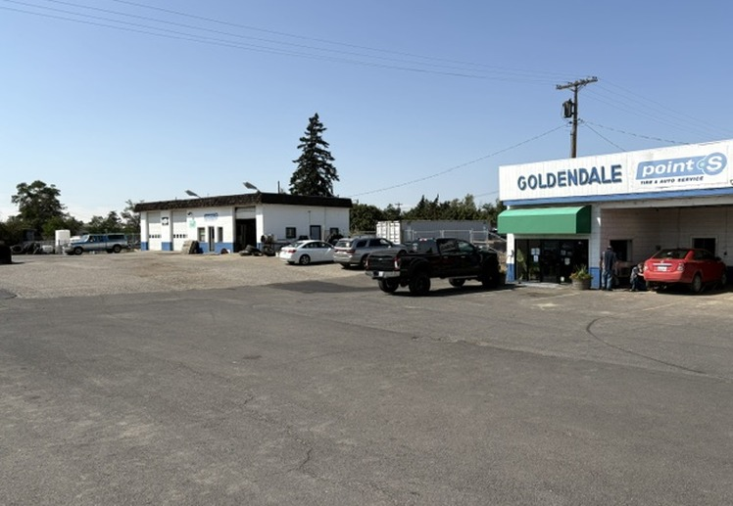  Paved operating area | 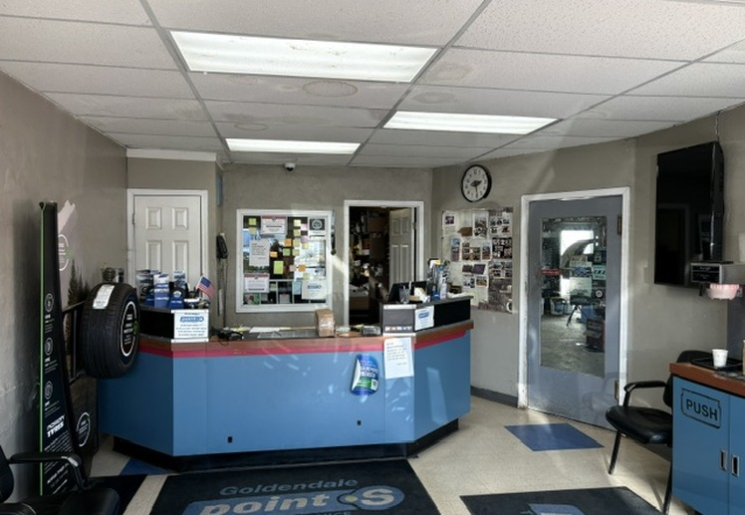  Customer reception
The approximately 1.6-acre site provides room for customer parking, service circulation, equipment staging, and outdoor operational needs, subject to applicable land-use requirements.

Automotive Service Areas
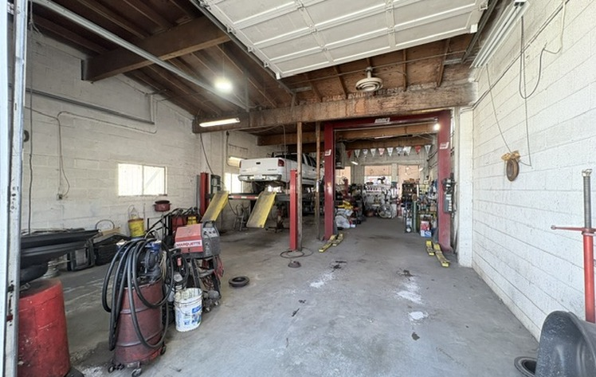  Service bay | 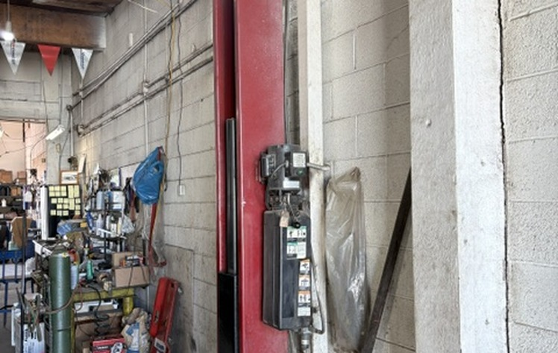  Vehicle lift
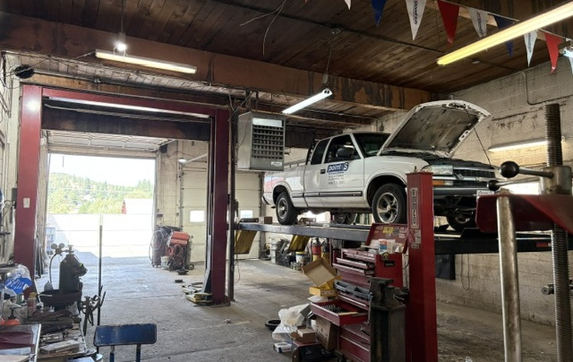  Additional service area | 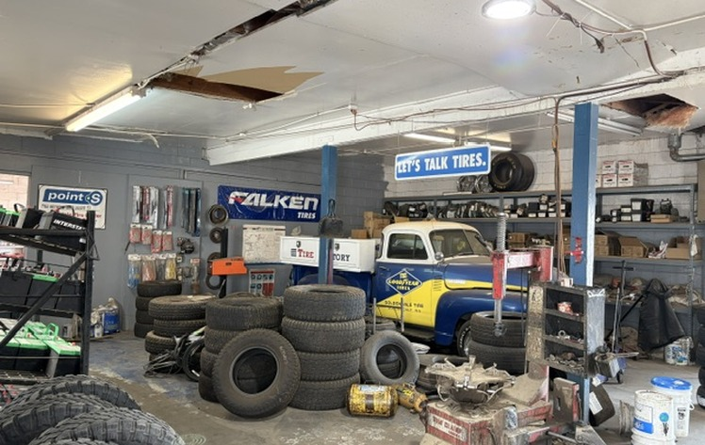  Tire and equipment area
Offering Terms
Offered at $460,000, including all existing equipment. Contact the broker for the equipment list and additional property information.
LYLE STRATTON AND JEFF CRUMBAKER  Venture Commercial Real Estate | 360.718.8787  Call for details and equipment list
Disclaimer
The information contained in this offering memorandum has been obtained from sources believed reliable but has not been independently verified. No warranty or representation is made as to its accuracy or completeness. Prospective purchasers should conduct their own independent investigation and verify all measurements, property characteristics, zoning, permitted uses, environmental conditions, equipment, and financial information. The property and equipment are offered subject to change, prior sale, or withdrawal without notice.

Additional Property Features
Additional improvements and operating features support the property’s current tire-store and automotive-service use.
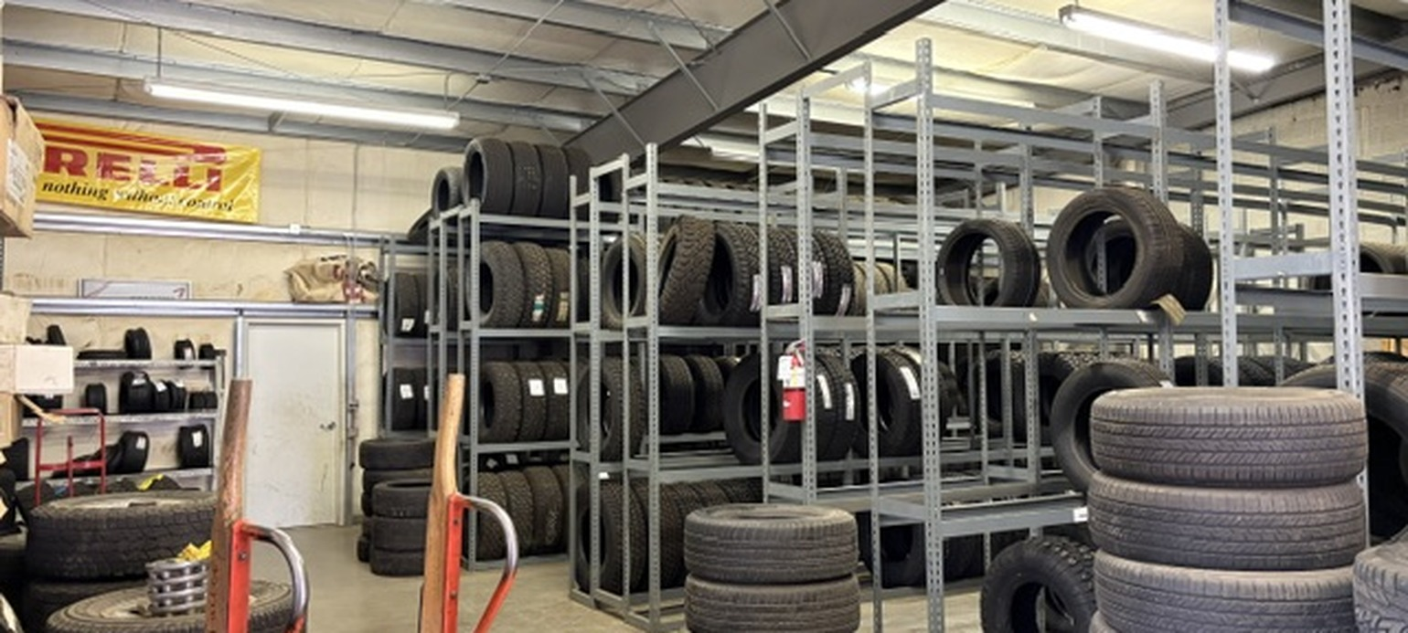
Tire storage and inventory area
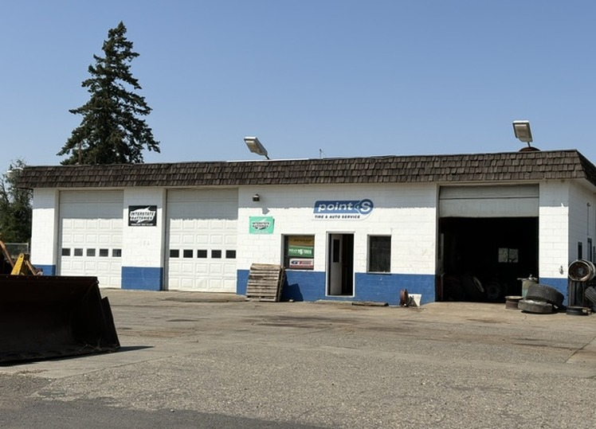  Separate shop building | 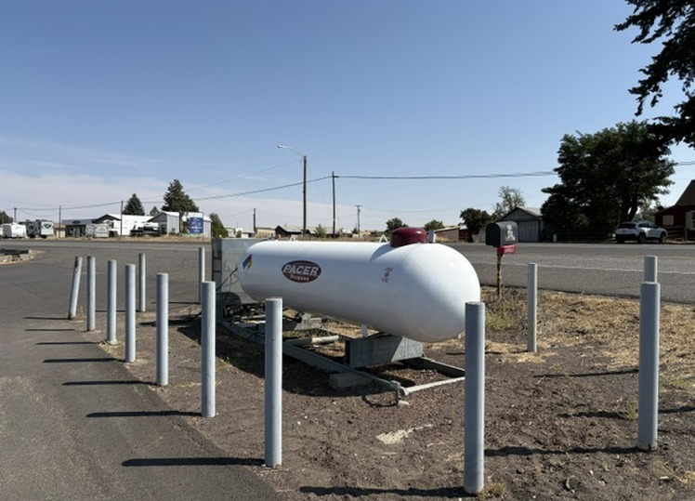  On-site propane tank
The included equipment and site features should be independently inspected and verified by prospective purchasers. Contact the brokers for the available equipment list and additional details.

