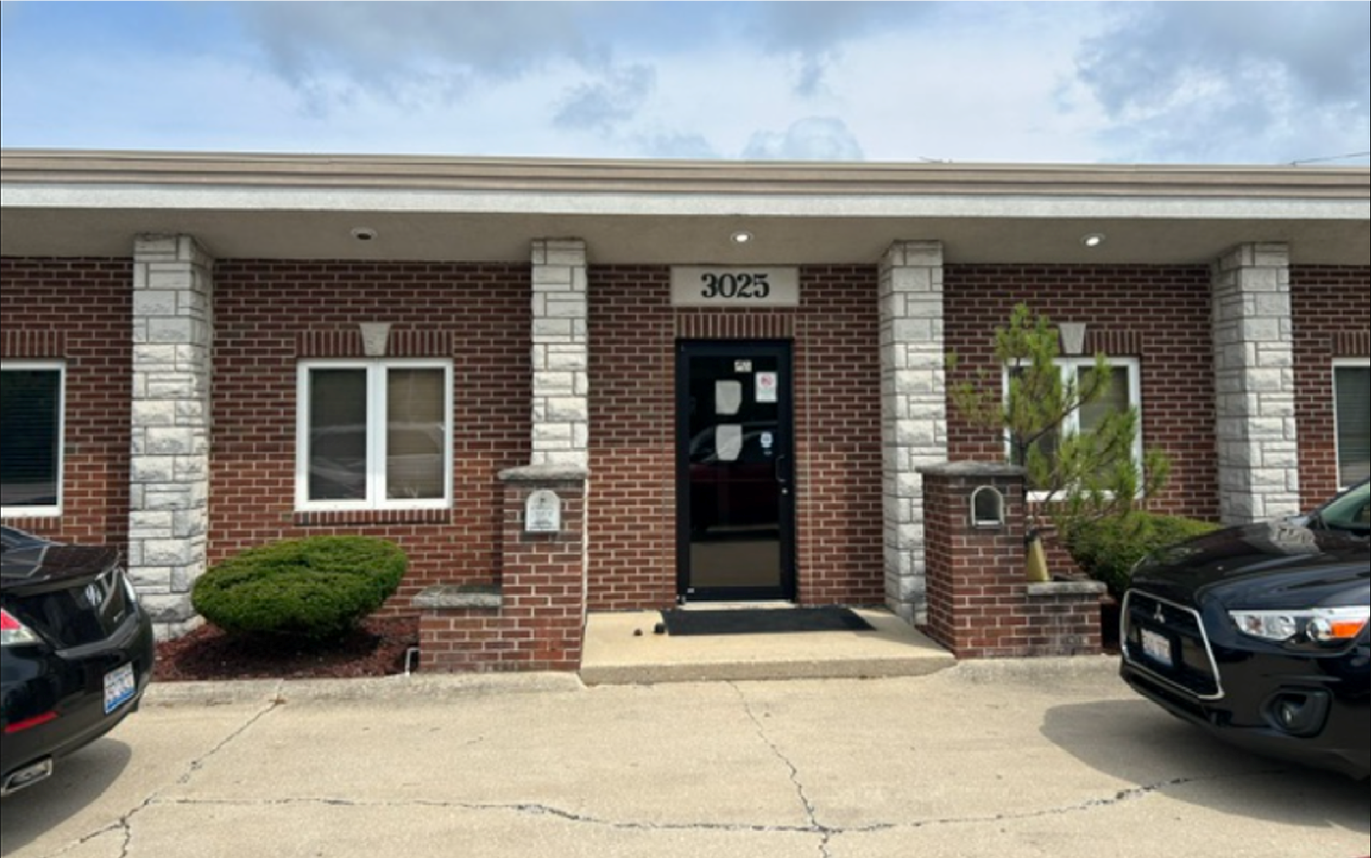




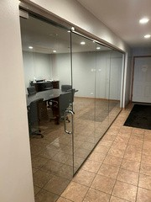
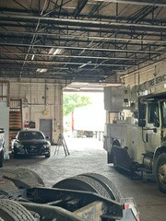
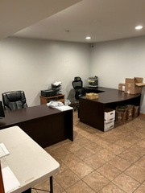
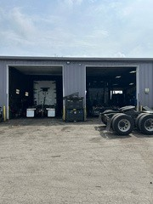
Available For Sale
SPECIFICATIONS:
3025
East End Ave, South Chicago Heights
294

KEY FEATURES:
Building Size: 19,500 SF
Property Size: 3.13 AC
Purchase Price: $2,500,000
(13) 14
' Drive In Doors
Fully Sprinklered
Updated Office
Glass Conference Room

HCB Realty Partners, Inc.
2115
Butterfield Rd. Suite
Truck Repair & Terminal
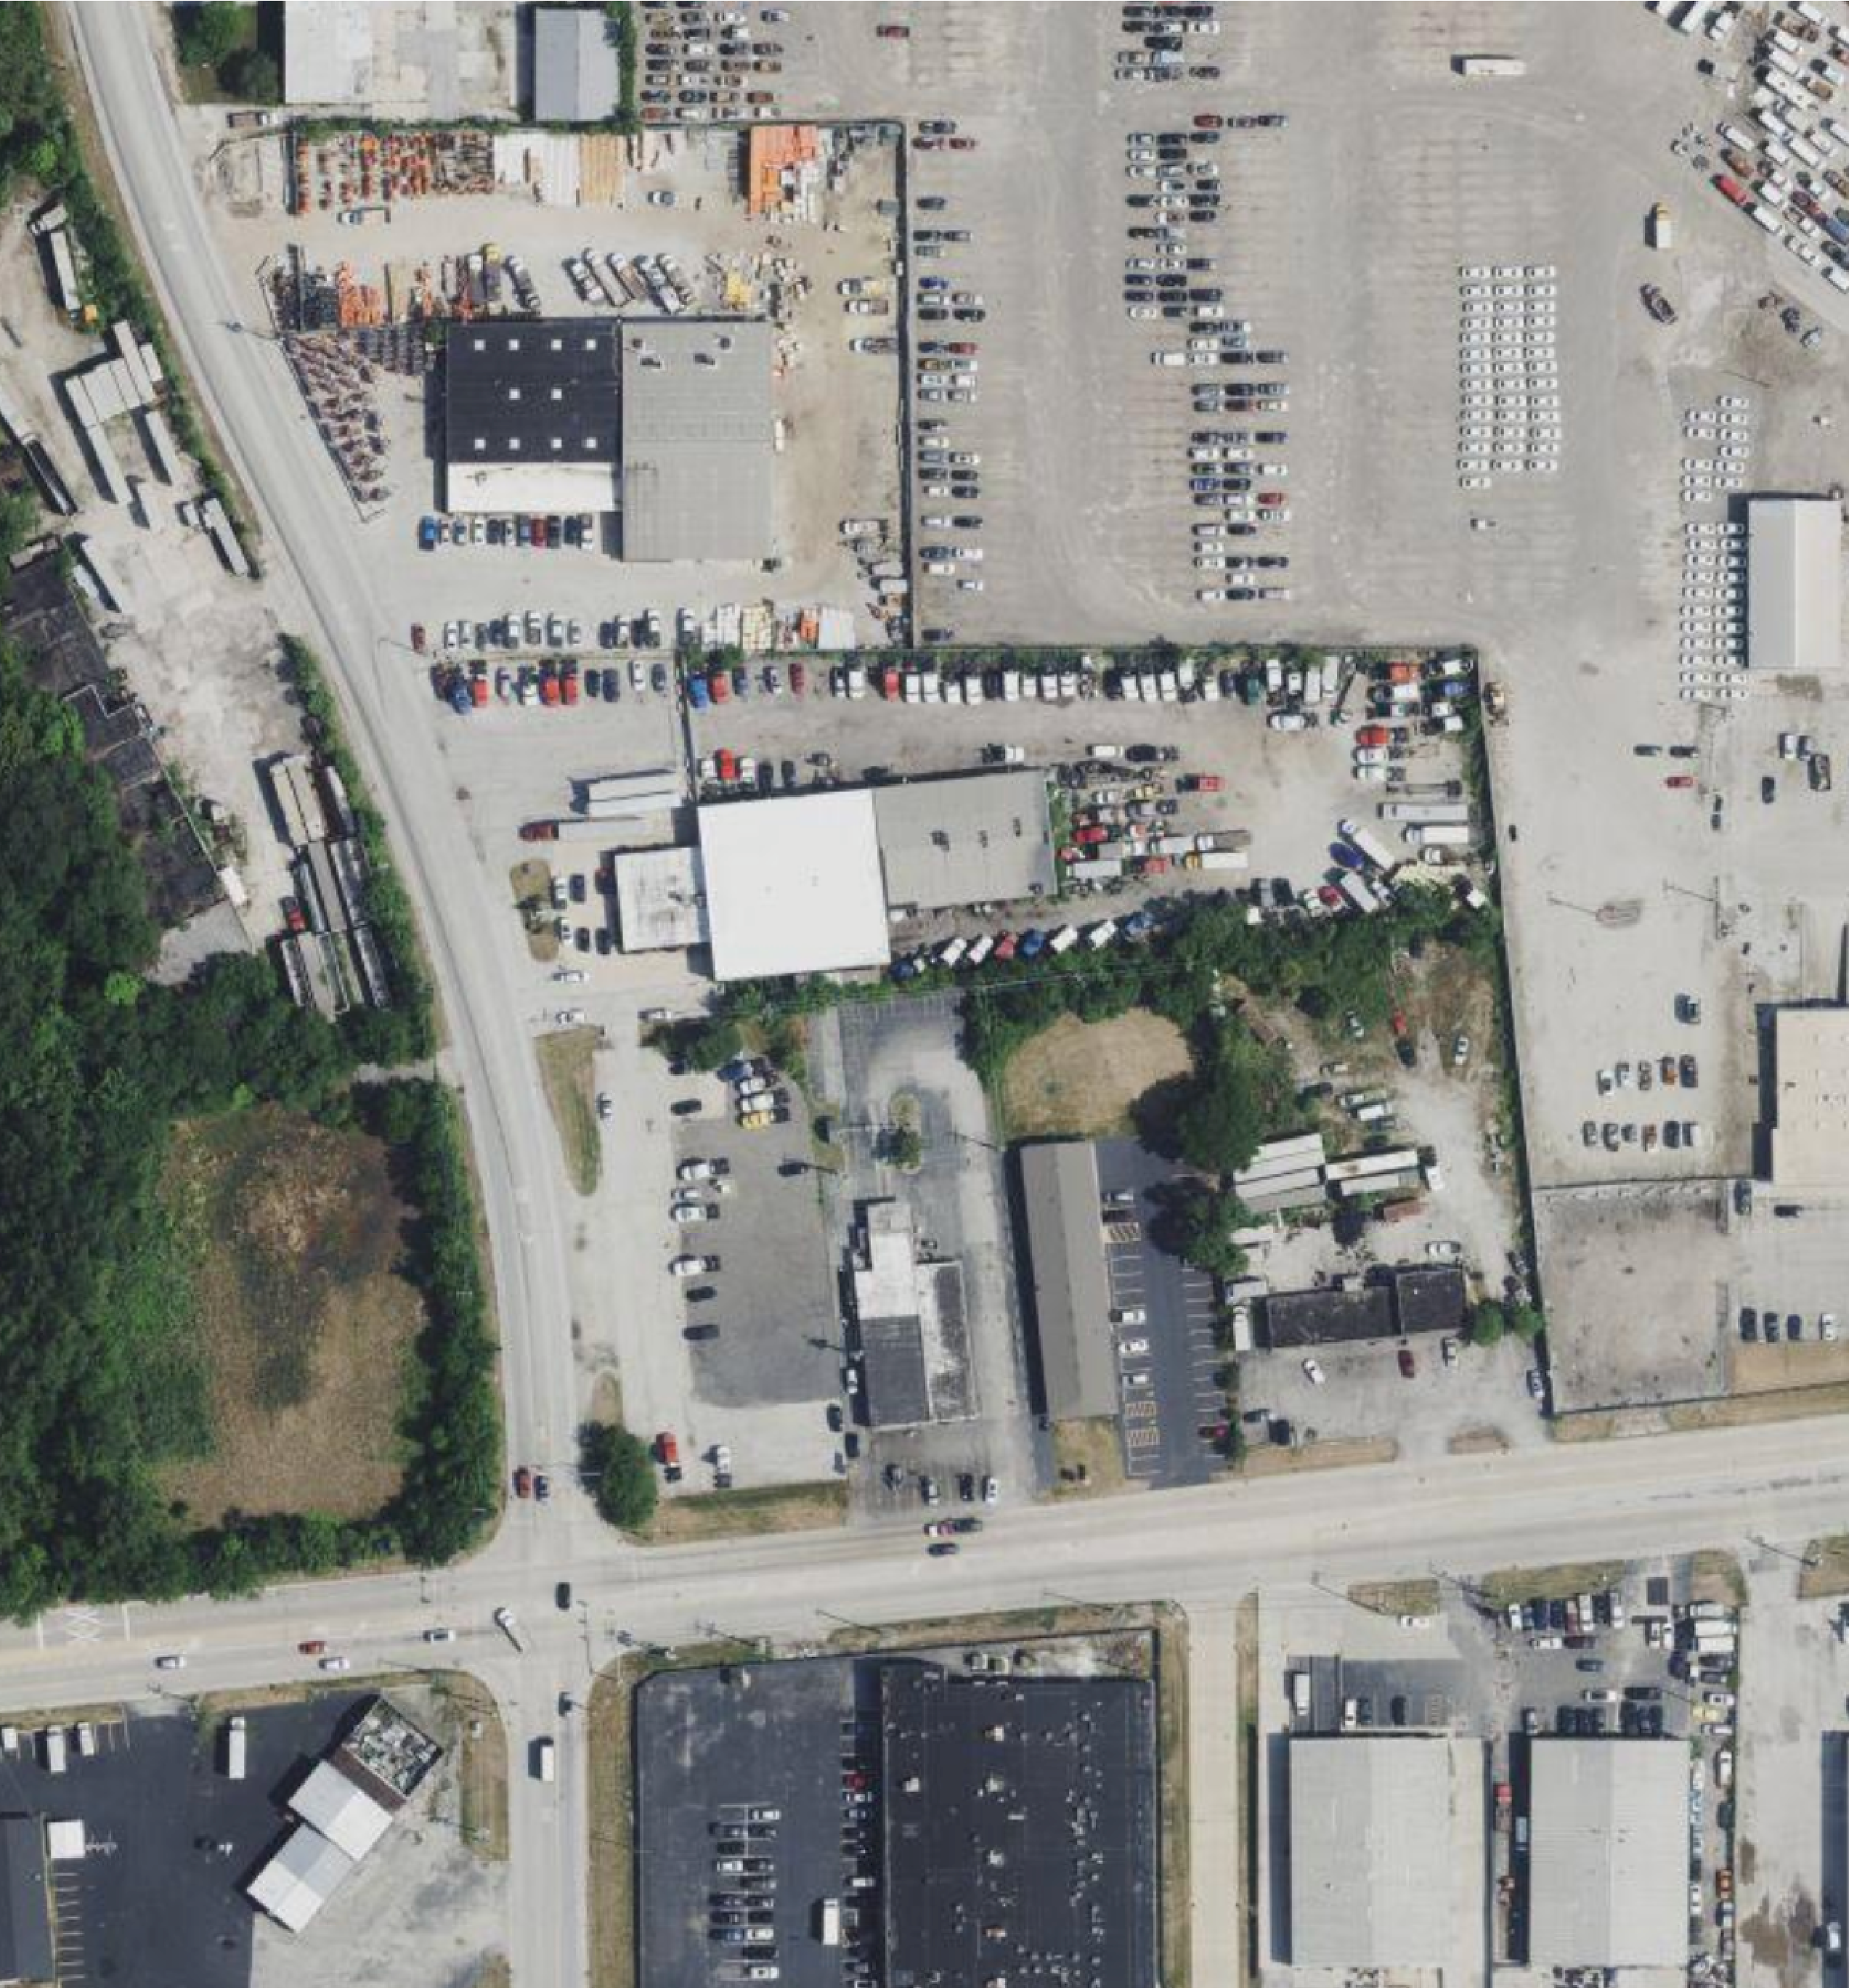


AERIAL PHOTO

HCB Realty Partners, Inc.
2115
Butterfield Rd. Suite
E

S
A
U
K

T
R
A
I
L
E

S
A
U
K

T
R
A
I
L
E

E
N
D

A
V
E


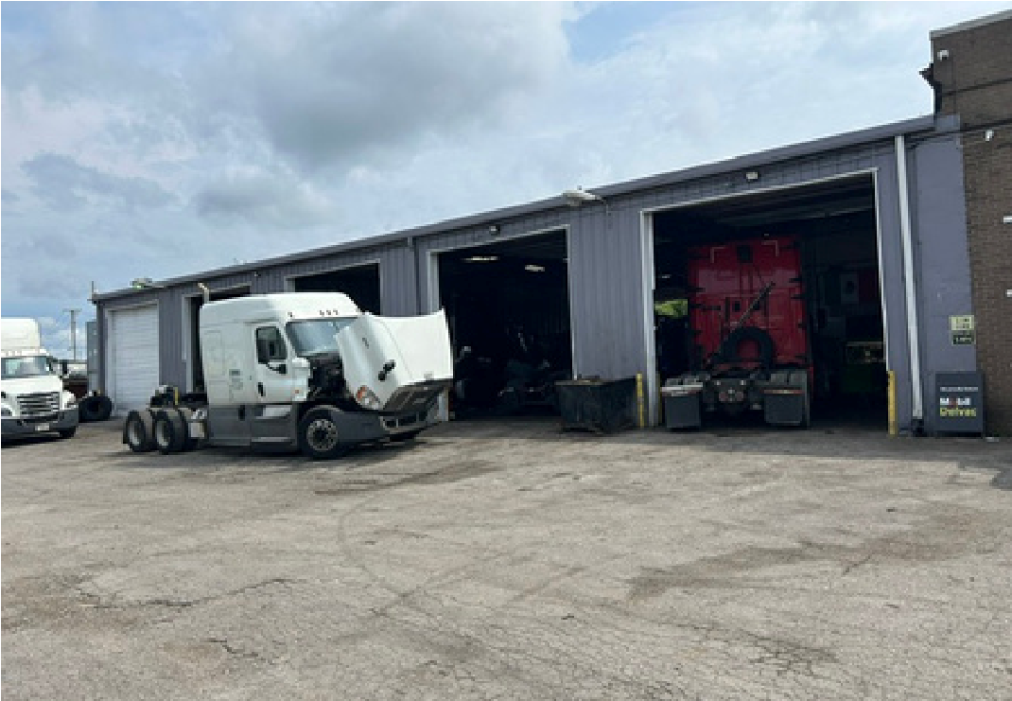
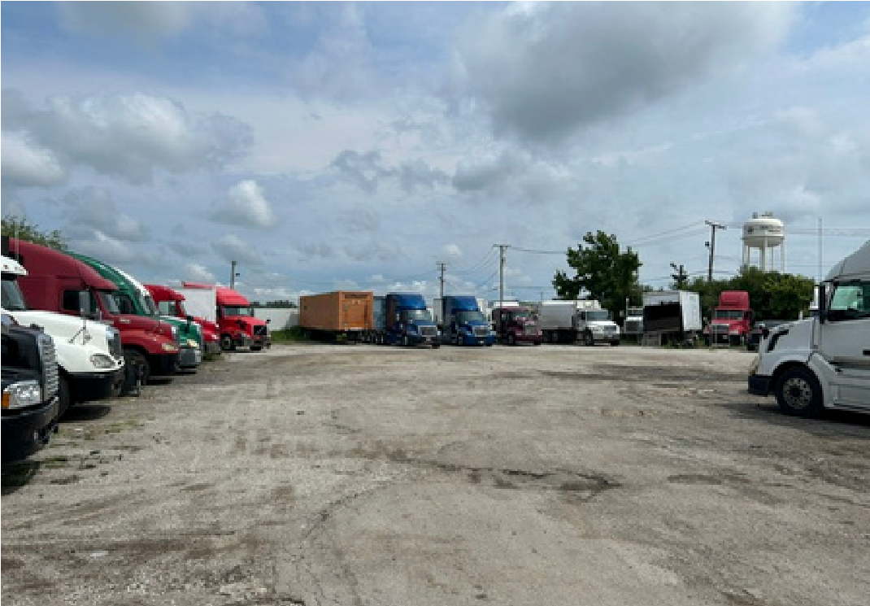
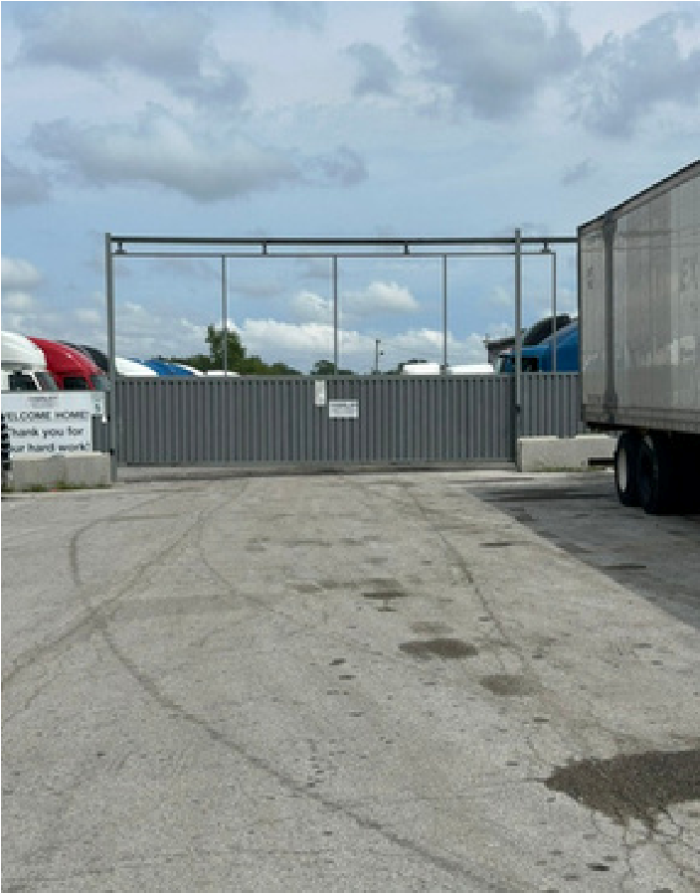
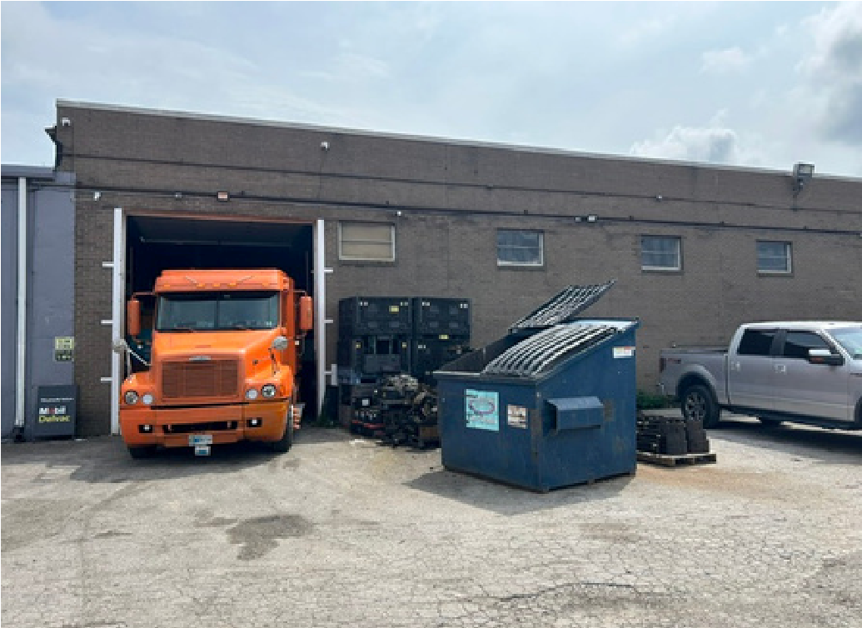
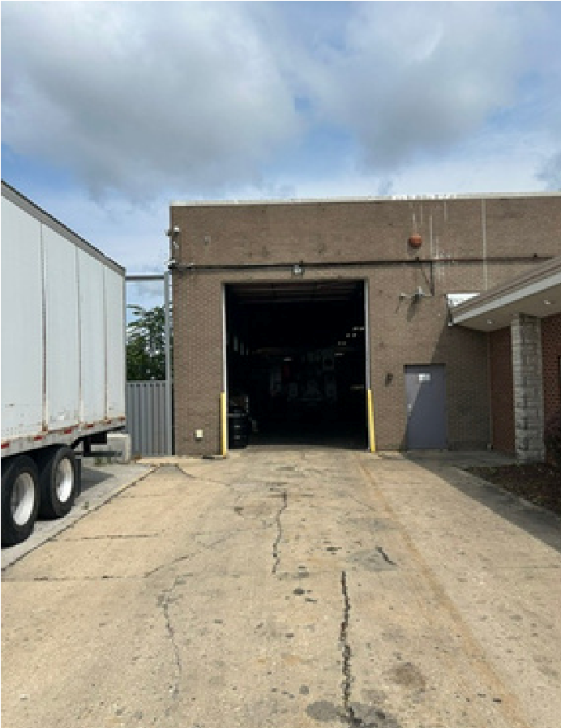
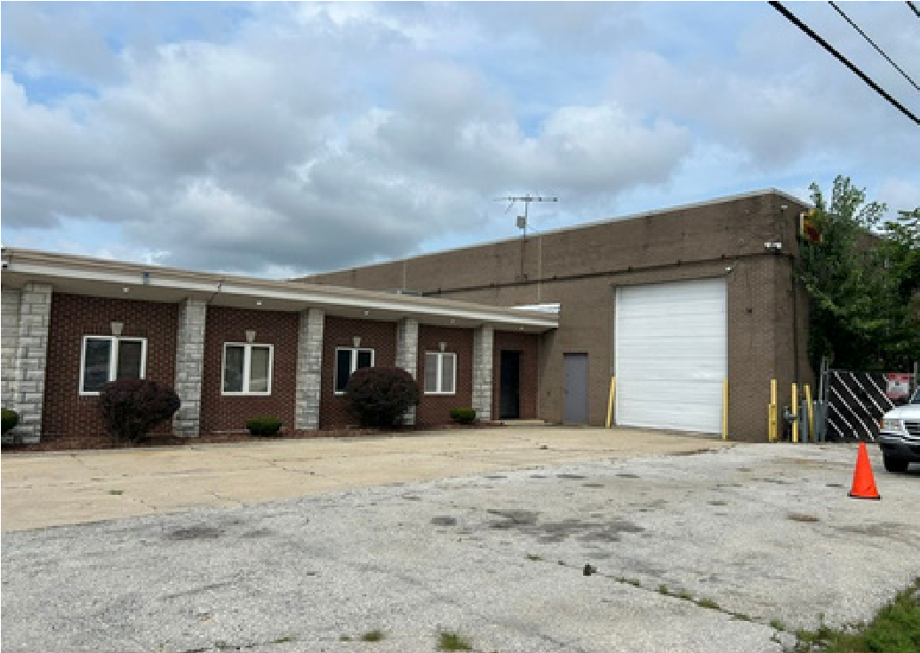
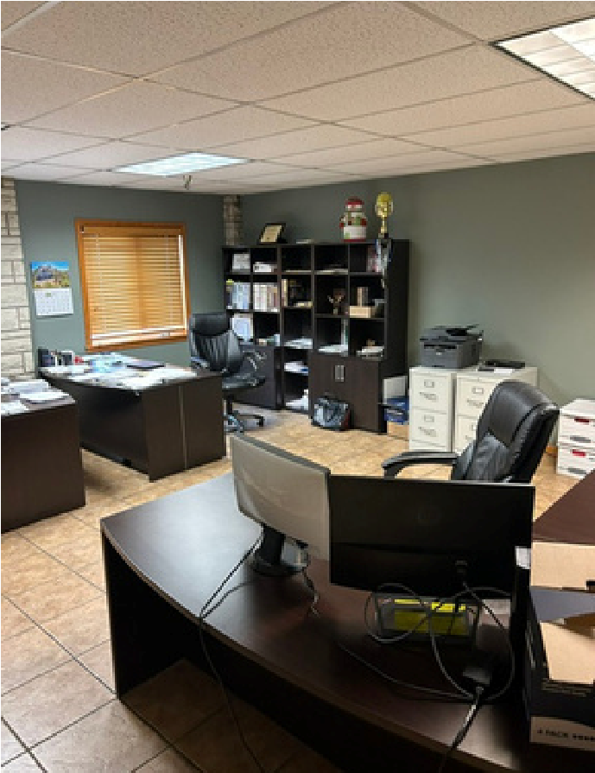
ADDITIONAL PHOTOS
HCB Realty Partners, Inc.
2115
Butterfield Rd. Suite

