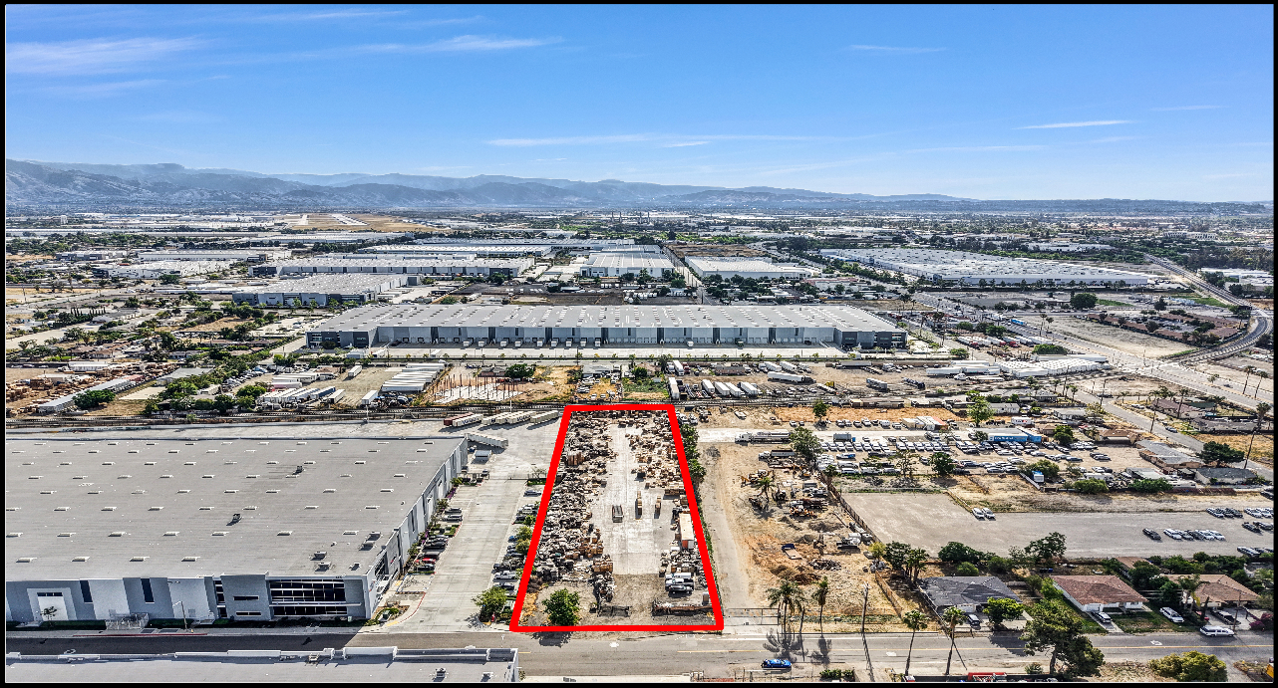

This large I-1 Zone is surrounded by industrial buildings and is ideal for the right investor or owner user. Permitted uses include: general manufacturing, wholesale/ warehouse services, truck terminals, contractor equipment yards, transportation services, limited outside storage.

Buyer to verify all data and permitted uses with the City of San Bernardino.

For More Information Contact:

Connie Velazquez
Commercial Associate

(310) 651-4069
cvelazquez@mgrrealestate.com
Agent DRE Lic#02060631 Brkr DRE Lic# 01841921
3800 Concourse Street, Ontario CA 91764 Office: 909-981-4466 Fax : 909-981-6267

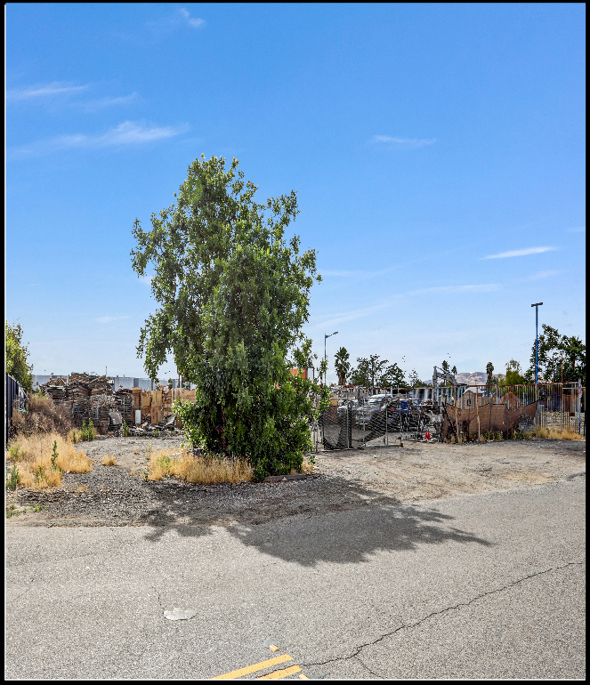
Land Details: Total Land: Total SF: Zoning: Price PSF: Asking Price:

± 1.5 Acres
± 65,340 sf
Industrial (I1)
$50.50 psf
Asking: $3,300,000

Property Highlights:

- Uses: Light Manufacturing,
- General Manufacturing
- Machine shops.
- Truck terminals, contractor's equipment storage yards.
- Full range of manufacturing, fabrication, assembly, warehousing associated with light industrial uses.
- Warehousing and storage.
- 1.50 Acres
· +/-65,340 Sq Ft

***Buyer to verify all data and permitted uses with the City of San Bernardino***

For More Information Contact:

Connie Velazquez
Commercial Associate

(310) 651-4069
cvelazquez@mgrrealestate.com
Agent DRE Lic#02060631 Brkr DRE Lic# 01841921

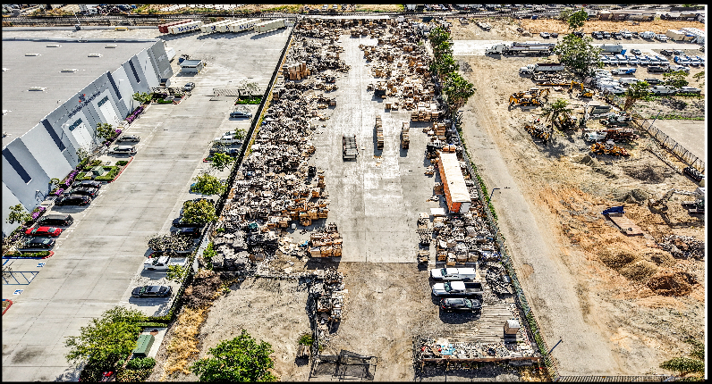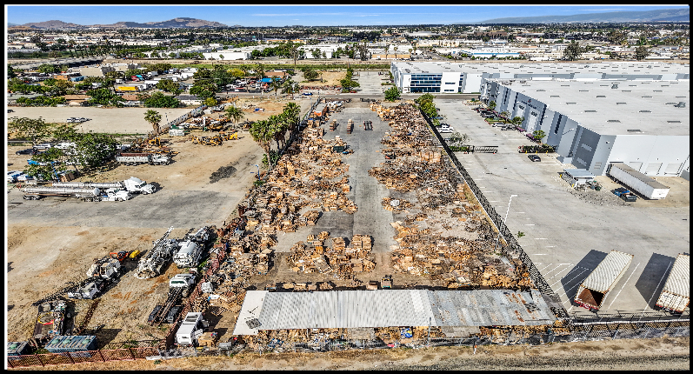
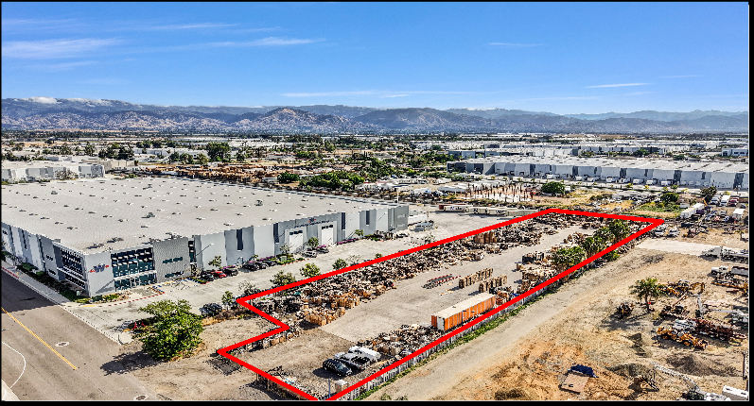
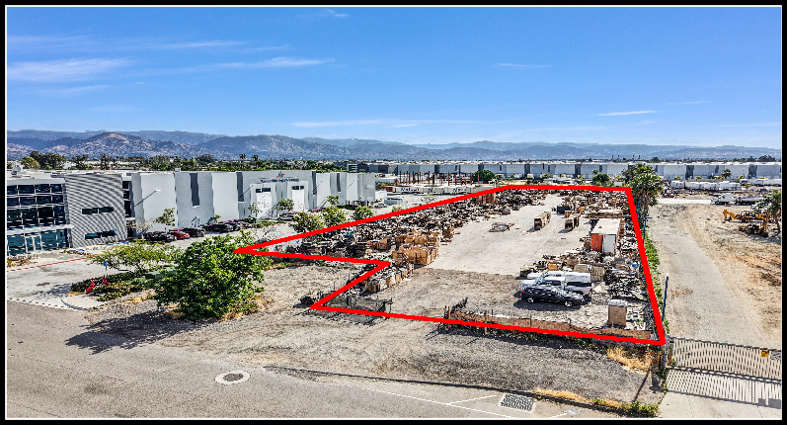

For More Information Contact:

Connie Velazquez
Commercial Associate

(310) 651-4069
cvelazquez@mgrrealestate.com
Agent DRE Lic#02060631 Brkr DRE Lic# 01841921

