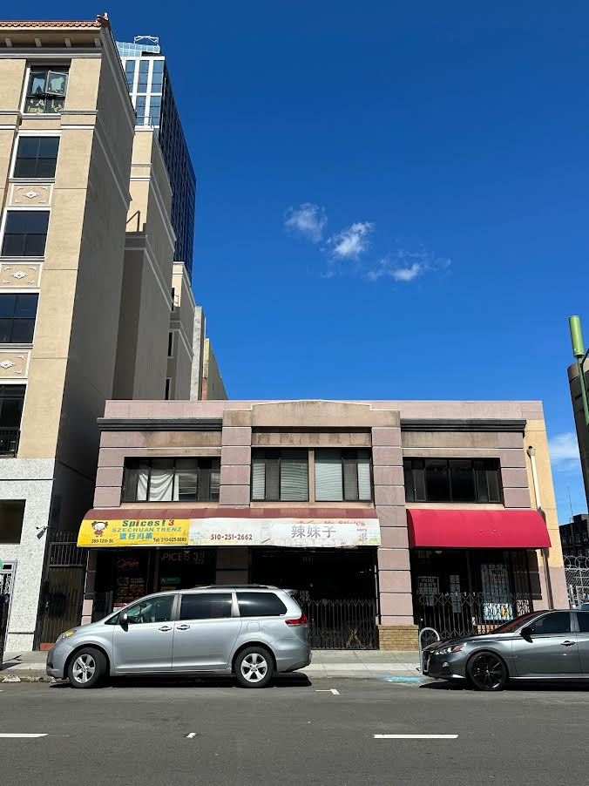

FOR SALE
368-370 12th Street, Oakland, CA 94607
Retail/Office/Residential Mixed

Building Size: An approx. 8168 sq. ft. per assessor
APN: 2-57-6
Year Built: 1997
Lot Size: 5000 sq. ft. per assessor

Location: Central location. Convenience to all.

Best Uses: Owner/User
NOI Investment: Proforma $114,000.
CAP: 5% CAP (proforma)

Asking Price: $2.2 million

Contact: B.C. Realty
Bonnie Chui, DRE #00894884 (510) 835-8888
Email: bcleader2015@comcast.net
Website: www.bcrealtyleader.com

Information deemed reliable but not guaranteed. Buyer to verify prior to entering into contract

