Offering Memorandum

1615 W. Texas ST, Fairfield, CA 94533 - Solano County
Asking Price: $888,000.00

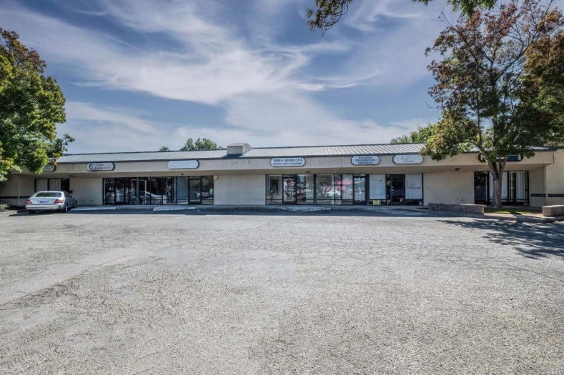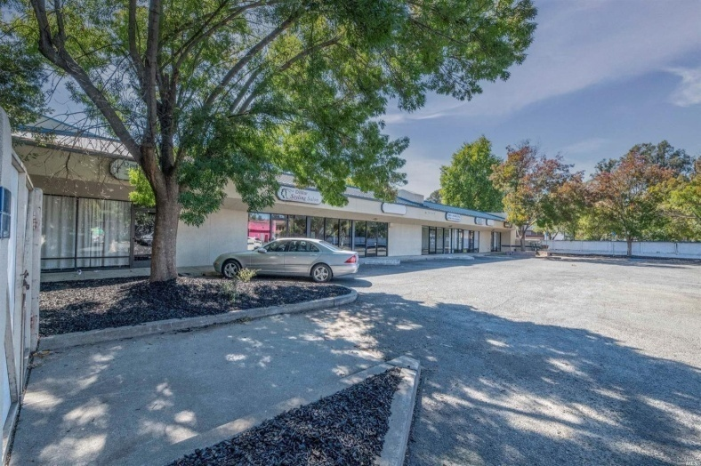

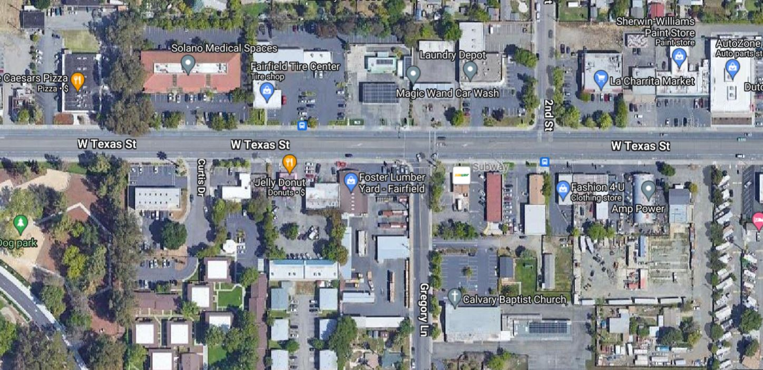

6 UNITS Office/Retail building with plenty of parking located behind Fairfield's best donut shop -Jelly Donut-. Close to I-80 and downtown main area, Superior Court,
City Hall, Solano Mall and Travis AFB

Century21 Real Estate Alliance
Hanna Ibrahim, Broker/Manager
209.814.4445 415.638.9175
C21funding@gmail.com
DRE#01356664, NMLS#2050600
Offering Memorandum

PROPERTY INFORMATION:

1615 Texas St #1-6, Fairfield, CA 94533, Solano County
APN: 0031-181-200
Bldg Sq Ft: 5,163
Lot Sq Ft: 22,125
Yr Built: 1989
Type: RETAIL TRD

MONTHLY RENT ROLL: All leases are month to month.

Unit 1&2: $ 1,700
Unit 3: $1,400
Unit 4: $1,500, (one year lease started 09/01/2024)
Unit 5: $1,390
Unit 6: $ 1,200

Current Total: $7,190.00 / month

All tenants pay for PGE and Garbage.
Owner pays for water only around $250.00 per month.

Demographic Insights and nearby cities
- American Canyon Real estate
- Benicia Real estate
- Dixon Real estate
- Fairfield Real estate
- Rio Vista Real estate
- Suisun City Real estate
- Travis AFB Real estate
- Vacaville Real estate
- Vallejo Real estate
- Winters Real estate

