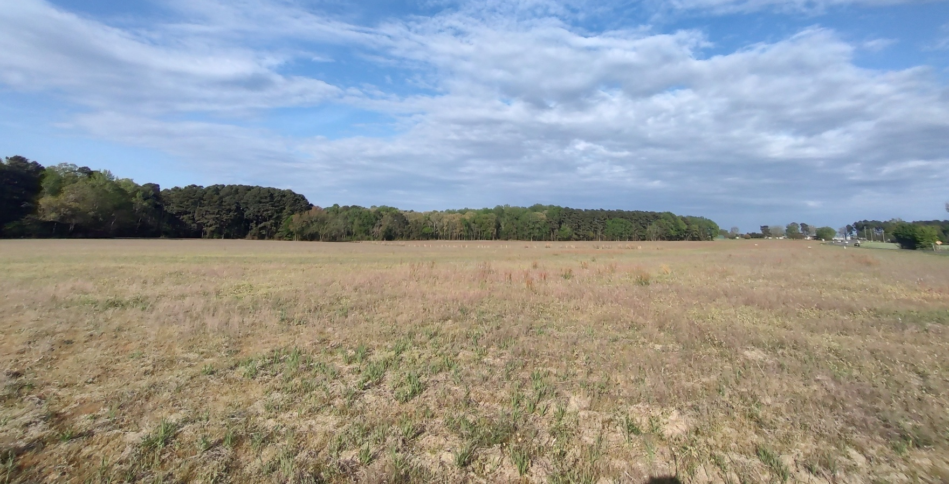
Price $3,500,000
0 Tramway Rd / Hwy 78 Sanford NC

Prime Development Land in Lee County NC.
Discover 38+/- acres in the high-traffic Tramway Rd / Hwy 78 area.
With approximately 1,800+/- feet of frontage on Tramway Rd (Hwy 78) this tract offers excellent visibility, access, and development potential.
Imagine residential, mixed-use, or community-driven projects in a rapidly expanding market. Sanford — centrally located with easy access to Apex, Cary, Raleigh, Fort Bragg, Southern Pines, award-winning golf, and the new Athletic Park.
Property Overview

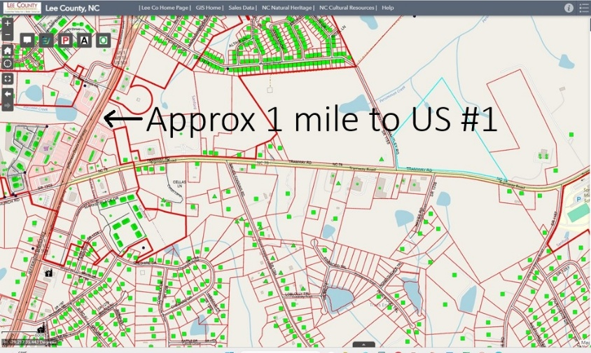

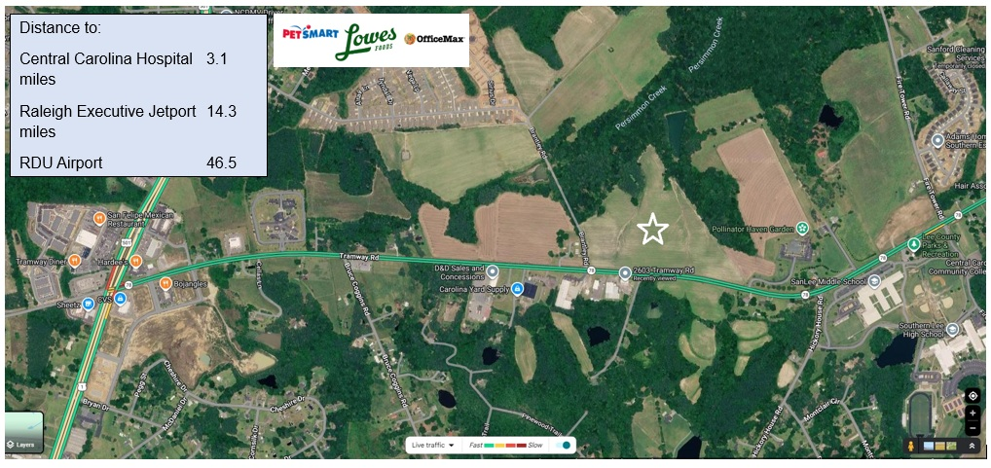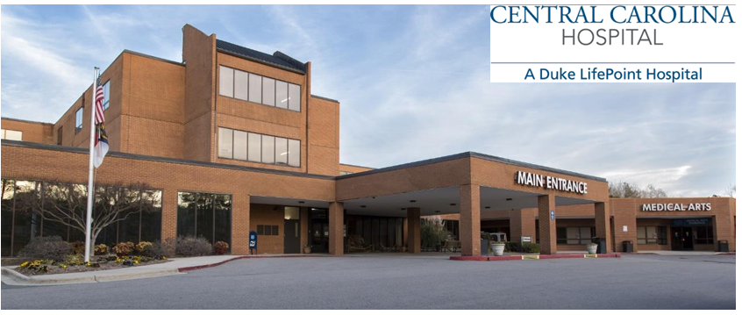



Depot Park

