1811 E CARSON STREET
TURNKEY HOSPITALITY INVESTMENT OFFERING | SOUTH SIDE | PITTSBURGH, PA

Offering Price: $435,000
Turnkey Hospitality Investment Offering Bundle including Real Estate, Liquor License, and all existing FF&E.

EXECUTIVE SUMMARY
1811 E Carson Street is a turnkey hospitality opportunity on the highly desirable 1800 block of Pittsburgh’s historic South Side. This exceptional asset bundle includes a multi-level brick building, a recently renewed Allegheny County “R” Liquor License, and all existing FF&E. With its historic brick exterior, pressed-tin ceilings, and existing bar, kitchen, and seating areas, the property offers a distinctive setting for a new bar or restaurant concept while reducing the time and capital typically required to reopen a hospitality venue.
1811 E Carson Street offers buyers the chance to acquire a fully equipped hospitality property in one of Pittsburgh’s best-known restaurant and bar corridors. The offering includes a historic multi-level brick building, prominent East Carson Street frontage, a transferable Allegheny County liquor license, and a full FF&E package for $435,000. For buyers focused on cost and speed to opening, this is a rare opportunity to acquire a property already configured for hospitality use.
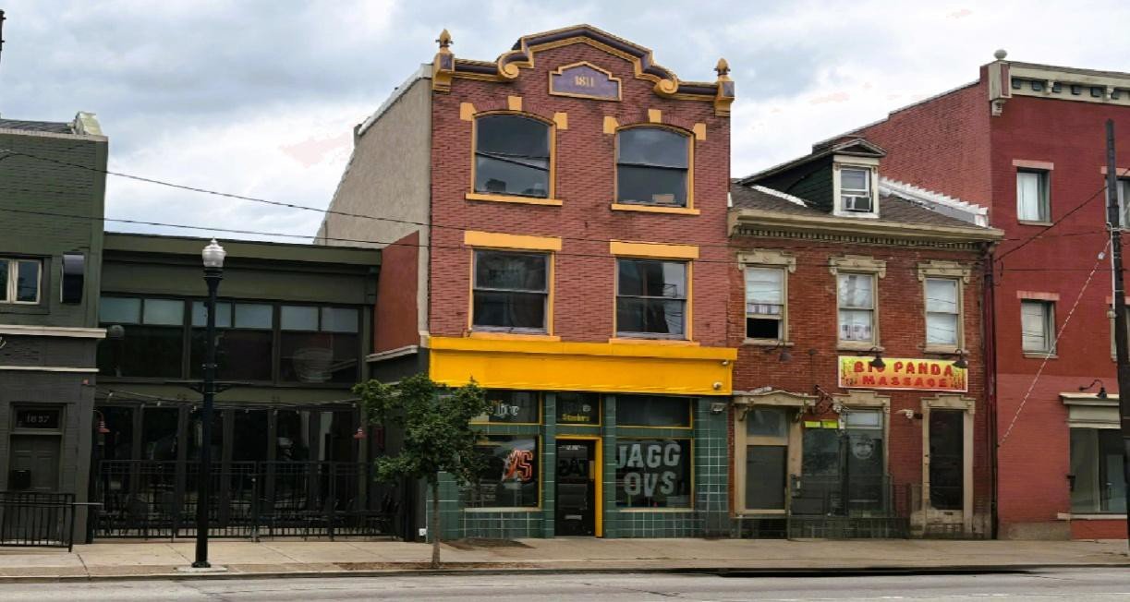

Photograph of the property storefront facade at 1811 E Carson Street.

The property also benefits from prior 20' x 40' rooftop deck approval and occupancy history—a rare outdoor hospitality differentiator along this stretch of East Carson Street—offering meaningful upside for a future destination-style food-and-beverage concept, subject to structural review and municipal approvals.

FINANCIAL & BUNDLE BREAKDOWN
The asking price includes real estate, transferable liquor license, and existing furniture, fixtures, equipment, and kitchen infrastructure—delivering a built-out hospitality package rather than just a vacant building. Built-In Value: The asking price includes the real estate, liquor license, and existing FF&E, giving a buyer more than just a building—it delivers a built-out hospitality package with meaningful embedded value.
Located within the East Carson Street Historic District, the property benefits from the curated strength of the 1800 block—an established destination for food, beverage, and experiential retail. Strong visibility, historic character, and abundant natural light help distinguish the building from standard row properties along the corridor.

Asset Component | Estimated Market Value | Included in Sale Price
Real Estate (4,096 SF above-grade building) | $450,000+ | Included
Allegheny County “R” Liquor License | $110,000 | Included
Turnkey FF&E and Commercial Kitchen | $50,000+ | Included
Total Estimated Asset Value | $610,000+ | Offering Price: $435,000

LOCATION INTELLIGENCE & MICRO-MARKET
East Carson Street remains the economic and cultural heart of Pittsburgh’s South Side, defined by historic architecture, an active business district, and a dense mix of restaurants, retail, and neighborhood services.
The 1800 block is particularly well-positioned for operators seeking a destination-oriented hospitality address within a corridor that continues to attract storefront investment, new restaurant openings, and sustained visitor traffic.
The property also benefits from strong urban connectivity. South Side’s walkable street grid, proximity to Downtown Pittsburgh, access to Oakland’s university and medical employment centers, and adjacency to the mixed-use South Side Works district all support the site’s long-term relevance for food, beverage, and entertainment concepts.

ASSET & BUILDING HIGHLIGHTS
Building Size: Approx. 4,096 SF above grade plus full-height basement for mechanicals and storage.

- First Floor (Revenue Engine): Large welcoming bar area, custom live-edge woodwork, main seating floor, fully equipped commercial kitchen, and ADA-compliant restroom.
- Second Floor (Flex / Private Event Space): Secondary bar and additional seating suitable for private parties, VIP lounge programming, or overflow revenue on peak nights.
- Third Floor / Loft Space: Dedicated management office or secure inventory and back-of-house support area.

- Basement Level: Full-height lower level supporting mechanical systems, draft lines, walk-in cooling and storage functions, helping preserve above-grade space for customer-facing revenue uses.
- Rooftop Deck Opportunity: The property previously included a rooftop deck of approximately 20' x 40' that was permitted, approved for occupancy, and actively used. In a tightly built historic corridor where true outdoor hospitality space is notably scarce, that history may offer a meaningful head start for a buyer exploring restoration of a destination-oriented outdoor component capable of broadening daytime, evening, and seasonal revenue appeal, subject to structural review and municipal approvals.
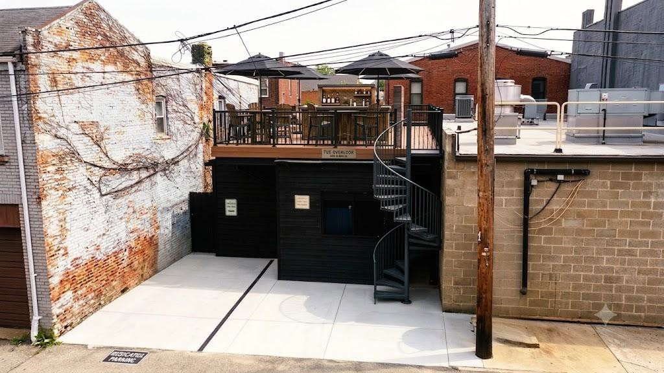

*(Note: This photo has been digitally altered to indicate the potential deck concept).*

OPERATOR USE-CASE SCENARIOS
Scenario A: Owner-Operator Entry — For an experienced chef, bar operator, or hospitality group, the offering materially shortens the path to opening by pairing a built-out venue with an existing liquor license and included FF&E. Compared with a ground-up build-out or second-generation conversion, this format can significantly reduce upfront capital requirements, pre-opening complexity, and time to launch.
Scenario B: Investor / Lease-Up Strategy — The asset may also appeal to investors seeking to acquire a highly specialized hospitality property with embedded operating infrastructure and then lease it to an established food-and-beverage tenant. The included improvements and transferable licensing component can enhance leasing appeal relative to dark-shell alternatives, particularly for operators prioritizing speed to market.

INVESTMENT HIGHLIGHTS

- Built-In Value: The price includes the real estate, liquor license, and FF&E.
- Faster Path to Opening: The existing build-out can save time and upfront costs compared with starting from scratch.

- Flexible Layout: The multi-level setup works for bars, dining, private events, or lounge concepts.
- Strong Location: Located on East Carson Street in one of Pittsburgh’s most established hospitality corridors.
- Efficient Use of Space: Storage and mechanical systems are below grade, helping keep the main floors focused on customer-facing use.
- Enhanced License Package: Recently renewed liquor license includes Sunday Sales, Amusement, and Extended Hours Food permits, supporting broader operating flexibility.
- Character and Function: Historic details give the property personality, while the existing setup makes it practical for a new operator.

BUYER REQUIREMENTS & DISCLAIMER
Buyer Requirements: Buyer is responsible for the City of Pittsburgh occupancy inspection and all municipal compliance. Proof of funds, lender letters, or commercial profile is required prior to scheduling tours.
Due Diligence: Taxes and square footage are deemed reliable but not guaranteed, and buyers are responsible for independently verifying all information and conducting their own due diligence.

Lori Kashellack • Cell: 412-969-3584 • Office: 412-521-5500

lorikashellack@TPRSold.com • https:// lorikashellack.thepreferredrealty.com/
BERKSHIRE HATHAWAY HomeServices | The Preferred Realty

