THE SHENIAN COMPANY
COMMERCIAL REAL ESTATE BROKERAGE

2,028 SF TECH/DESIGN SPACE FOR LEASE!
1429 Walnut Street
Philadelphia, PA 19102

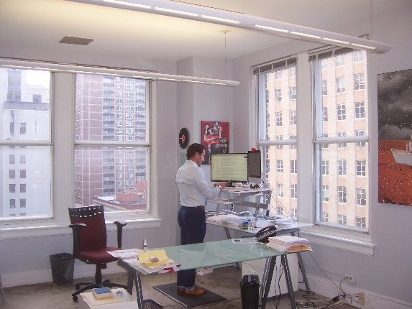
Space Features:
- Great tech/web/designer space!
- Exposed ceilings/concrete floors
- Walnut panel walls. Café kitchen.
- 2,028 square foot suite
- 12th floor FACING Walnut Street
- 24/7 access
- Three high speed elevators
- Lots of natural light
- Manned security desk
- Asking rent: $25.00 plus electric
For further information contact:
P. Chris Shenian
The Shenian Company
1518 Walnut Street
Philadelphia, PA 19102
Mobile: 610-331-2797
Email: shenian@aol.com

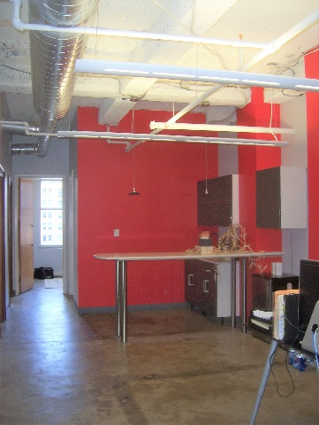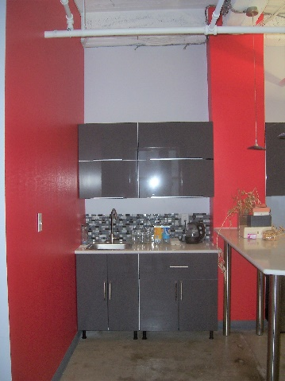
Disclaimer: This information has been obtained from sources believed reliable. We have not verified it and make no guarantee, warranty or representation about it. Any projections, opinions, assumptions or estimates used are for example only and do not represent the current or future performance of the property. You and your advisors should conduct an independent investigation of the property to determine to your satisfaction the suitability of the property for your needs+
