OFFERING MEMORANDUM
CIBOLA ESTATES
A Destination Recreation Community on the Lower Colorado River
66021 South Melody Lane · Cibola, Arizona · La Paz County

$965,000 | 28 | 36 | 6%
ASKING PRICE | IMPROVED SITES | LICENSED SITES (28 IMPROVED, 1 PENDING UTILITIES,3 RV, AND 4 FUTURE EXPANSION) | IN-PLACE CAP

River · Dunes · Refuge · Starry Skies. City water, month-to-month leases, 95% remotely managed, and an almost immediate documented path from $77,580 to $135,000 (with greater value add potential with additional capital expense)
cibolaestates@gmail.com
Principals and licensed brokers welcome · 3% commission offered to buyer's broker at closing · All inquiries confidential

The Opportunity
Cibola Estates is a 30-site recreation community on three acres in Cibola, Arizona — one mile from the Colorado River, adjacent to the Cibola National Wildlife Refuge, and forty minutes from the Imperial Sand Dunes at Glamis.
This is not a conventional affordable-housing park and should not be underwritten as one. Most residents are here for recreation, using their site as a second home or seasonal basecamp — arriving with wake boats, side-by-sides, sand rails and enclosed trailers in tow. Cibola is the most affordable place in the Southwest to keep a permanent foothold within reach of three world-class recreation assets, and almost nothing competes with it. Alongside these recreational owners, the community also includes a base of full-time, year-round tenants, adding steady, non-seasonal occupancy to the income profile.
The result is a tenant base with discretionary income and low turnover, on a property that ownership manages remotely for at least 95% of the workload. Offered at $965,000 — a 6% capitalization rate on in-place net income, $32,167 per revenue site.

Investment Highlights
- Destination -demand is driven by boating, hunting, off-road recreation and starry-sky tourism rather than by local employment. The 700 mile offroad Arizona Peace Trail is just a minute away.
- City water, direct-billed power, free trash — the park is on city water, not a well. Ownership pays water; electricity is billed directly to each tenant by APS; trash service is free. There is no utility infrastructure liability of the kind that discounts rural parks.
- 95% remotely managed — ownership handles at least 95% of management remotely, with a single on-site manager compensated by a rent-free lot. The asset does not require the buyer to live nearby.
- All month-to-month leases — every lease is month-to-month. Rents currently run $175 to $340 against a $350 market lot rent, and can be marked up on 30 days’ notice with no lease burn-off.
- 73% occupancy — 22 of 30 revenue sites are occupied. The open sites are turnkey opportunities: three RV sites (often used for short-term stays), three sites already have trailers in place needing only rehab to re-lease, and two vacant sites have full utility hookups ready for a trailer to be moved in.
Real property included — the land, the cabin, the park-owned homes and all improvements convey.

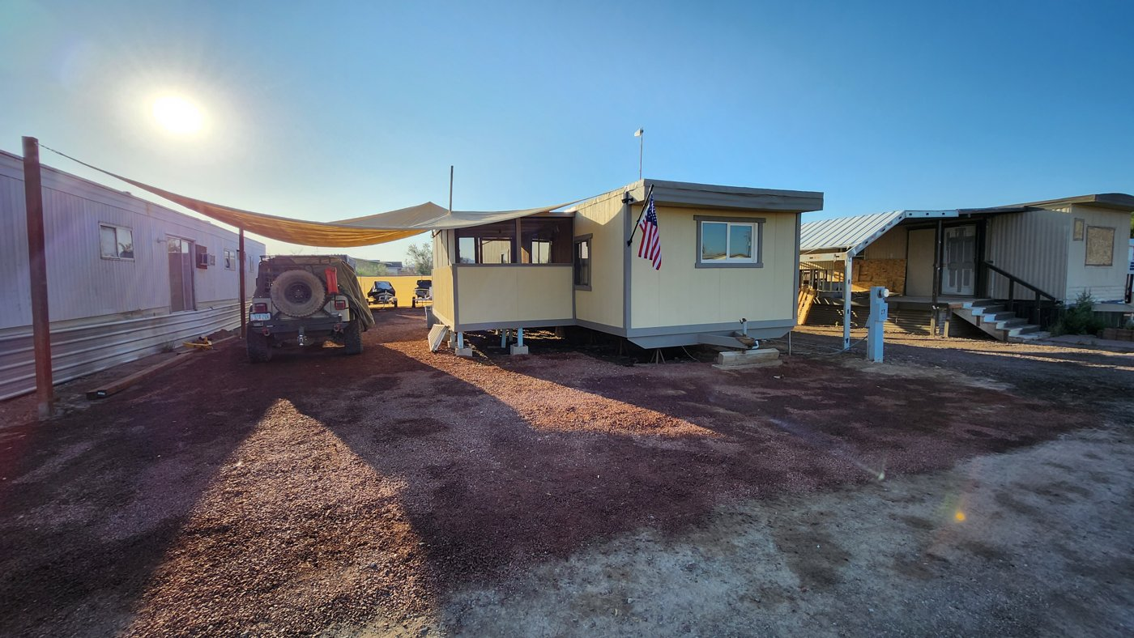  Improved sites along S Melody Lane. | 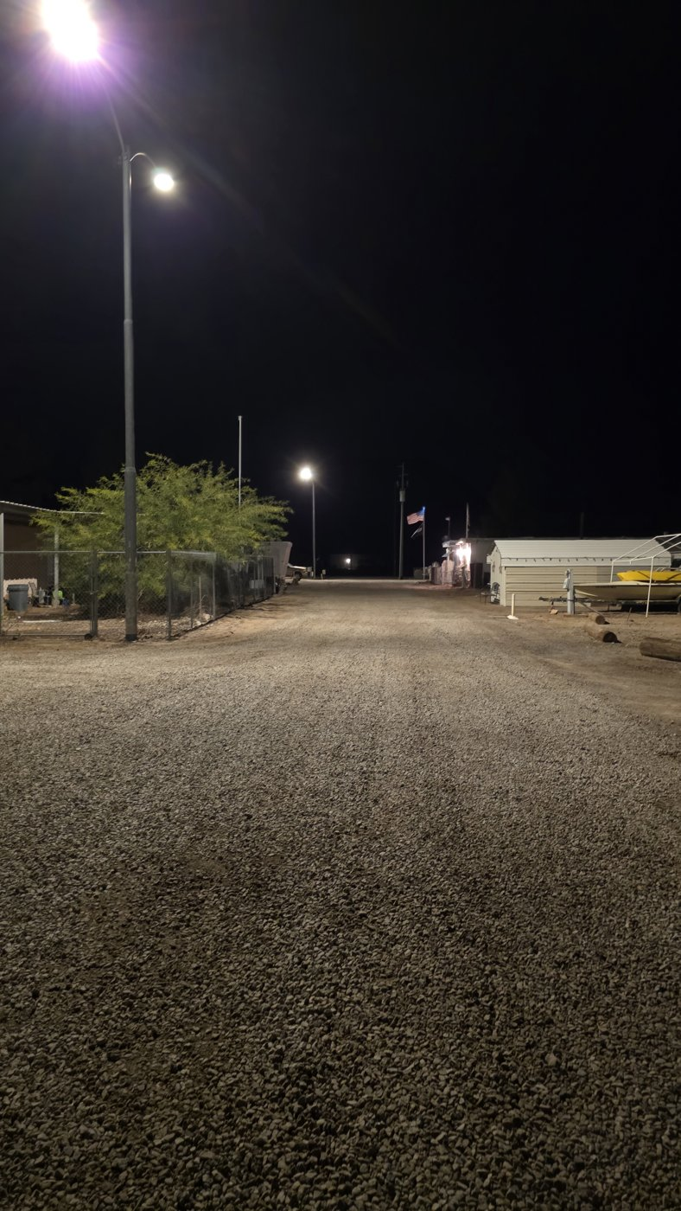  Graded and graveled interior drive.

Location & Demand Drivers
Cibola sits on the east bank of the Colorado River in southwestern La Paz County, Arizona with California directly across the water. There is consistent demand for recreation in this corridor throughout all seasons.
DRIVER | WHY IT MATTERS
Colorado River — 1 mile | Boating, wakesurfing, jet skis and year-round fishing. Residents keep boats on site and launch within minutes — the reason most tenants choose Cibola.
Imperial Sand Dunes (Glamis) — 40 minutes | The most visited BLM recreation area in the United States, drawing more than 1.2 million visitors a year. The October 1 – April 15 sand season overlaps precisely with peak occupancy here, and dune-country lodging is chronically scarce.
Cibola National Wildlife Refuge — adjacent | 18,444 acres of Colorado River bottomland managed by the U.S. Fish & Wildlife Service. Waterfowl and upland hunting through the cool season, and one of the strongest winter birding destinations on the lower river — sandhill cranes, geese and cormorants in the thousands.
Starry skies | No metropolitan light dome in any direction and roughly two inches of annual rainfall. Astronomy and night-sky photography draw a growing visitor segment to this stretch of the river.
Desert trails & climate | 1000s of acres of open BLM are just 2 minutes away for off-roading and shooting. The Sonoran winter is high season for every activity above, which supports snowbird demand alongside year-round tenancy.

  The Colorado River, one mile from the property. | 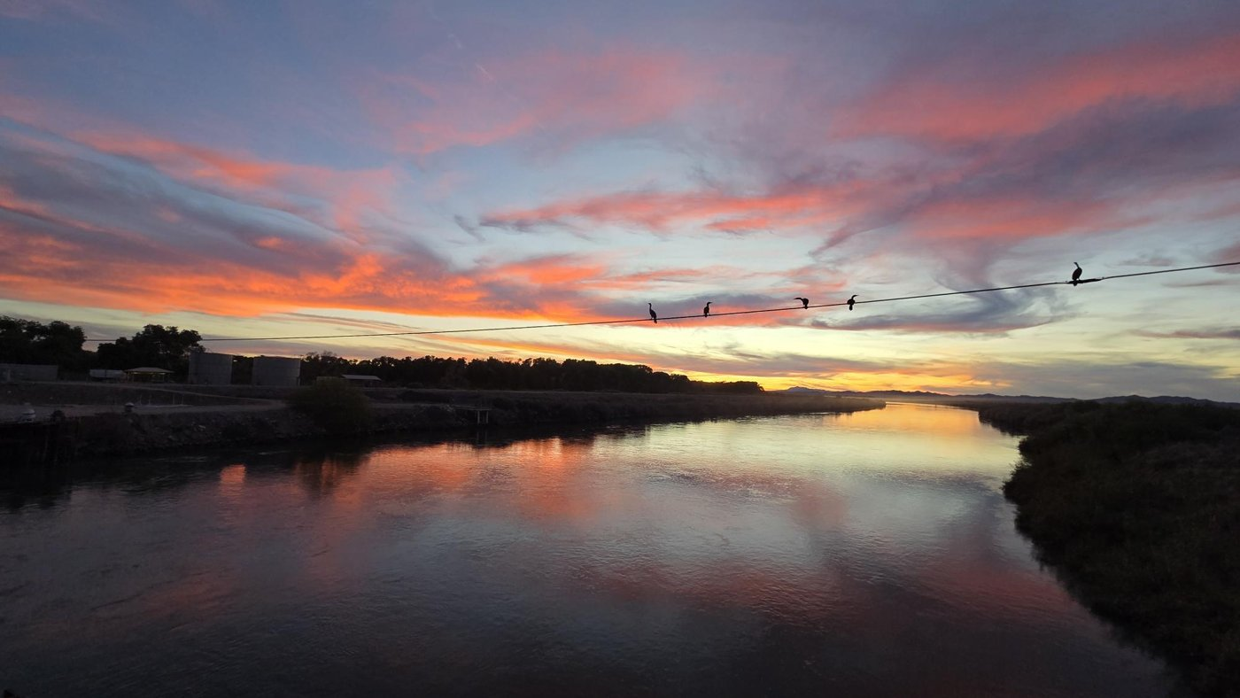  Cormorants at sunset — the refuge corridor at dusk.

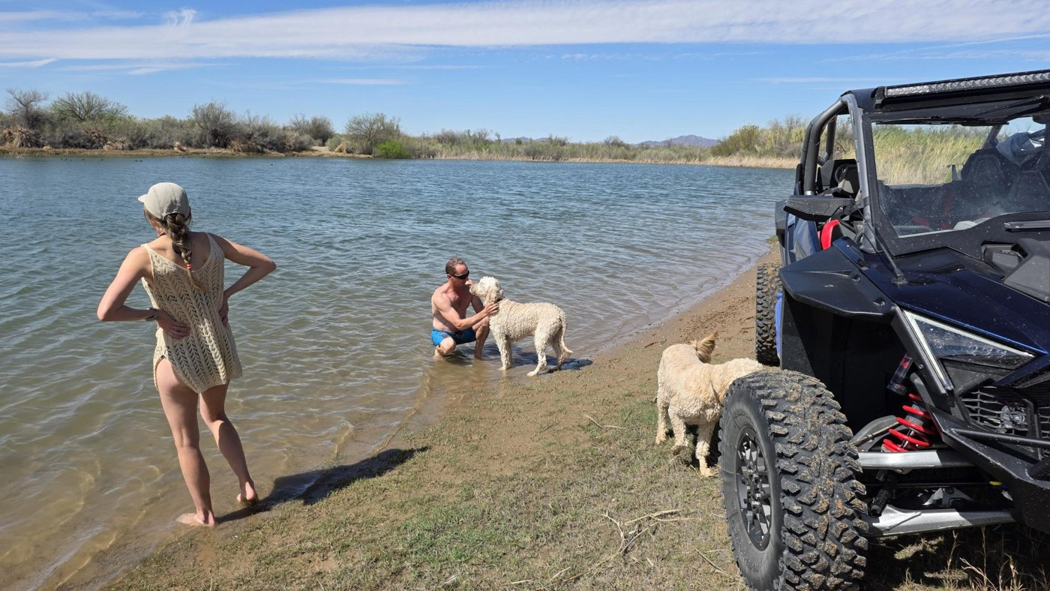  Riverside afternoon — a short drive from any site in the park. | 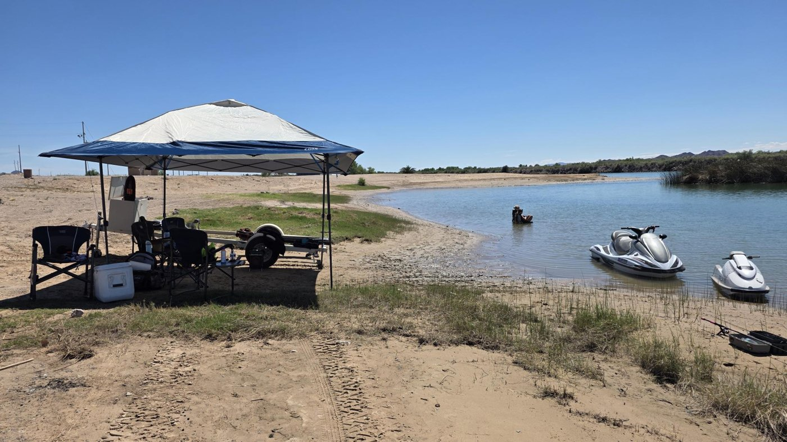  Jet skis and shade on the river beach.

Property Overview
Address | 66021 South Melody Lane, Cibola, Arizona 85328 — La Paz County
Land area | Approximately 3.0 acres
Sites | 30 revenue sites (26 manufactured-home lots, 1 stick built “cabin” and 3 RV pads) plus potential for 6 additional licensed sites pending utilities — 36 entitled sites in total
Occupancy | 22 of 30 revenue sites occupied
Improvements | The cabin, located beside site Res 1, is the only stick-built structure on the property. It was remodeled this year with new floors, paint, ceiling can lights, kitchen, bathroom and shower. Every other site is a manufactured-home lot; Res 1 and Res 2 are simply oversized lots. Homes are predominantly tenant-owned, with a limited number of park-owned units conveying in the sale.
Water | City water. Ownership pays the water bill — there is no well to maintain or replace.
Electric | Billed directly to each tenant by APS. Ownership pays common-area, RV sites, and lighting power only.
Trash | Free — no cost to ownership or tenants.
Sewer | Private septic.
Leases | All leases are month-to-month, allowing rents to be marked to market on 30 days’ notice.
Management | Ownership performs at least 95% of management remotely. One on-site manager is compensated with a rent-free lot (site 24) no salary expense.
Access | Baseline Road frontage; interior drives (S Melody Lane, S Grace Street) recently graded and graveled, with pole lighting throughout.

Site Plan
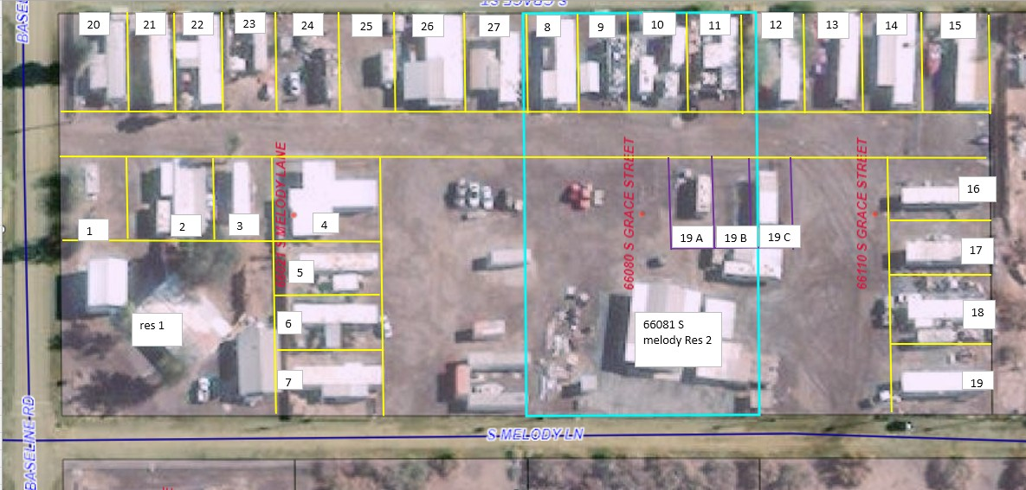
Note: this aerial is several years old. Since it was taken the park has been cleaned up throughout, and the interior roads have been graded and graveled. It is provided to show site numbering and layout only — it is not a survey, and boundaries, dimensions and site counts are to be verified by the buyer.

Rent Roll
Details provided on request.
TOTAL — MONTHLY | $6,465 | $11,250 or $15050 (nightly rentals)
TOTAL — ANNUAL | $77,580 | $135,000 or $180,600
Sites 19A–19C (RV pads) are not on the roll above as they are typically for short-term tenants. Other than site 1, the remaining potential sites are not on this list, as they would have to be fully developed to maximize licensure. A certified rent roll designating home ownership on every site is available in due diligence.

Financial Summary
 | IN PLACE | STABILIZED
Gross scheduled income | $77,580 | $135,000
Common-area electric | $2,809 | $3,600
Water | $4171 | — charge back to tenants
Liability insurance | $5,808 | $6,500
Property taxes | $2161.69 | $2200
Trash | $0 | $0
Nightly-rental operating costs | —
Repairs, grounds & reserves | $2680 | $9,000
Administrative (rent management software) | $1637 | $3200
Total operating expenses | $19,267 | $24,500
Expense ratio | 24.8% | 18.1%
NET OPERATING INCOME | $58,313 | $110,500
Return at the $965,000 asking price | 6% | 11.4%
In place reflects how the property runs today — owner-operated remotely, tenants on APS for their own power, free trash, and an on-site manager paid with a rent-free lot rather than salary. Stabilized assumes market lot rents, water reimbursed by tenants, the ten unmonetized sites brought online, storage let, and the cabin plus sites 1 and 7 on nightly rental. Property taxes are an estimate pending the current La Paz County assessment.

The Value-Add Plan
The gap between $58,313 and $229,440 is not speculative rent growth. It is a defined set of actions on specific sites. Conversion of premium owned sites to nightly rentals would further increase income potential
ACTION | ANNUAL GROSS ADDED
Mark 23 standard lots to $350 market rent | $39,840
Premium sites 1 & 7 — remodeled units on nightly rental | $48,000
Cabin repositioned to nightly rental | $14,400
4 new sites — licensed, add septic + power | $16,800
RV pads 19A/19B/19C — previously leased to paying tenants; bring back online at $450 monthly | $16,200
Covered toy, boat & RV storage on surplus acreage | $6,000
Oversized lots Res 1 & Res 2 to market | $4,620
TOTAL IDENTIFIED UPSIDE | $145,860

Capital required
Septic and electrical service — sites 30–35 | $25,000
Two remodeled park models installed on sites 1 & 7 | $80,000
Cabin refresh and furnishing for nightly rental | $15,000
Storage area grading and fencing | $10,000
TOTAL ESTIMATED CAPITAL | $130,000
Estimates are ownership’s and should be independently bid.

Pricing
ASKING PRICE
$965,000

Priced below the market on a per-site basis
Per-site pricing is how buyers of small parks actually compare deals, and it is where Cibola Estates is most clearly underpriced. Arizona parks of this size trade in a $25,000 to $60,000 per-lot band, and quality assets rarely change hands below $40,000 a lot.
COMPARABLE | SITES | PRICE | PER SITE
Higgins Lane MHP1701 W Higgins Ln, Tucson Az | 11 | $450,000 | $40,909
Cedar Mobile Home Court111 S Papago St, Springerville Az | 37 | $1450000 | $39,189
53390 US-60, Miami Az | 18 | $787000 | $43,722
6643 S Sparrow Ave Tucson Az (short term rentals near casino) | 8 | $625000 | $78,125
CIBOLA ESTATES — 30 improved sites | 30 | $965,000 | $32,167
CIBOLA ESTATES — 36 licensed sites | 36 | $965,000 | $26,805

Rents are below the Arizona market
PARK | TYPE | MONTHLY RENT
Palo Verde Estates, Tucson AZ | MH lot, double-wide | $449 + utilities
Palo Verde Estates, Tucson AZ | MH lot, single-wide | $439 + utilities
Casita Linda, Yuma AZ | MH lot | $285 + utilities
Arizona West RV Park, Yuma AZ | RV, monthly | $550 ($650 Jan–Mar)
Palo Verde Estates, Tucson AZ | RV, monthly | $500 + utilities
CIBOLA ESTATES — today | MH lot | $175 – $340
CIBOLA ESTATES — market | MH lot, trash and water included | $350

Next Steps
A full due diligence package — certified rent roll, utility invoices, tax statements, insurance declarations, licensing documentation, and property access — is available to qualified buyers on request.
CIBOLA ESTATES
66021 South Melody Lane · Cibola, Arizona 85328
cibolaestates@gmail.com
Principals and licensed brokers welcome · 3% commission offered to buyer's broker at closing · All inquiries held in confidence

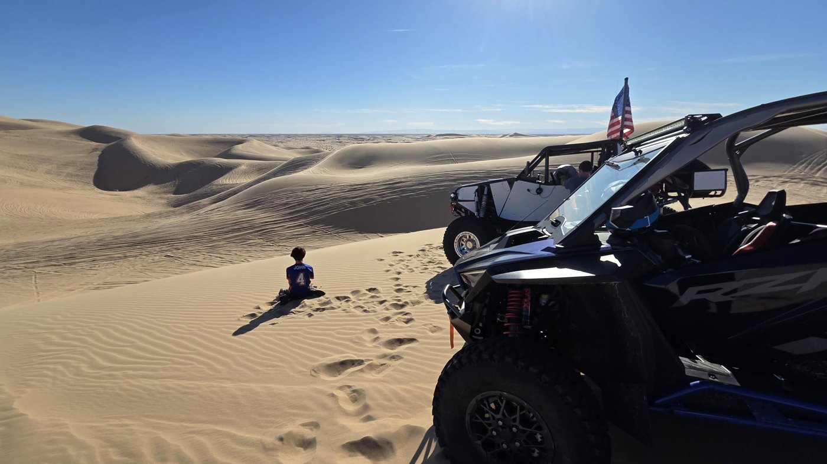  Glamis, forty minutes from the front gate. | 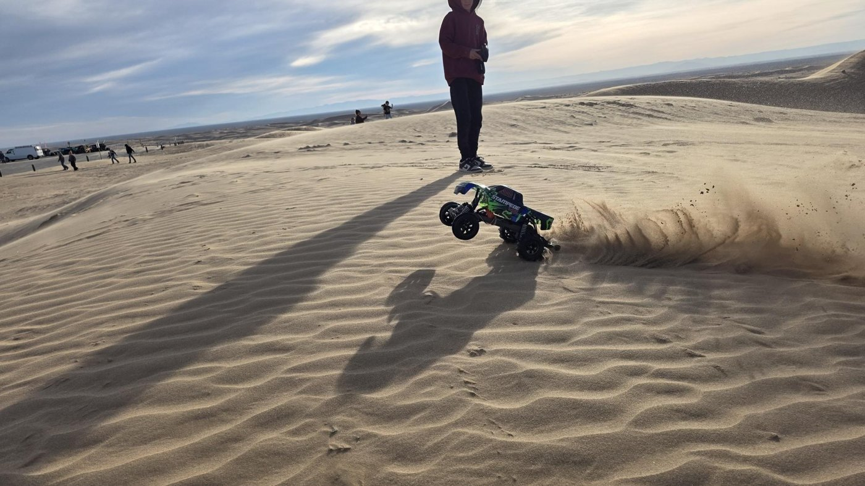  Sunset on the dunes.

Disclaimer
This memorandum has been prepared by ownership from information believed to be accurate but not independently verified. All financial information — rents, expenses, projections, capital estimates and property taxes — is provided for reference only and is subject to buyer verification. Projected and stabilized figures are estimates of future performance, not guarantees, and depend on capital being deployed and market conditions holding. Comparable rents and listing prices are drawn from publicly advertised rates and listings and are not verified transaction records. Site counts, acreage, licensing status, utility capacity, zoning and permitted use are subject to confirmation with La Paz County and the Arizona Department of Housing. Photographs and the site plan are illustrative and are not surveys. Prospective purchasers should conduct their own due diligence and consult their own legal, tax and engineering advisors. This document is not an offer to sell or a solicitation of an offer to buy a security. Ownership reserves the right to withdraw the property or modify terms at any time.

