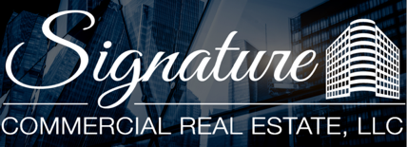

PRIME MIAMI COMMERCIAL REDEVELOPMENT OPPORTUNITY
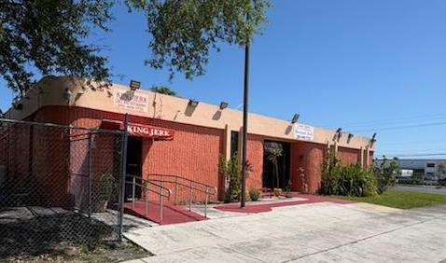
For Sale $4,000,000
161 NE 183rd St
Miami, Fl 33179

TWO PARCEL CORNER LOCATION ENDLESS POSSIBILTIES

Unlock the potential of one of North Miami's most strategic commercial redevelopment opportunities.
Positioned on a highly visible corner with approximately 153 feet of frontage along NE 183rd Street, this rare two-parcel assemblage offers investors, developers, and owner-users the flexibility to capitalize on one of Miami-Dade's busiest commercial corridors. The offering includes an existing 4,905-square-foot commercial building plus an adjacent parcel that significantly enhances parking, expansion, or future redevelopment potential.
- Rare two-parcel assemblage
- Major corner location with exceptional visibility
- Minutes from I-95, Florida's Turnpike, SR-826, and the Golden Glades Interchange
- Existing income-producing commercial structure
- Additional parcel provides valuable parking or redevelopment flexibility
- BU-1A zoning supports a broad range of commercial uses
- Potential mixed-use redevelopment opportunity utilizing Florida's Live Local Act incentives (subject to approvals)
- Located within a densely populated trade area serving nearly 200,000 residents within three miles.
- One Property. Two Parcels. Unlimited Potential
- Corner Commercial Assemblage with Exceptional Redevelopment Upside
- Prime Miami Development Opportunity in a High-Traffic Corridor
- Location. Visibility. Flexibility. Opportunity
Endless Possibilities
- Medical Office Campus
- Urgent Care or Specialty Medical Facility
- Retail Plaza
- Professional Office Complex
- Church or Religious Facility
- Childcare / Educational Center
- Fitness Studio
- Banquet & Event Venue
- Mixed-Use Residential / Commercial Development
- Investment Hold with Future Redevelopment Potential

Location Matters
This property sits in the heart of the Golden Glades/North Dade market with immediate access to South Florida's major transportation network, placing millions of consumers within easy reach.
Whether you're an investor seeking value-add potential, a developer pursuing your next mixed-use project, or a business looking for a flagship location, this unique assemblage offers the location, flexibility, and upside rarely available in today's South Florida market.

