FOR SALE
Prime Commercial
Development Land
London, ON
2.83 acres
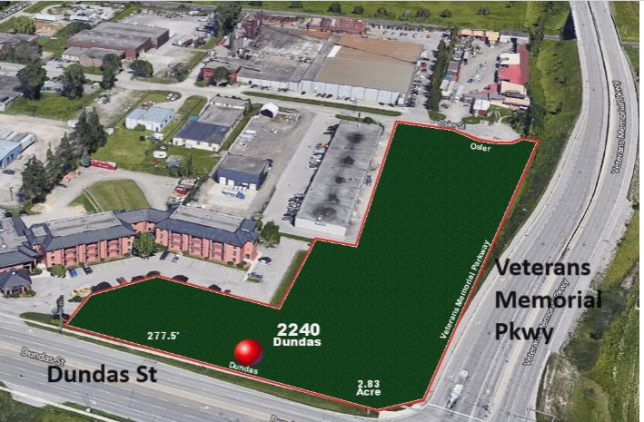
LISTED FOR SALE
2240 DUNDAS STREET, LONDON, ONTARIO CANADA
LISTING PRICE $3,150,000.00 FRONTAGE 278 ft.
ACREAGE 2.83
ZONING RSC 2,3,4 & HS 1,4 & LI2
TAXES $15,993 (2022)
PRIME LOCATION NEAR LONDON INTERNATIONAL AIRPORT (4 MIN)
ARGYLE MALL (3 MIN)
3 STREET FRONTAGES
Proximity to Hwy 401
Fronting on Veterans Memorial Pkwy
Potential for severance
- Fronting on /immediate proximity of major roadways
- High-visibility for signage and flagship building
- 18,000+ vehicles daily along Arterial (Dundas Street)
- 18,000+ vehicles along Freeway (Veterans Memorial Parkway)
- Public transportation at the door
- Immediate vicinity of Best Western London Airport Inn, London Automall, Canadian Tire, Home
Depot, McDonald’s, Tim Horton's, hotels, residential developments
- Directly across from Peavey Mart
- Immediate access to Veterans Memorial Parkway, a main highway interchange of London

LAND FEATURES
- FLAT OPEN LAND
- POTENTIAL TO SEVER
- No out buildings or demolition required
- Existing flexible zoning permits a wide range of immediate uses including Convenience Stores,
Financial Institutions, Restaurants, Auto Sales & Service, Clinics & Laboratories, Pharmacies,
Hotels/Motels, Medical/Dental Offices, Gyms, Self-Storage and more
- LI2 zoning permits Light Industrial/Manufacturing
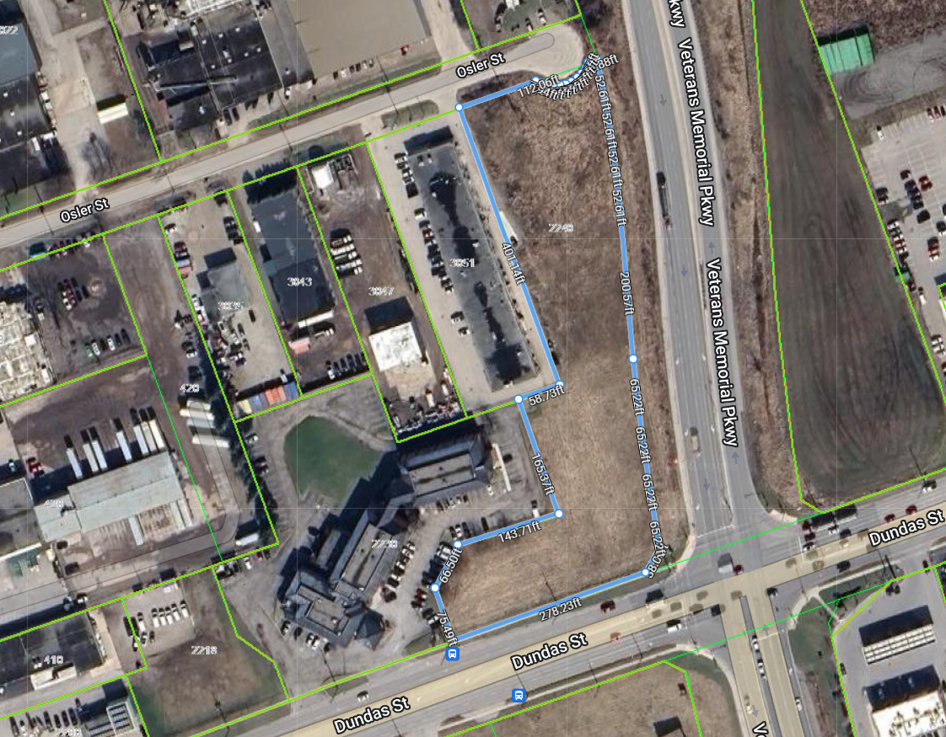
ZONING

HS1 (a) Any use permitted in the HS Zone Variation: (Animal Hospitals; Automotive uses, Restricted;
Convenience Service Establishments; Convenience Stores; Duplicating Shops; Financial Institutions;
Personal Service Establishments; Restaurants; Video Rental Establishments; Brewing on Premises
Establishments); (b) Assembly Halls; (c) Private Clubs; (d) Taverns.

HS4 (a) Hotels; (b) Motels; (c) Restaurants.
RSC2 (a) Any use permitted in the RSC1 Zone variation: (Animal Clinics; Automobile Rental Establishment;
Automobile Repair Garages; Automobile Sales and Service Establishments; Automobile Supply
Stores; Automotive Uses, restricted; Catalogue Stores; Duplicating Shops; Home and Auto Supply
Stores; Home Improvement and Furnishing Stores; Kennels; Repair and Rental Establishments;
Service and Repair Establishments; Studios; Taxi Establishments; Self-storage Establishments; Tow
Truck Business); (b) Bulk Beverage Stores; (c) Dry Cleaning and Laundry Depots; (d) Liquor, Beer
and Wine Stores; (e) Pharmacies; (h) Bulk Sales Establishment.

RSC3 (a) Assembly Halls; (b) Clinics; (c) Commercial Recreation Establishments; (d) Emergency Care
Establishments; (e) Funeral Homes; (f) Laboratories; (g) Medical/dental Offices; (h) Private Clubs.
RSC4 (a) Automobile Repair Garage; (b) Automotive Uses, restricted; (c) Bake Shops; (d) Convenience
Service Establishments; (e) Convenience Stores; (f) Day Care Centres; (g) Duplicating Shops; (h)
Financial Institutions; (i) Florist Shops; (j) Personal Service Establishments; (k) Restaurants; (l) Video
Rental Establishments; (m) Brewing on Premises Establishments; (n) Self-storage Establishments.
LI2 (a) Any use permitted in the LI1 Zone variation (Bakeries; Business Service Establishments;
Laboratories; Manufacturing and Assembly Industries; Offices, Support; Paper and Allied Products
Industries, excluding Pulp and Paper and Asphalt Roofing Industries; Pharmaceutical and Medical
Product Industries; Printing, Reproduction and Data Processing Industries; Research and
Development Establishments; Warehouse Establishments; Wholesale Establishments; Custom
Workshop; Brewing on Premises Establishments; Service Trade; Existing Self-storage
Establishments; Artisan Workshop; Craft Brewery; Tow Truck Business); (b) Dry Cleaning and
Laundry Plants; (c) Food, Tobacco and Beverage Processing Industries, excluding Meat Packaging;
(d) Leather and Fur Processing, excluding Tanning; (e) Repair and Rental Establishments; (f) Service
and Repair Establishments; (g) Service Trades; (h) Textile Processing Industries.

Home of the University of Western Ontario (founded in 1878).

LONDON THE CITY
London, Ontario, often simply called London, is a city in Southwestern Ontario, Canada. It is the regional center of the region of Middlesex County and is located about halfway between Toronto and Detroit, Michigan. Here are some key points about London, Ontario:
- Population: As of the 2021 Canadian Census, London has a population of over 422,000 people, making it one of the larger cities in Ontario.
- Education: London is home to several post-secondary institutions, including Western University (formerly the University of Western Ontario), which is known for its medical, business, and law programs, and Fanshawe College, a large community college offering a variety of vocational and technical programs.
- Transportation: The city is served by the London International Airport and has good road connections via Highway 401 and 402. Public transportation is provided by the London Transit Commission.
- Industries- London’s industries include the manufacture of food products, brass and steel products, diesel locomotives, textiles, electrical appliances, and clothing.

