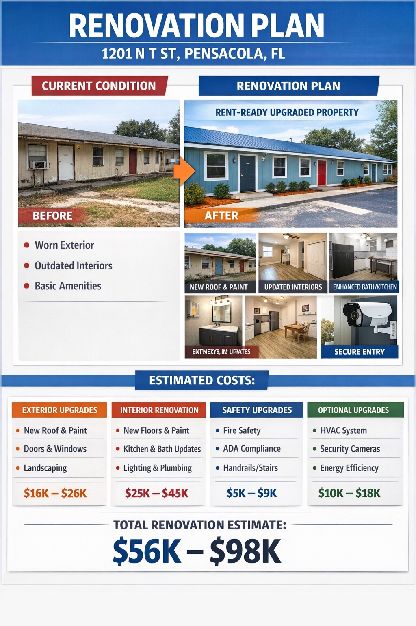
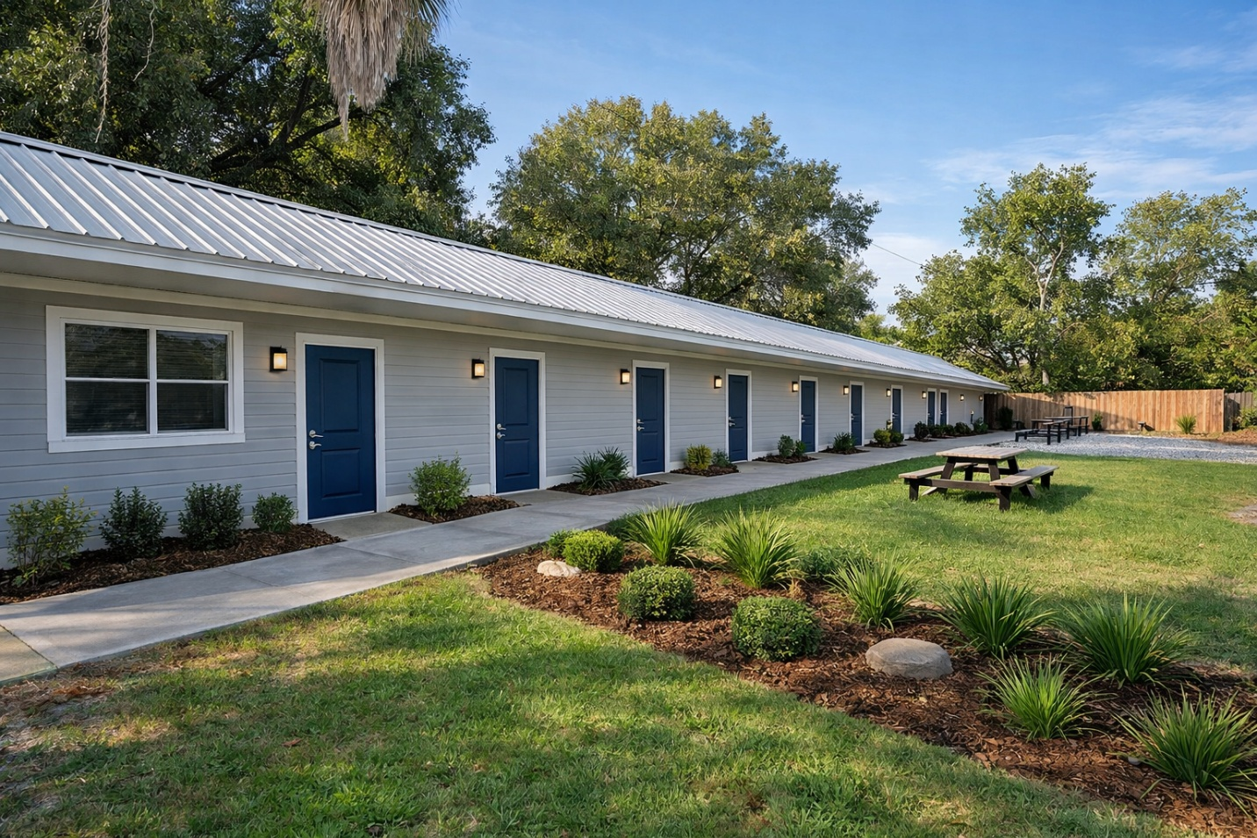

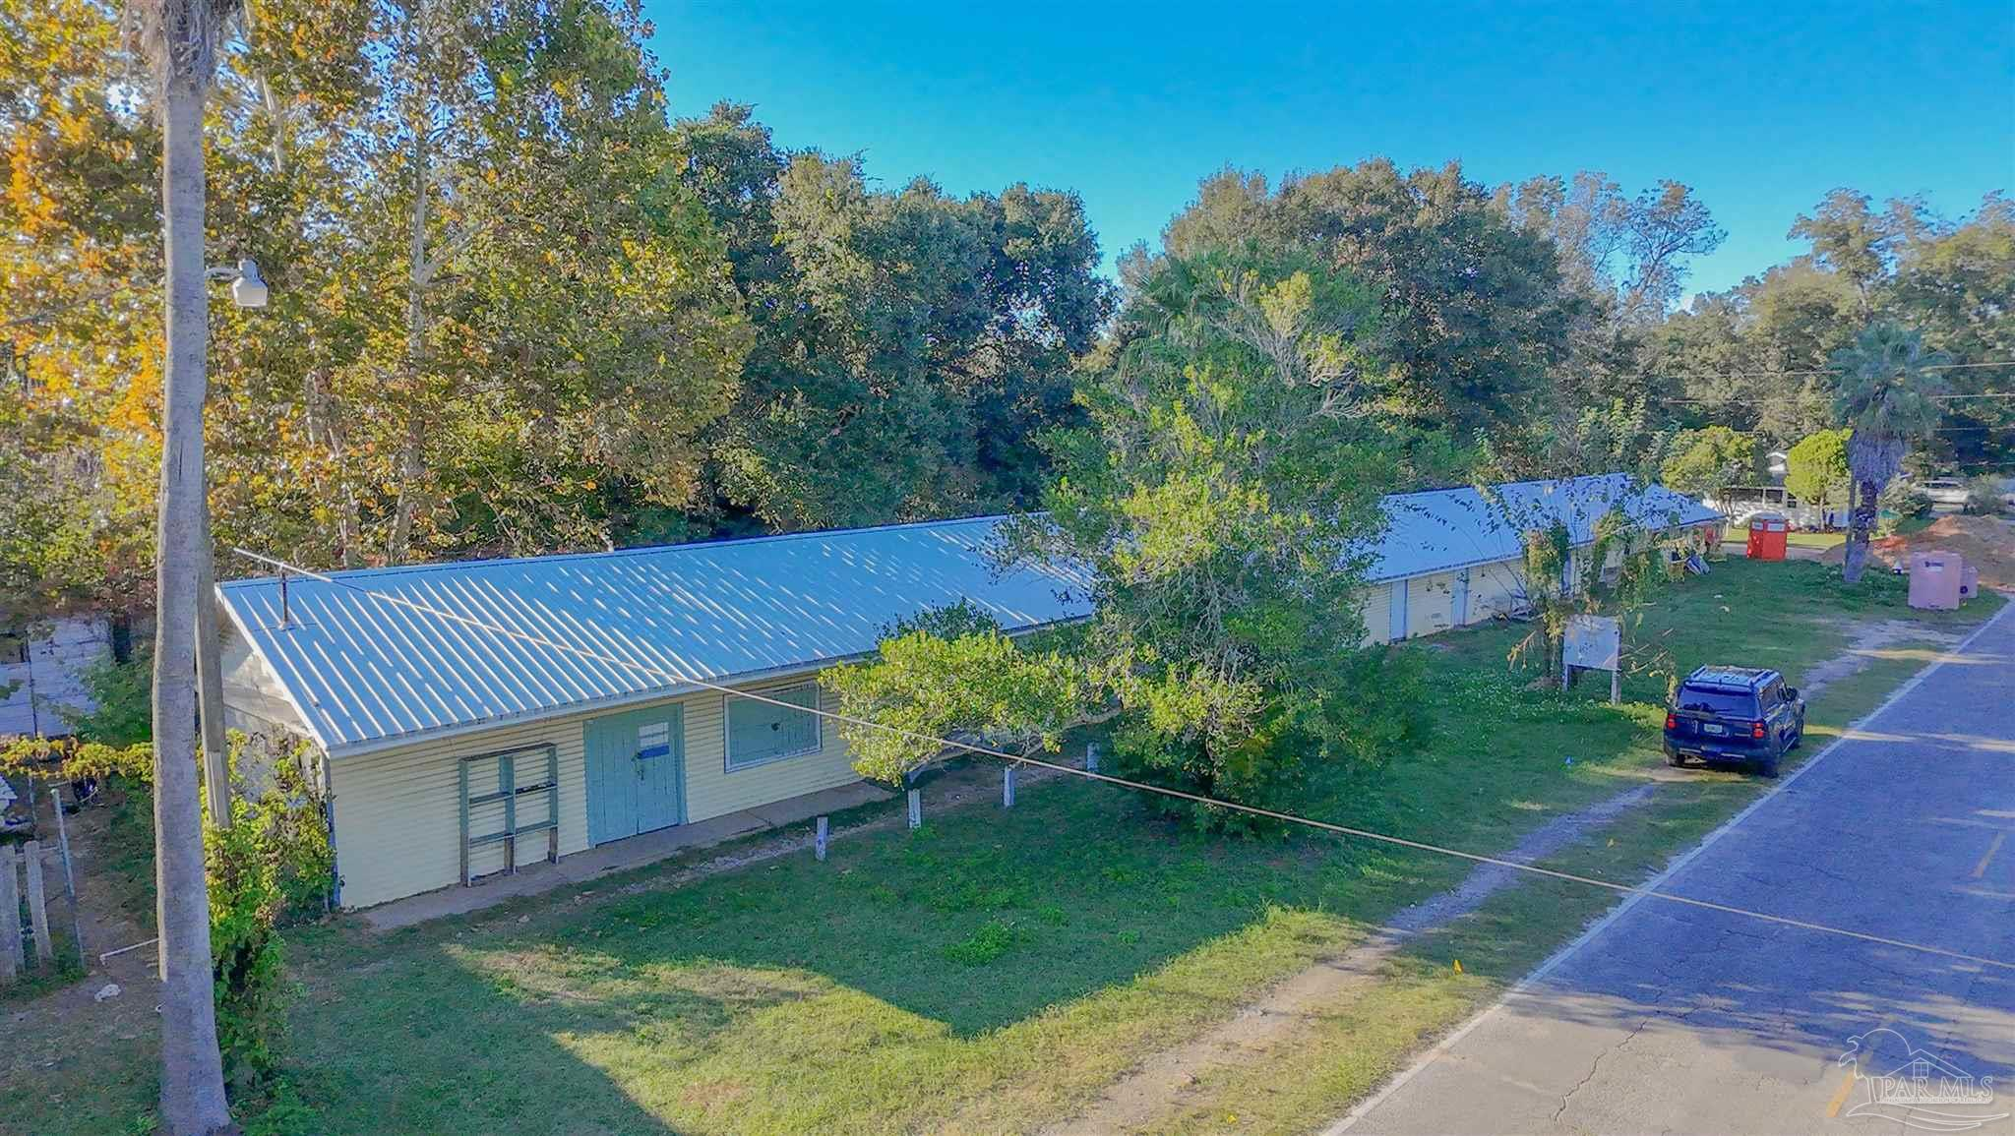
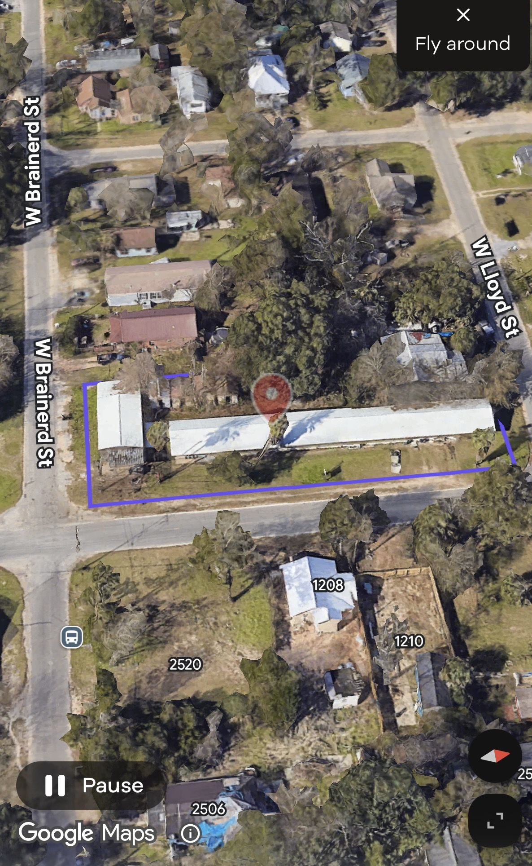

Investment Potential Analysis Report with endless possibilities
16-Room value-add multi-unit development investment opportunity 3 corner lot
. The building offers multiple revenue streams and substantial upside through renovation and lease-up, RIO, NOI

Property: 1201 North T Street, Pensacola, Florida 32505
1. Property Overview
Address: 1201 N T Street, Pensacola, FL 32505
Property Type: Multi-Unit Residential / commercial mixed use Conversion Opportunity
Year Built: 1965
Building Size: 5,148 sq ft
Lot Size: ~0.48 acres
Total Rooms / Units: Approximately 14–16 units
Structure: Wood frame with concrete foundation
Roof: Metal
The property is located in an established urban area of Pensacola with access to public transportation and commercial corridors. The configuration allows the property to be repositioned as multi-family rentals, workforce housing, co-living units, or commercial conversion (storage or offices). Etc.

2. Market Overview – Pensacola Rental Market
Pensacola has experienced strong rental demand driven by:
- Military presence (NAS Pensacola)
- Gulf Cost Growing economy
- Healthcare and tourism employment
- Pensacola State College
- Limited affordable housing supply

Typical commercial / office rental rates in Pensacola range around:
- $12 per square foot annually (~$1/sq ft/month) for basic office space.
Workforce housing and small unit rentals often generate $700–$1,200 per unit monthly depending on size and condition.

3. Potential Rental Scenarios
Scenario 1 – Workforce Housing / Room Rentals
Assuming 16 rentable units
Average rent estimate per unit:
Rent per Unit | Units | Monthly Revenue | Annual Revenue
$700 | 16 | $11,200 | $117,600
$850 | 16 | $13,100 | $142,800
$1,000 | 16 | $16,000 | $168,000
Projected Gross Income:
$127,600 – $188,000 annually
The property listing suggests that similar units could reach $1,000/month each in the market.
2. Example Rental Income
One strong concept for this building is a Mail & Shipping Hub Business Center.
Possible services:
• mailbox rentals
• FedEx / UPS shipping
• Amazon return center
• packaging supplies store
• printing and copying
• small office suites
These services produce daily customer traffic and stable rent income.

Tenant | Monthly Rent
Shipping center | $2,500
Mailbox / printing | $1,800
Packaging store | $1,500
Office suite | $1,000
Office suite | $1,000
Office suite*12 | $12,000

Total Monthly Income
$19,800
Annual Income
$237,600

4. Alternative Income Strategy
Co-Living / Affordable Housing Model
Because the property contains many rooms, it could operate as:
- Transitional housing
- Workforce housing
- Shared housing

Example:
Rooms | Rent | Monthly Income
16 rooms | $650 | $10,400
16 rooms | $800 | $12,800
Annual revenue potential:
$124,800 – $153,600

5. Commercial Conversion Potential
The property could also be repositioned as:
- Self-storage
- Small business suites
- Contractor workspaces
Average Pensacola commercial rents:
~$12/sq ft per year.
Example:
5,148 sq ft × $12
= $61,776 annual gross revenue

6. Estimated Operating Expenses
Typical small rental property expenses:
Expense Category | Estimated
Taxes | $2,500–$4,000
Insurance | $3,000–$6,000
Maintenance | $8,000–$15,000
Utilities | $5,000–$10,000
Management | 8–10%
Estimated total:
$25,000 – $45,000 annually

7. Net Operating Income (NOI)
Example mid-range scenario:
Gross rent:
$142,800
Expenses:
$35,000
Estimated NOI:
≈ $107,800 per year

8. Investor Value (Cap Rate Example)
If NOI = $107,800
Cap Rate | Property Value
6% | $1,796,000
7% | $1,540,000
8% | $1,347,000
This shows the value-add potential after renovation and stabilization.

9. Key Investment Advantages
✔ Large 5,148 sq ft building
✔ Multiple unit configuration
✔ Located in a growing Florida market
✔ Strong workforce housing demand
✔ Multiple exit strategies
- Multi-family rentals
- Co-living housing
- Storage conversion
- Small business offices
- workspace

11. Summary
Estimated Gross Income Potential
$117,600 – $273,000 annually
Estimated NOI
$80,000 – $210,000 annually (after stabilization)

Disclaimer
All Number are estimate depends on the investor vision.

