PALM BUSINESS CENTER
17802-17812 S. MAIN STREET
CARSON, CA 90248

AVAILABLE UNIT 17810-A
5,025 SQ.FT
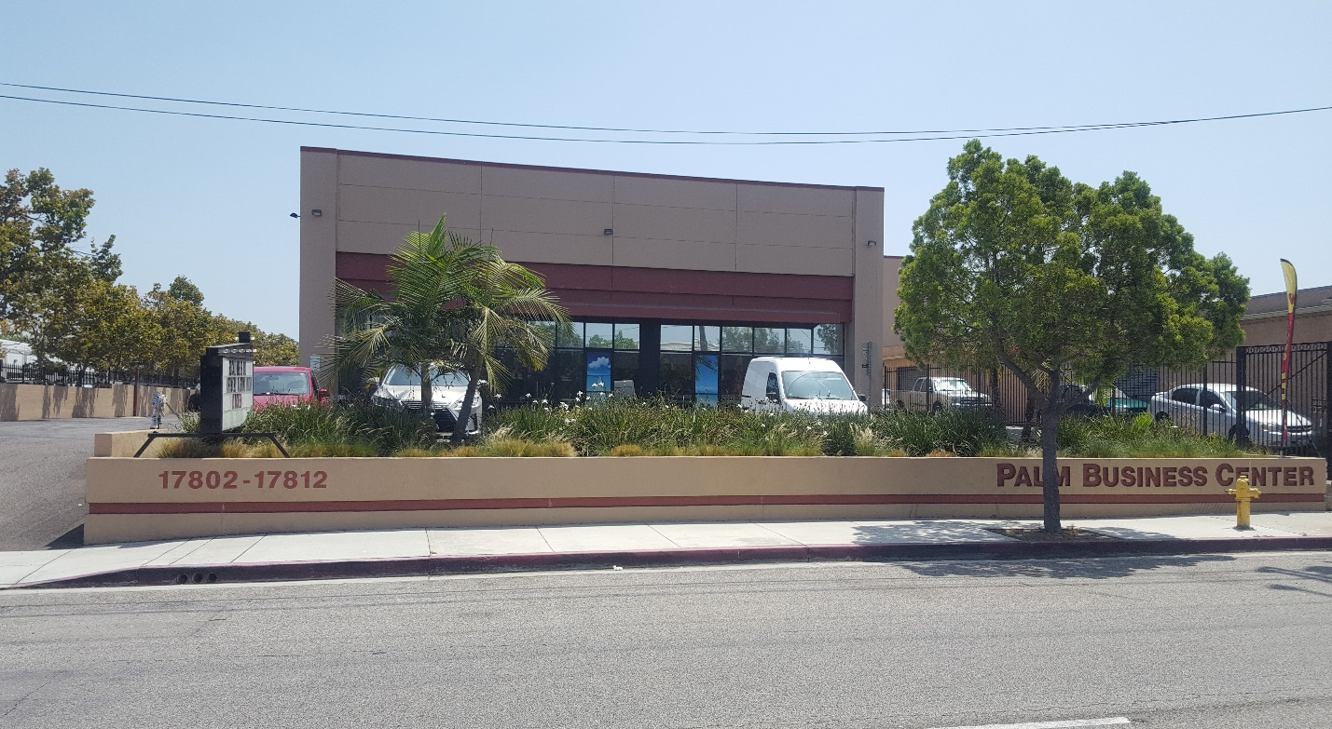

- BUILT in 2017 HIGH END INDUSTRIAL CENTER
- WAREHOUSE/INDUSTRIAL SPACE WITH A 500 SF, AIRCONDITIONED OFFICE
- ROLL UP DOOR
- HIGH CEILINGS (21-23 FEET). NO COLUMNS. PLENTY OF SKYLIGHTS
- GLASS FRONT. SKYLIGHTS THROUGHOUT
- INDIVIDUAL POWER (400 AMP 3 PASE), WATER, GAS, TELEPHONE, CABLE, FIBER OPTICS, SECURITY CAMERAS AND ALARM
- DEDICATED PARKING STALLS (7)
- WITHIN MINUTES FROM FREEWAYS 110, 405, AND 91
- CLOSE PROXIMITY TO LONG BEACH & LOS ANGELES PORTS AND AIRPORT
- LEASE TERM: NEGOTIABLE
- NNN RENT: $22/YEAR
- NNN CHARGES: $4.25/YEAR
- PROPERTY ZIP CODE SHOWS GARDENA, BUT THE PROPERTY IS IN CITY OF CARSON

17810-A South Main Street
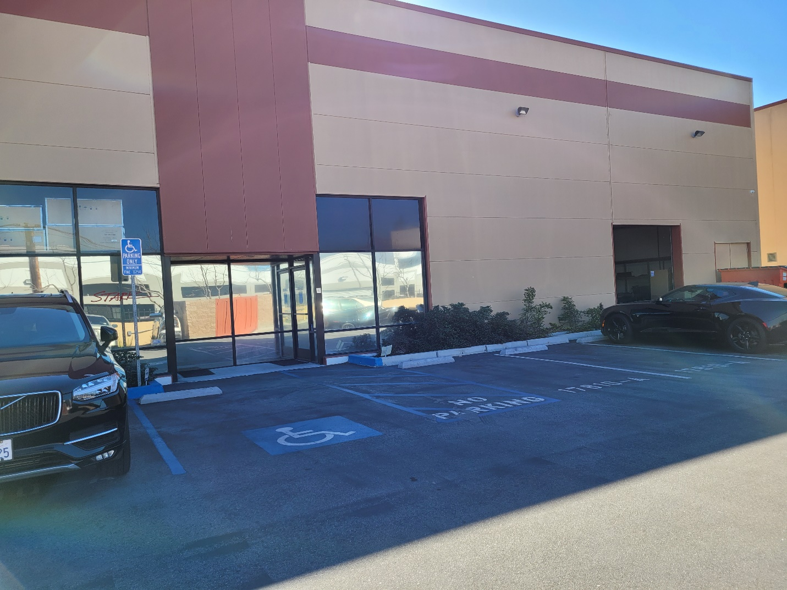

Parking Area
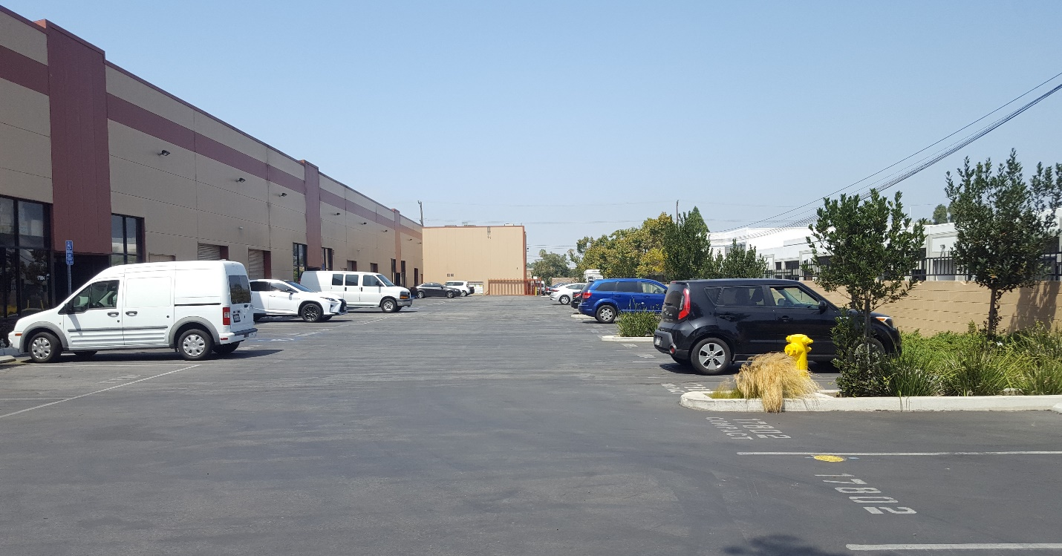
Warehouse/Manufacturing Area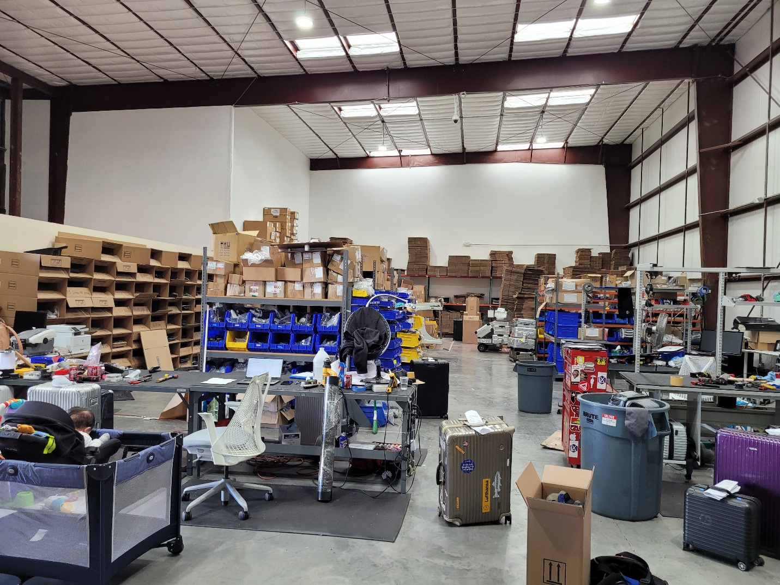
Office Area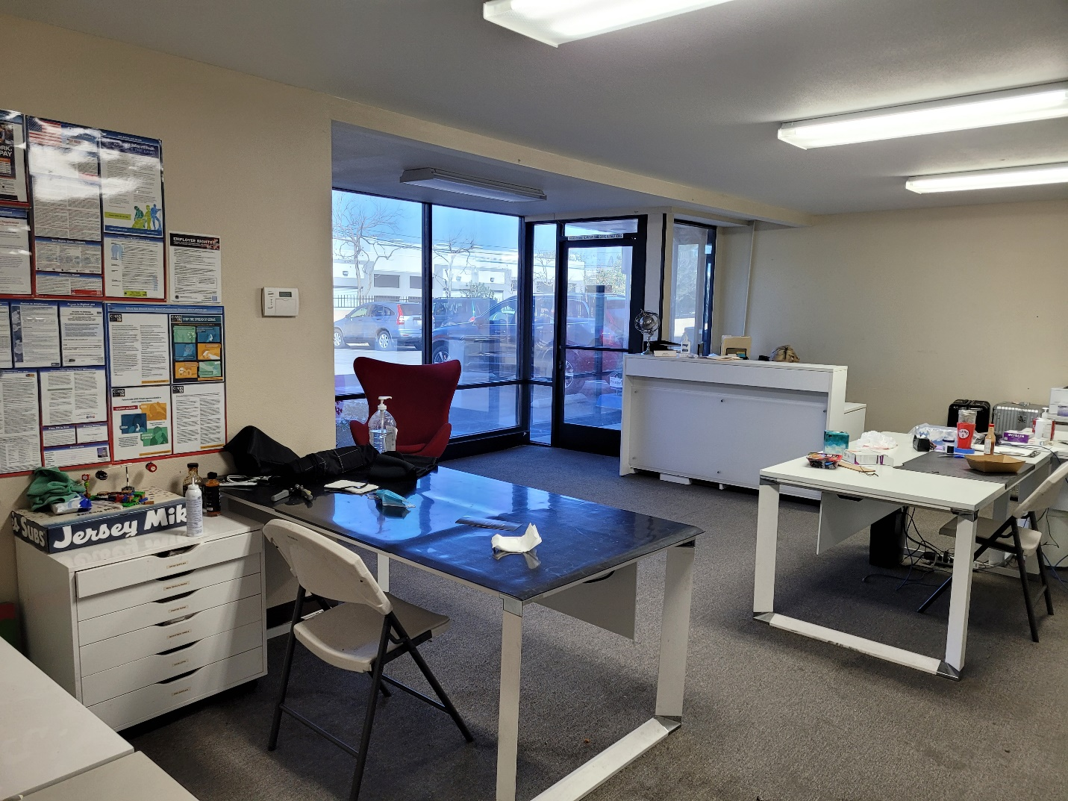Bathroom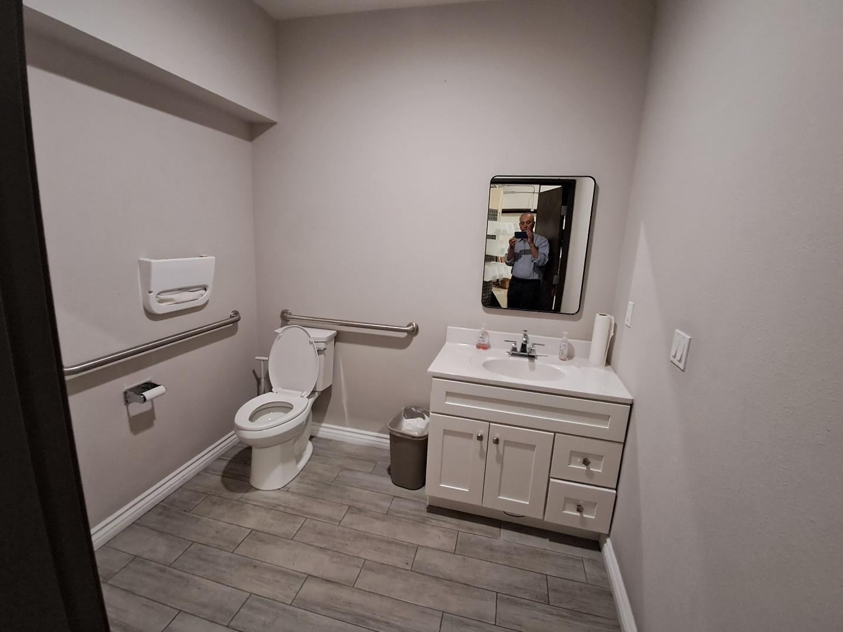
Site Plan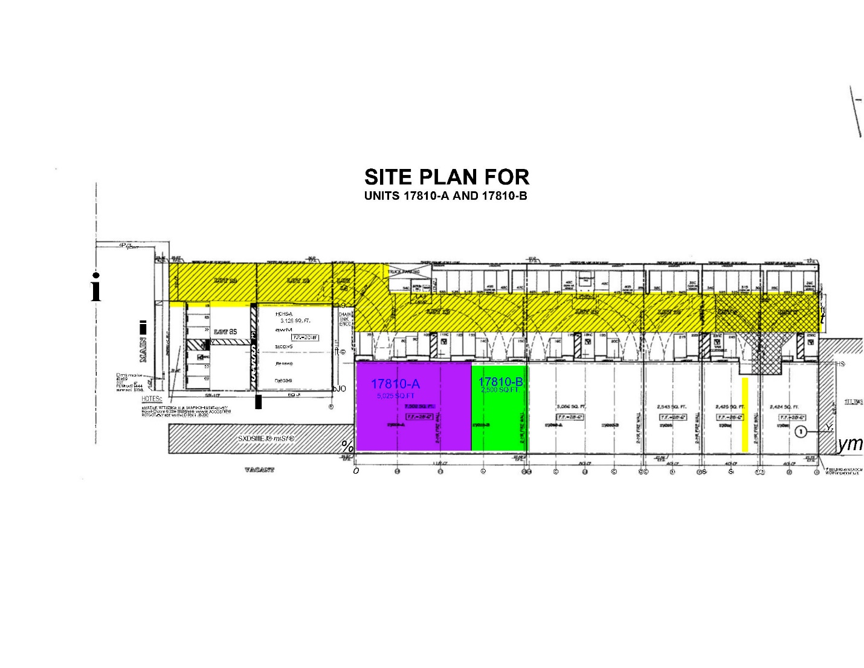

Area Map


