FOR SALE
12 ac (+/-) vacant land zoned R3
$550,000
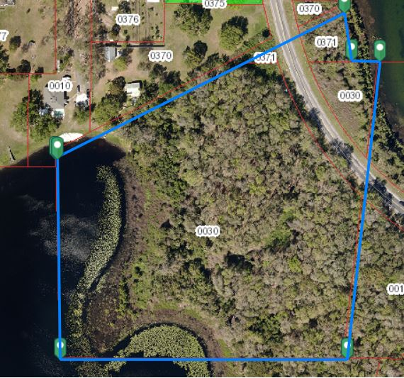
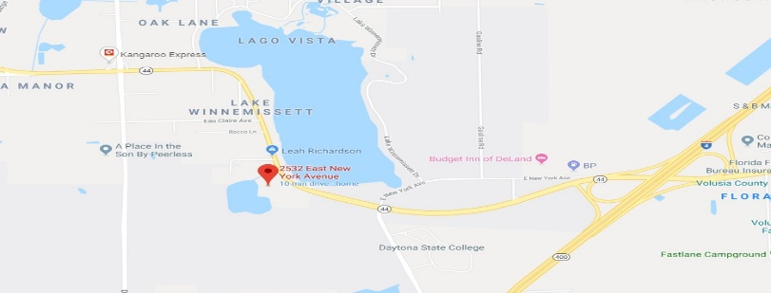
Troy Baumgartner, CCIM
The Baumgartner Company
386.734.1665
www.thebaumgartnerco.com

