SANDY SPRINGS PROFESSIONAL BUILDING
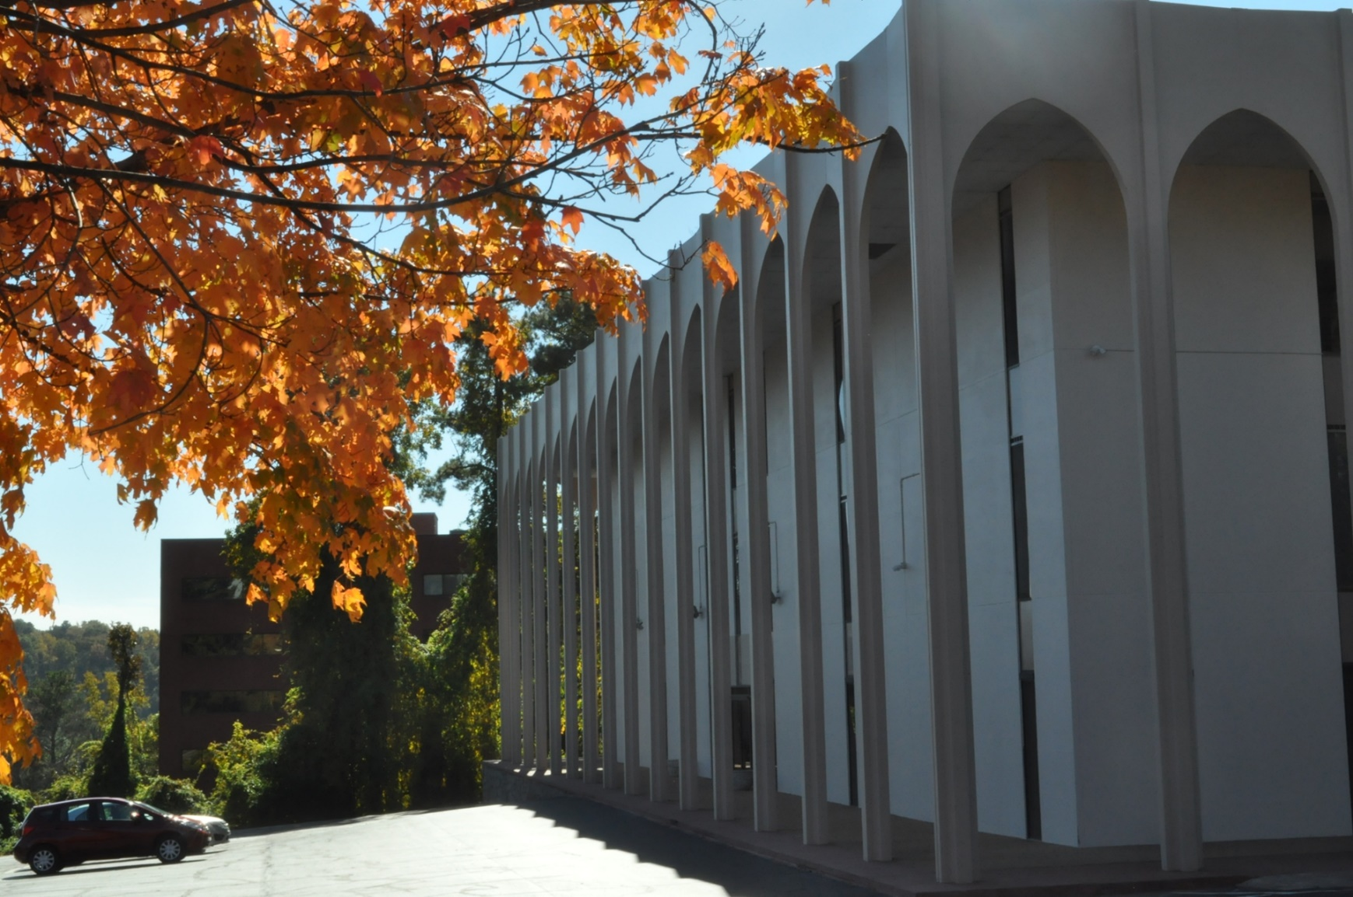

INNOVEST PROPERTIES
275 Carpenter Drive
Atlanta, GA, 30328
404-250-9888
innovest@gmail.com
Location
Sandy Springs Professional Center
Central Perimeter Cluster
Fulton County

Description
Attractive well maintained 3 story building . Two elevators.
Located on the northside at I285 and Roswell Rd., near Ga 400.
Near major hospitals, premiere business centers, restaurants and banks.

