GARY W. CASE
III
AND COMPANY, INC.
AVAILABLE
OFFICE BUILDING
FOR LEASE

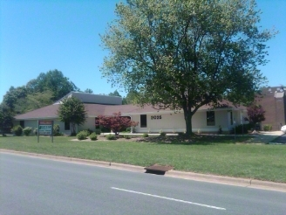
2025 TATE SPRINGS RD.
LYNCHBURG, VA

Building: 10,360 Sq. Ft., Multiple Suites

- Rent: Upper level - 5,520 Sq. Ft.
$20.00 Sq. Ft./$110,400 Yr./$9,200.00 Mo.

Lower level - 4,840 Sq. Ft.
$18.00 Sq. Ft./$87,120 Yr./$7,260.00 Mo.

Landlord pays real estate taxes, building insurance, all interior and exterior maintenance, all utilities and janitorial service five (5) days per week.

Tenant pays its insurance on its furniture, fixtures and equipment; public liability insurance, telephone/data services and janitorial supplies.

- Parking: On Site, Multi-Level

- Location: Corner Lot of Tate Springs Rd. and Langhorne Rd.
Directly across from the Centra Health/Alan Pearson Regional Cancer Center, Bank of America, Carter Bank and Trust, and one (1) block from Centra Health-Lynchburg General Hospital.

- Zoning: B-3

Enterprise Zone: Businesses may qualify for Enterprise Zone benefits.

FOR ADDITIONAL INFORMATION PLEASE CONTACT:

307 Brook Park Place
Forest, VA 24551
OFFICE: (434) 847 – 6692 • FAX: (434) 847 – 0125
E-MAIL ADDRESS: gary@garycaseco.com

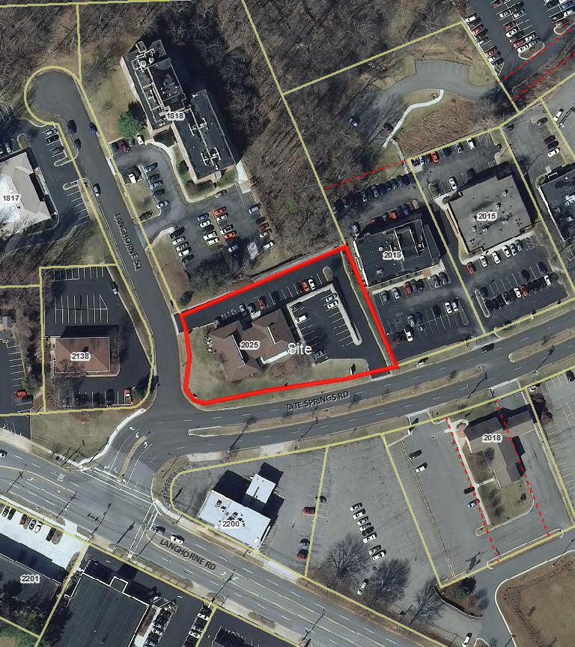

2025 TATE SPRINGS RD.
LYNCHBURG, VA

