Michigan Avenue Homes

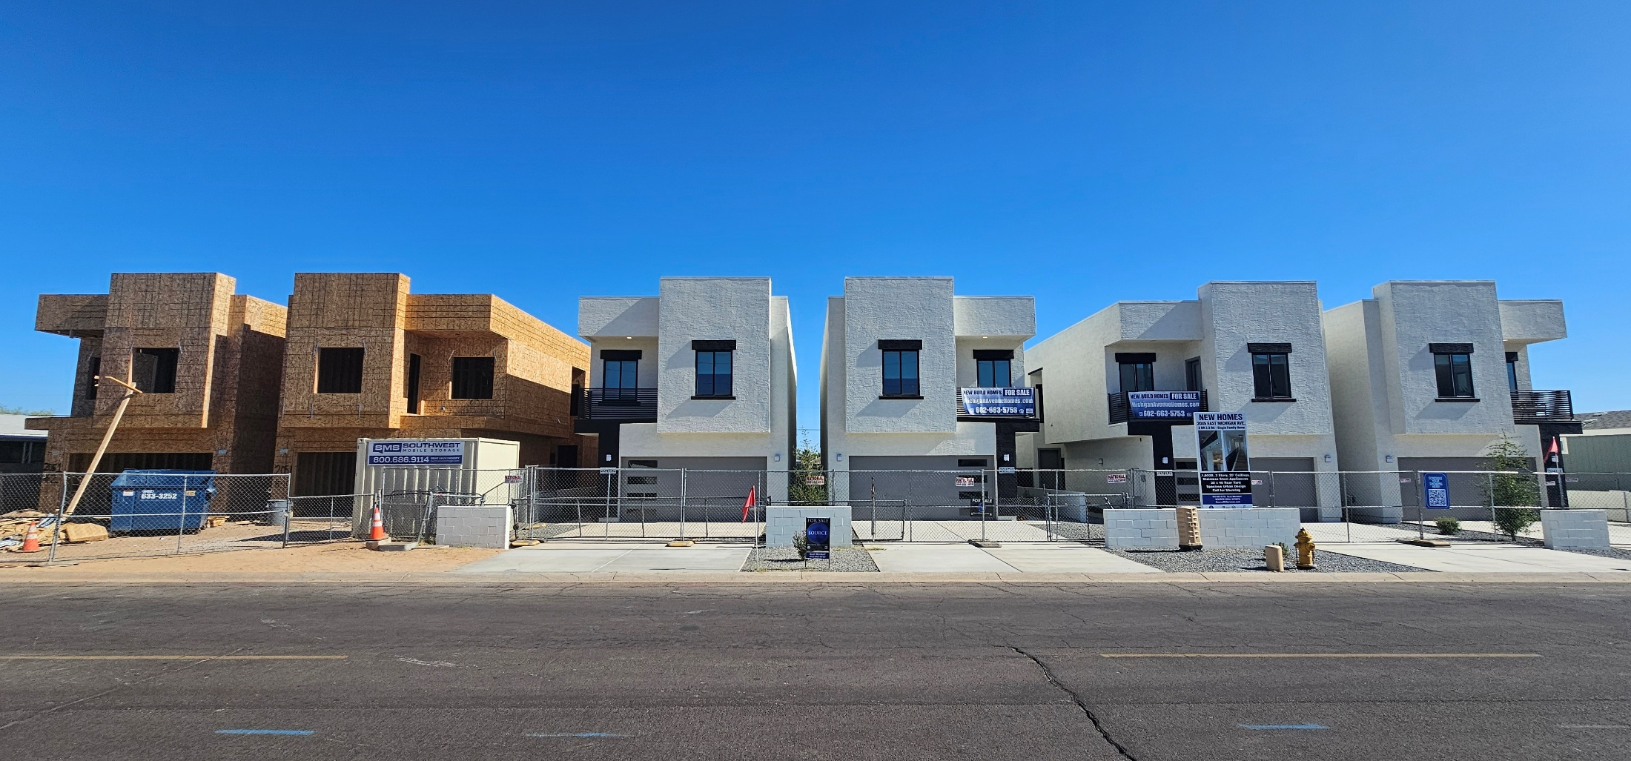
2041 – 2051 East Michigan Avenue
6 Brand New Build Homes


The portfolio consists of 6 single family homes, each homes is 1600 SF and sites on a 3300 Square Foot Lot.
The homes are built by Granite Crest Homes and are completed with the highest quality materials throughout.
2 x 6 Construction, Quartz Countertops, Luxury Laminate Flooring, Shaker Cabinets and custom wrought iron railings throughout.
The Backyard is 30 x 40 and has a 8 x 10 poured concrete patio and the remainder is crushed granite rock.
The 2 car garage face the street and has a driveway that can park 4 cars.
There is NO HOA!
3 Bedrooms and 2 Full Baths are upstairs with a half bath, on the main fooor.
Laundry room with cabinets also are located upstairs.
These homes are very contemporary and will be quite easy to rent due to the high end finishes.
The 4 completed homes have C of O’s from the city in place and are ready to occupy.
A buyer will have their 2 year home warranty in place upon closing.


