FOR LEASE – LIGHT INDUSTRIAL/FLEX SPACE – ELKHART (1,800SF @ $1,650 NNN)
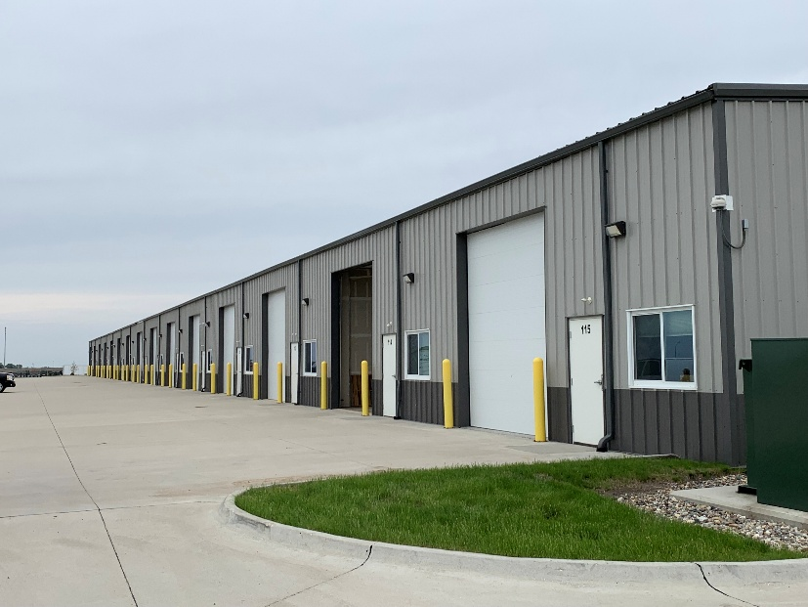
- Conveniently located in Elkhart Industrial Park 1.5 miles east of I-35/NE 126th Ave. interchange (Exit 96)
- Great space for contractors, warehousing/distribution, and storage. Next to Costco/N. Ankeny expansion/development.
- Light Industrial District (Zoning District L-I).
- $11 per square foot NNN. One-year lease term minimum.
- 1,800 SF unit (i.e., 30’ x 60’).
- Water, sewer and electric utilities. 3-phase power. 20-Amp outlets. LED overhead lighting.
- Finished bathroom. Utility sink with counter and cabinets.
- Heat available. No A/C.
- 14’ high x 12’ wide overhead door, and steel entry door
- Insulated steel structure
- 16’ to 20’ ceiling height
- Includes two parking spaces. More parking available.


