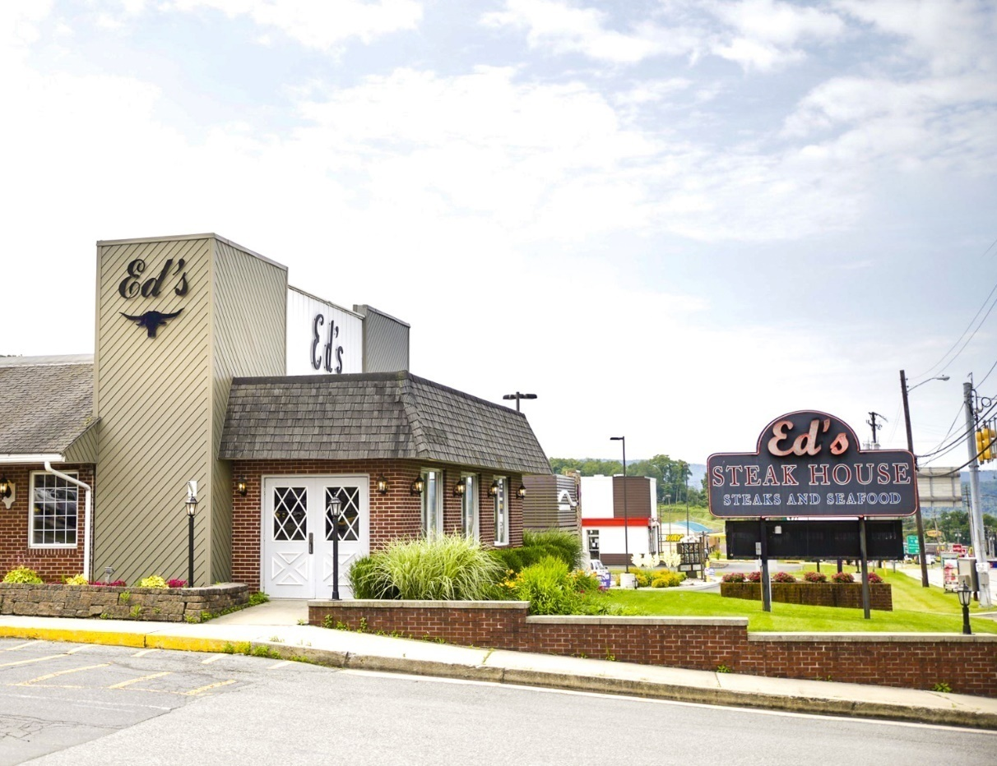
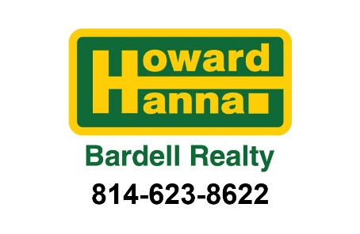
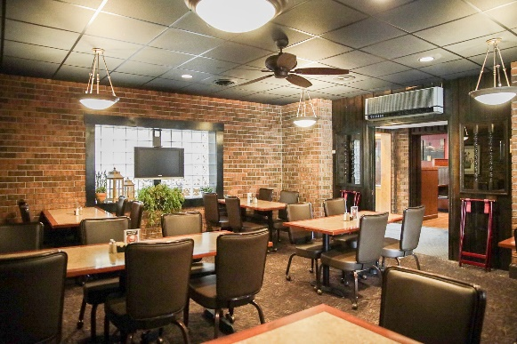
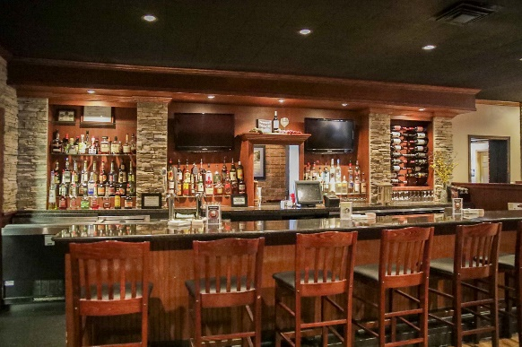


FOR SALE

Operating Restaurant & Lounge!
$1,795,000

Please contact listing agent
for more information:

Sean T. Bardell, Broker/Owner
814-977-8731
stbardell@yahoo.com
www.HowardHanna.com/SeanBardell

Business Route 220, Bedford, PA 15522
Commercial
Property

F Features Include:

- Seating for 250

- Prime Location

- Liquor License

115 S. Anderson Street
Bedford, PA 15522
Prime commercial location at the Bedford Turnpike Interchange!! +/- 9,000 square foot building has been very well maintained and most areas have been updated over the last several years.​ Large kitchen, walk-in coolers and freezer and a basement for additional storage.​ Seating for approximately 250, multiple dining areas, a lounge, banquet and meeting rooms and a liquor license.​ Adequate parking lot for customers and employees.​ This was a very profitable family owned restaurant for 65 years.​ Turn-key with all real estate, equipment, and liquor license.​ Lease option available, or can be repurposed into a new use or owner will also considered a land lease.​

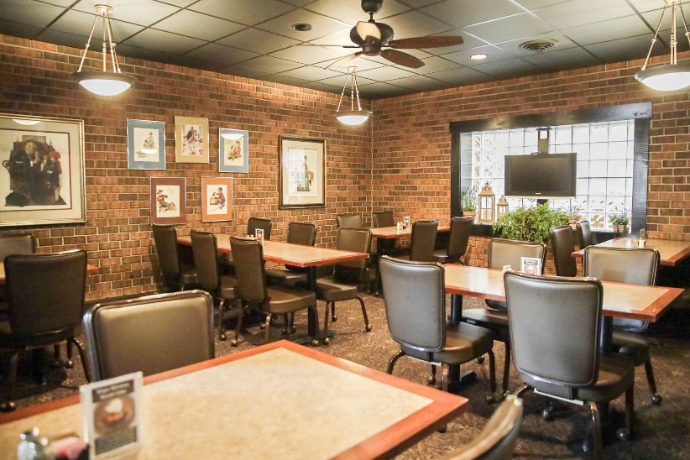
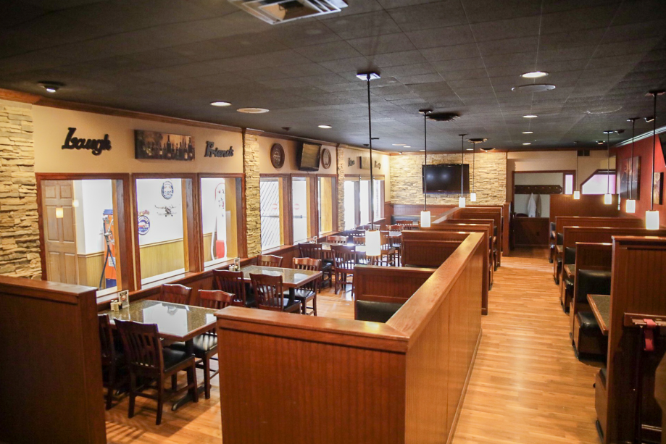

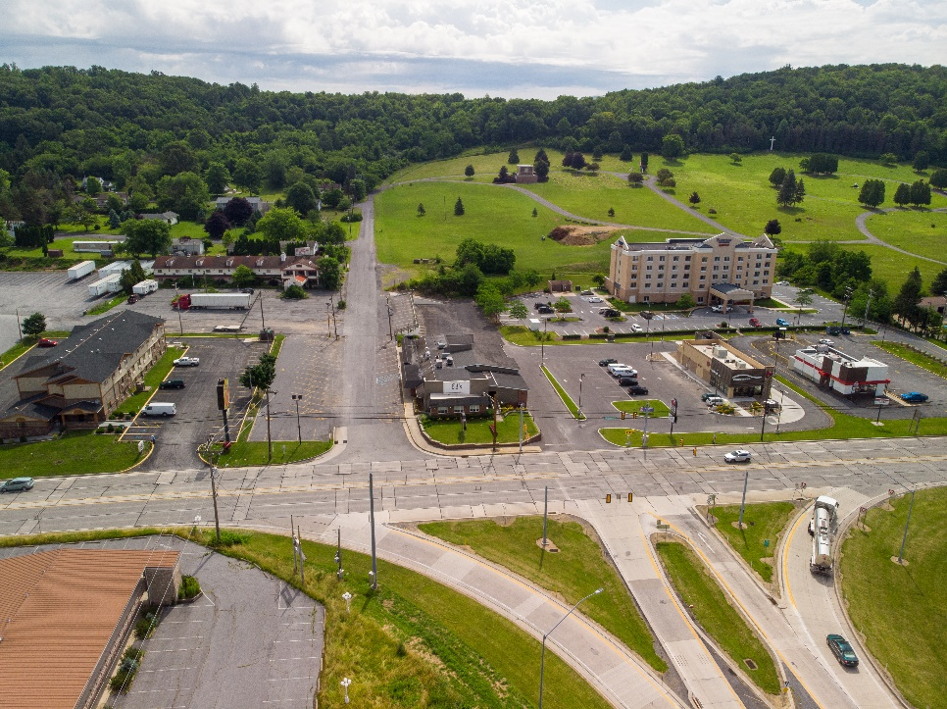
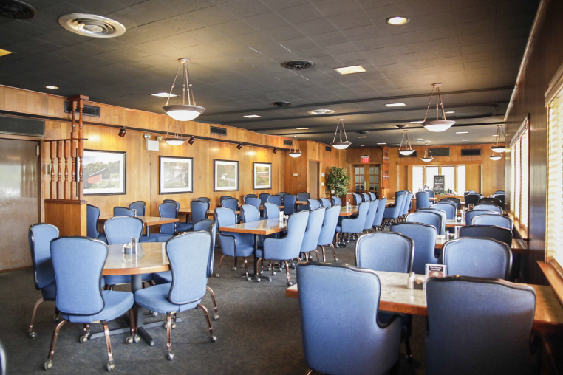
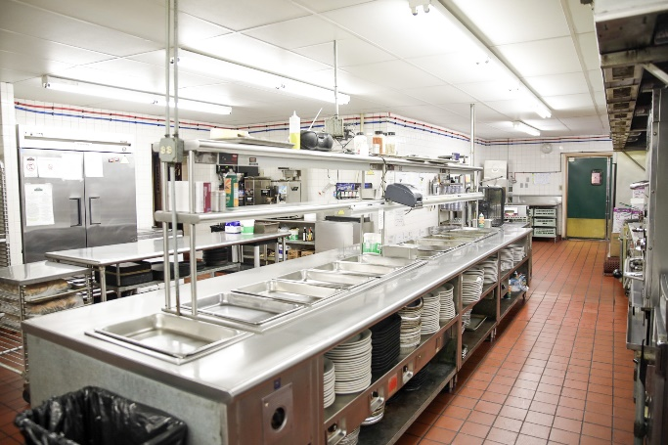

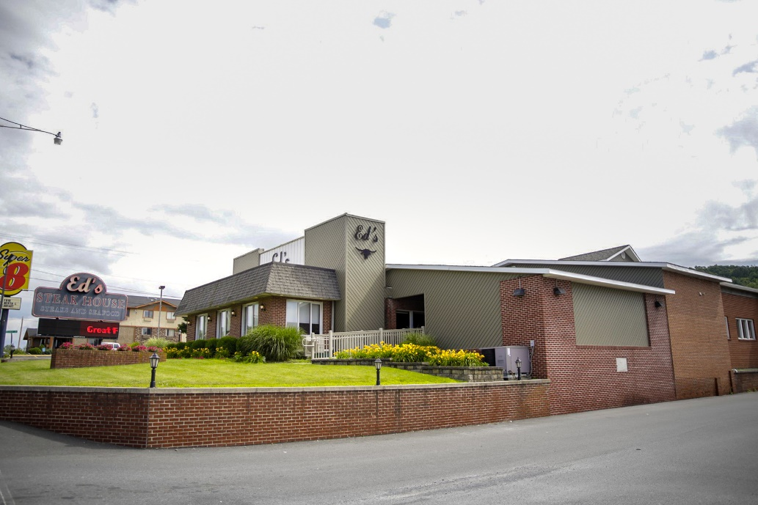

115 S. Anderson Street
Bedford, PA 15522

Sean T. Bardell, Broker/Owner

814-977-8731
stbardell@yahoo.com
www.HowardHanna.com/SeanBardell

