
101 VICTOR HEIGHTS PARKWAY
Victor, NY

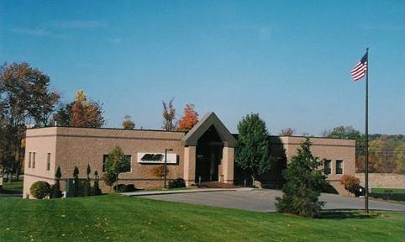

- Address: 101 Victor Heights Parkway, Victor, New York 14564
- Town/County: Town of Victor/County of Ontario
- Location: Just off Rt. 96 and Rt. 251
Five minutes from the I-490 expressway and the NYS I-90 Thruway
- Zoning: General Industrial
- Built: Constructed in 1991
- Land: 2.6 acres
- Total SF: 14,200
Available SF: Suite 200: 7,131 RSF (Vacant)
Rental Rate: $10.50 PSF NNN + Utilities
- OpEx: $4.00 PSF (approximately)
- Utilities: Tenant (Pro-rata share)
- Parking: 51 (approximately)
- Sprinklers: Wet
- Signage: Signage available
- Roof: Rubber Membrane
- Available: Vacant
- Description: Suite 200 is currently a wide-open area that is ready to be designed and built to a Tenants space requirement. Conveniently located in proximity to numerous retail amenities and Eastview Mall.

Building is owned and shared with Holdsworth Klimowski Construction (HKC)

FOR LEASE
Corporate Office Space

1892 s. winton road, suite 100
rochester, ny 14618
phone: 585.546.4170
fax: 585.546.3587
www. moorecre.com

