SEEDCO INDUSTRIAL PARK

Labor Force – 45 Minute Drive

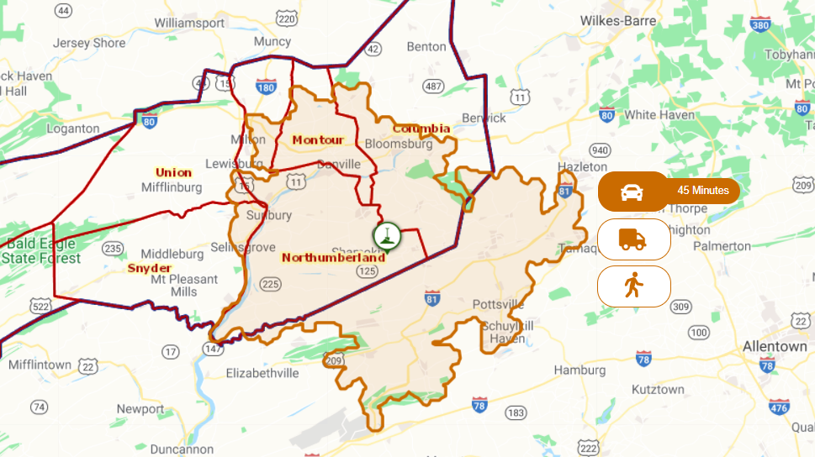

Total Establishments – 7,243
143 Establishments – 100+ Employees
7,100 – 1-99 Employees

Total Employees – 89,244
15% - Manufacturing

Manufacturers within 20-mile radius of SEEDCO Industrial Park

Processed Food, Textiles, Clothing – 82 Establishments, 3,730 Employees
Chemical, Fuel, Paper, Plastic, Wood – 82 Establishments, 3,325 Employees
Electronics, Furniture, Machinery, Metal, Transp, Misc. – 153 Establishment, 3,035 Employees

Shamokin Area Wages

Link to Sunbury MSA (nearest area) Wages – Mean/Median Hourly
Recent local company posted positions:
Parea Biosciences (medical marijuana grower/processor): Trim/Packing Assoc. start at $13/hr
Performance FoodGroup (Reinhart food distribution): Warehouse Order Selector $21/hr
Kurt Weiss Greenhouse: Growers/Assistant Growers start at $15/hr

Building Products

MADE IN CENTRAL PA

Access to raw materials, a strong history and existing industry base in manufacturing of building products, proximity to major markets, low energy costs and world-class training and research institutions make Central Pennsylvania a uniquely competitive location to support manufacturing in the building product industry.

The diversity of products MADE IN CENTRAL PA that contribute to both the commercial and industrial building of many types of products is significant! From wood products like cabinets, modular homes, doors to drywall to stone to precast to bricks and much more! Central Pennsylvania is rich with hard and soft woods including oak, cherry, maple, basswood, ash, poplar, hickory, walnut, birch, and pine. Among our prominent lumber product manufacturers are First Quality, Bingaman Lumber, Conestoga Wood Specialties and Heister House Millworks.

The Keystone Wood Products Association (KWPA) strives to strengthen and expand the base of lumber and wood products manufacturers in the Central Pennsylvania region to maintain and enhance the industry’s competitive position in today’s global economy. View a video here on Pennsylvania Working Forests https://youtu.be/m4xhL0MEK2Y.

Building Product Employers in the Central Pennsylvania Region

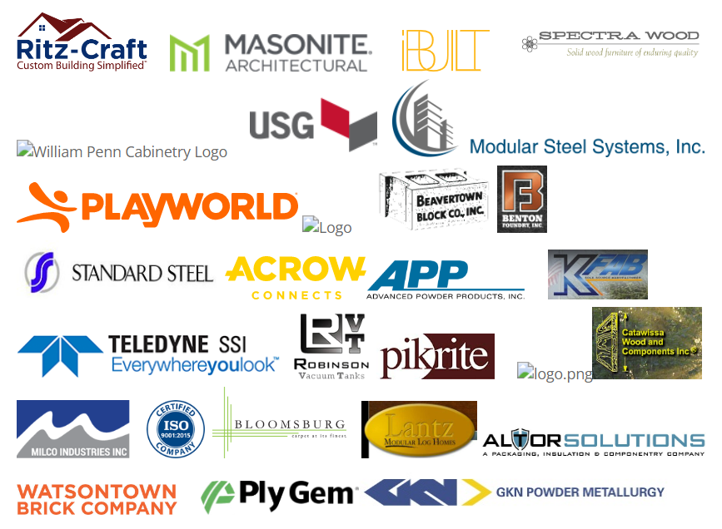
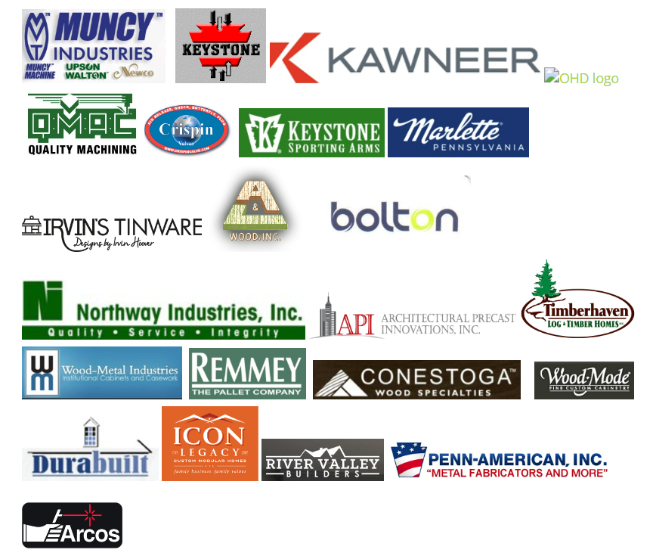

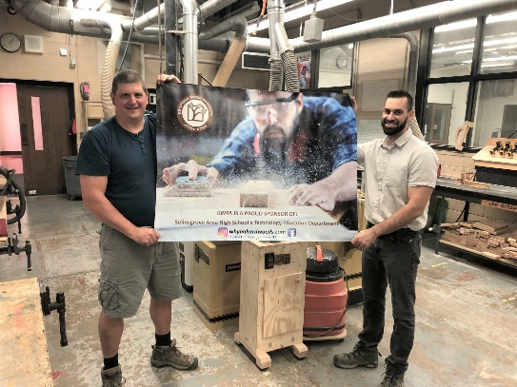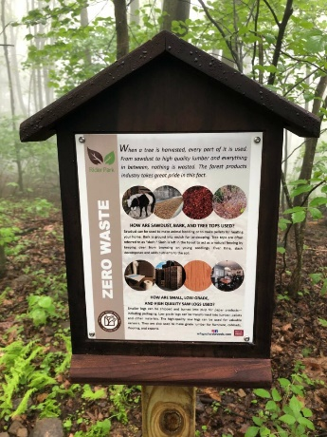

www.FocusCentralPA.org

