55 Rome St  Farmingdale |  | 5,600 Sqft  •  Industrial
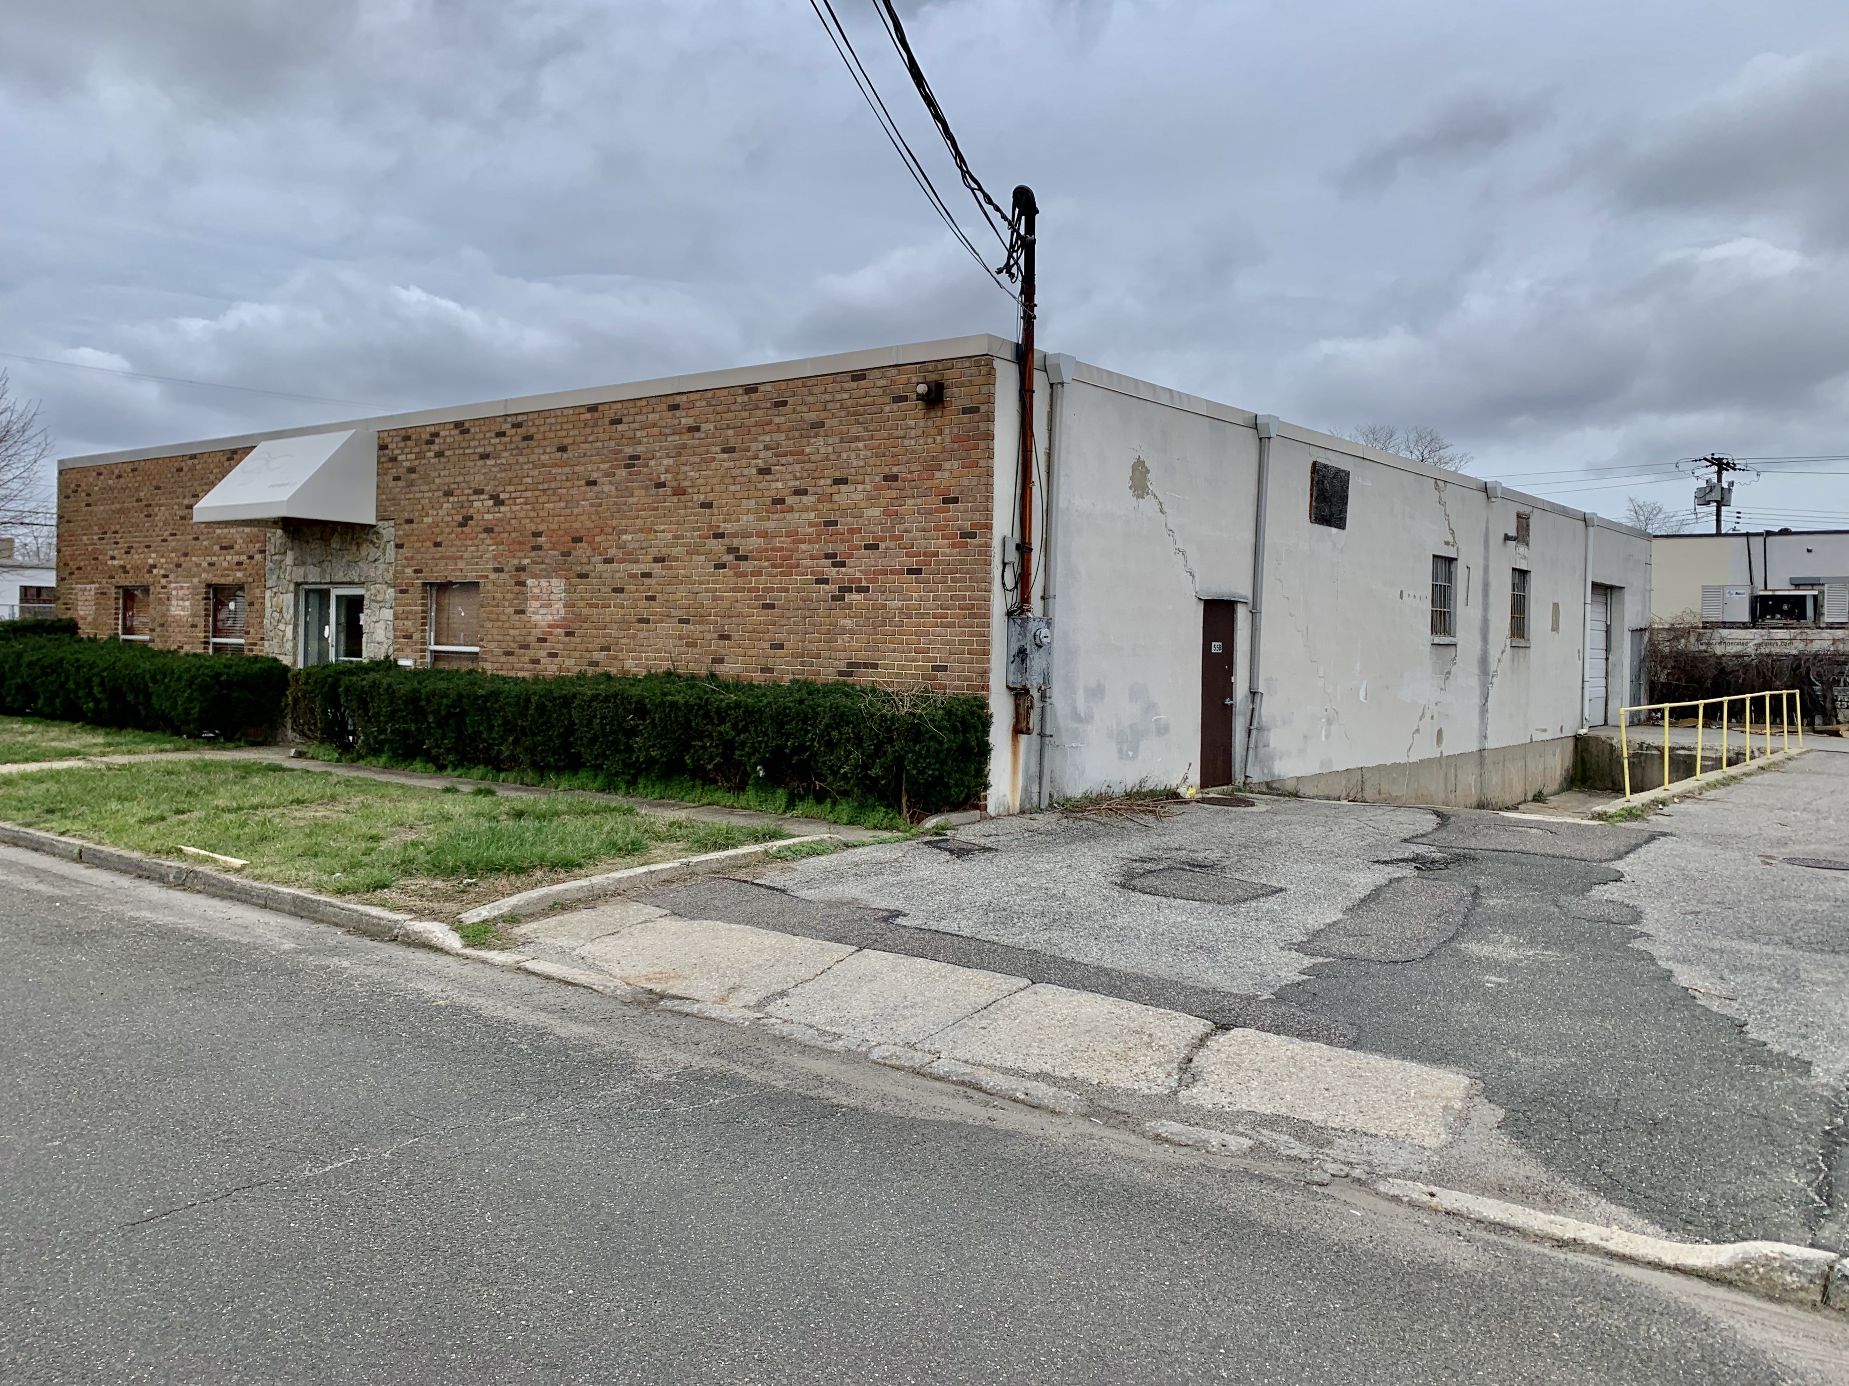 |  | 
Lot size +/- .4 acres  Building size +/- 5,600SF  Rental Price. $18 psf  Free Standing Building  Loading dock drive in combo |  | Michael Freedberg  Michael.freedberg@gmail.com  (646) 623-5242

