3.76 AC. PRIME LAND INVESTMENT - $395,000! - Town of Keedysville

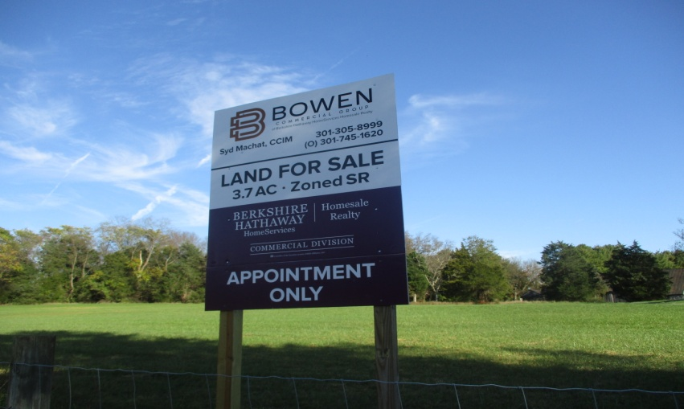
NEW LISTING - Shepherdstown Pike/MD 34

FEATURES:
- Good topography – gently-upward sloping terrain, tree borders, tillable field
- Large Parcel - In Town – tone of the last available larger tracts fronting MD Rt. 34
- Affordable Price – perfect for small investors; family compound – full-time or weekends
- Inflation Hedge & Land-Bank Investment – hold for possibly appreciation, warranty deed
- Entrance Driveway – gravel lane divides property into 2 sections, r/w road; entrance
shared with owner of adjacent small farm; road maintenance agreement is in place
- Zoned: Suburban Residential (“SR”) – refer to Town Zoning & Subdivision Ordinances
- Development Potential - residential land uses only, per Town of Keedysville Ordinances
- Ideal Property for Homebuilders & Investors – State Road, public utils, convenient location
- Close to historic Antietam National Battlefield – trails for walking, jogging, biking; about 10 minutes to the C&O Canal National Park and Potomac River recreation + boat ramps; Antietam Creek is very popular for canoeing and kayaking – one of top-rated creek locations in U.S.
- Access to Balto-Washington Metro Area – via I-70 and I-270. 3 Int. Airports, 1 ½ hrs.
Contact: Syd Machat, Associate Broker, owner-agent, CCIM. Berkshire Hathaway HomeServices, Homesale Realty, Bowen Commercial Group. O: (301)745-1620 Cell: (301) 305-8999.
Information herein is believed to be accurate, but should not be relied upon without verification.

