
226 Old Bridge St., E. Syracuse, NY 13057
(2) “STAND ALONE BLDGS.”

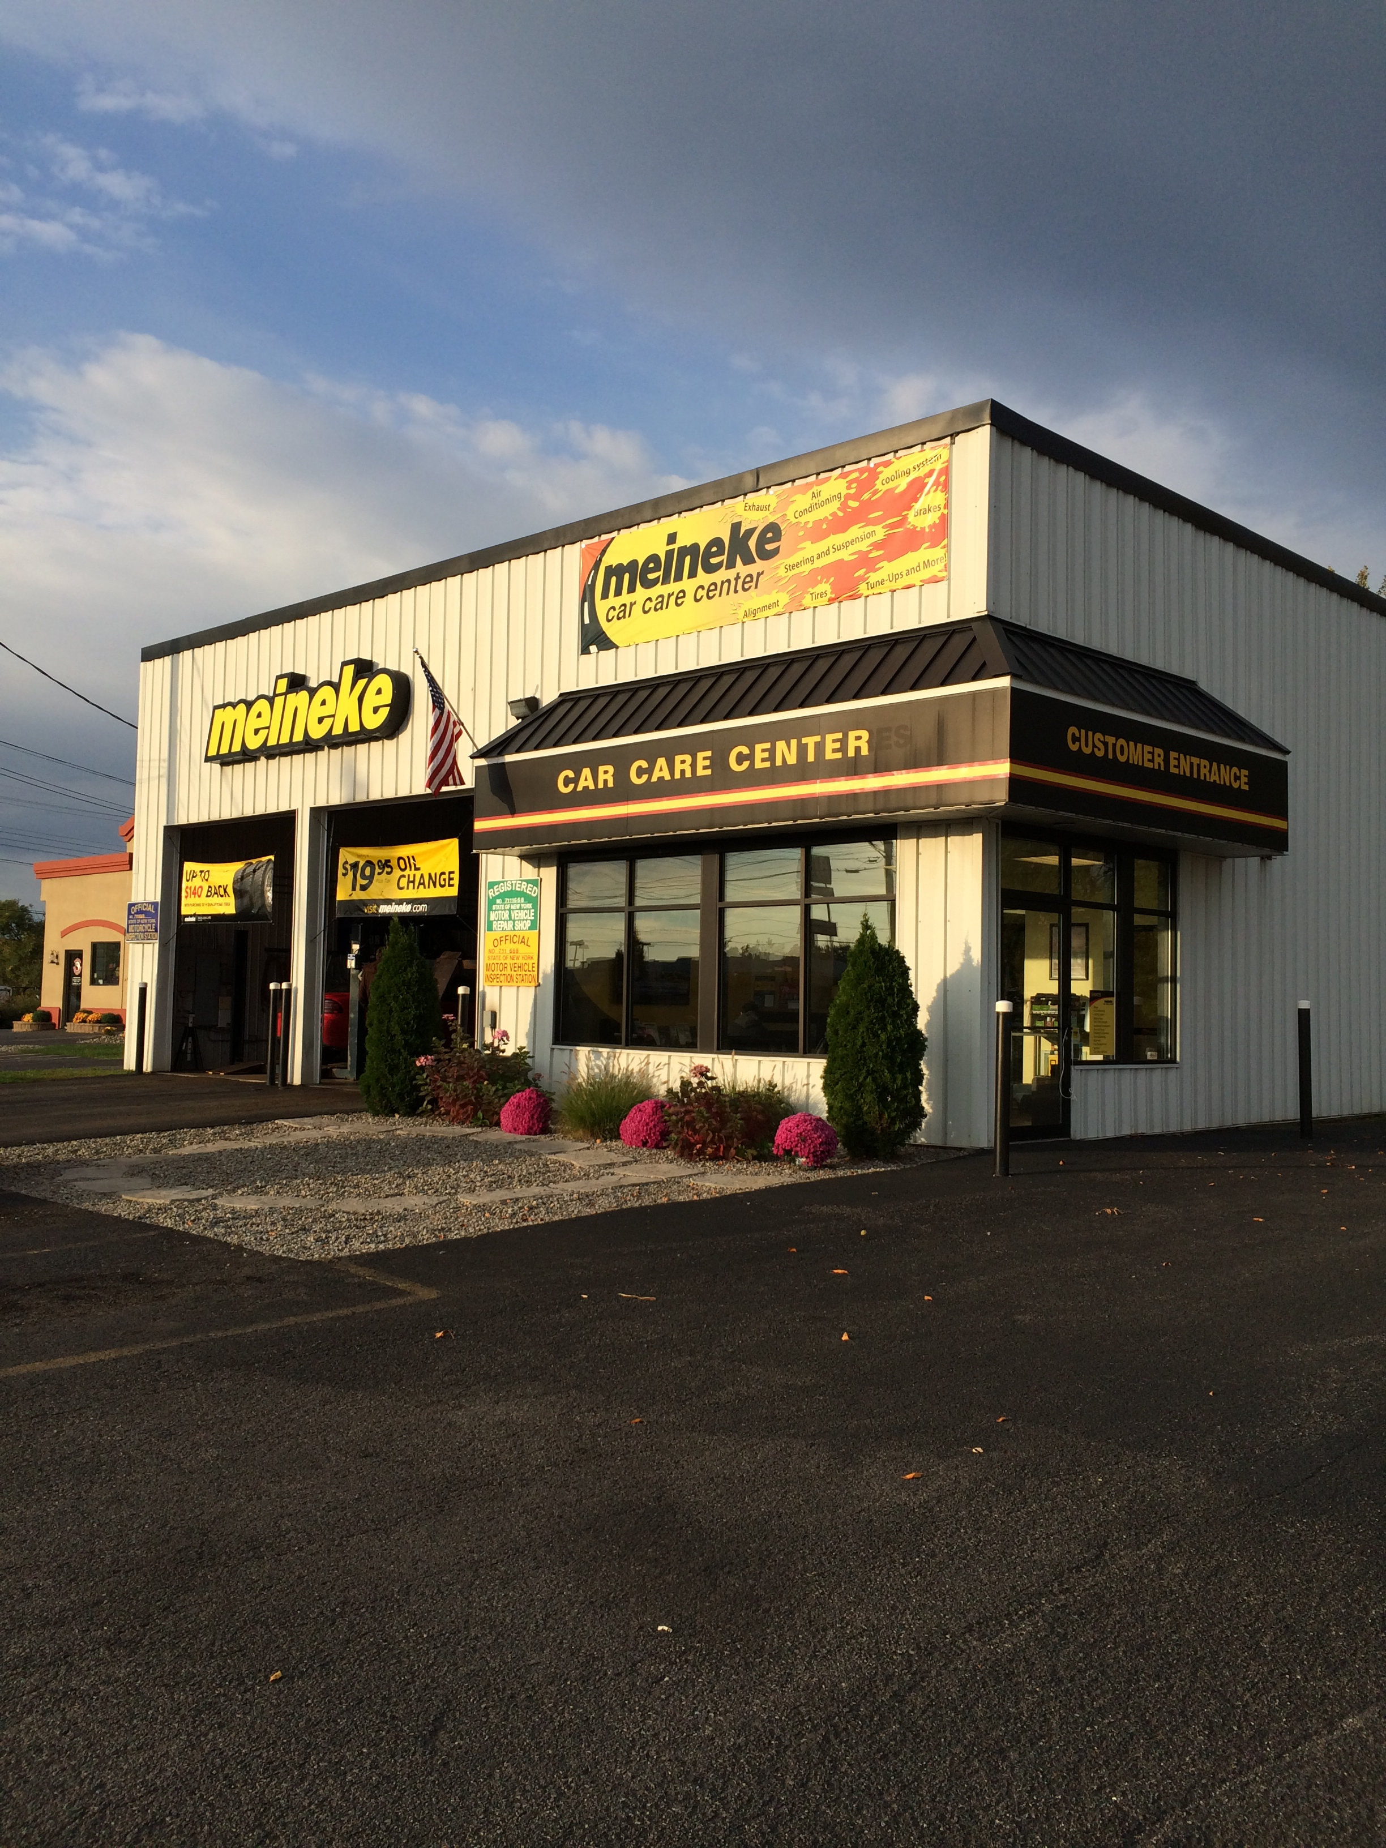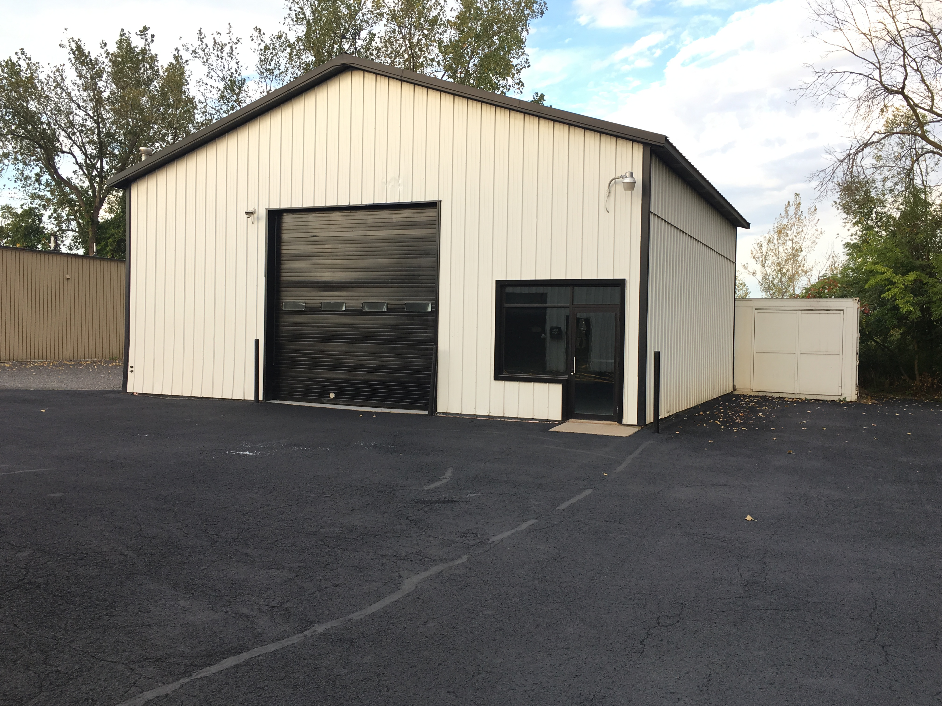

Frontage: 80 lf Municipality: Village of E. Syracuse

Front Building SF: 3,000 sf Zoning: General Commercial
Rear Building SF: 1,600 sf w/1,400 storage containers.

Traffic Counts: Bridge St: 31,502 ADT. Manlius Center Rd (298): 17,712 ADT.
1690 East: 54,843 ADT. Bridge St – Over Bridge: 13,560 ADT.

Property Description:
- Property is situated across from BJ Wholesale, Staples and Dunkin’ Donuts.
- Convenient access to I-690, I-481, I-81 and the NYS Thruway.
- Centrally located minutes from Downtown Syracuse.
- Less than 5 miles to Hancock International Airport.
- Exceptional visibility to over 30,000 cars/day.
- Sign Exposure.

For More Information Call: Jim 315-952-0607

All information furnished, regarding property for sale, rental or financing is from sources deemed reliable, but no warranty or representation is made to the accuracy thereof and same is submitted subject to errors, change of price, rental or conditions prior to sale, lease or financing or withdrawal without notice.

Areal of Location

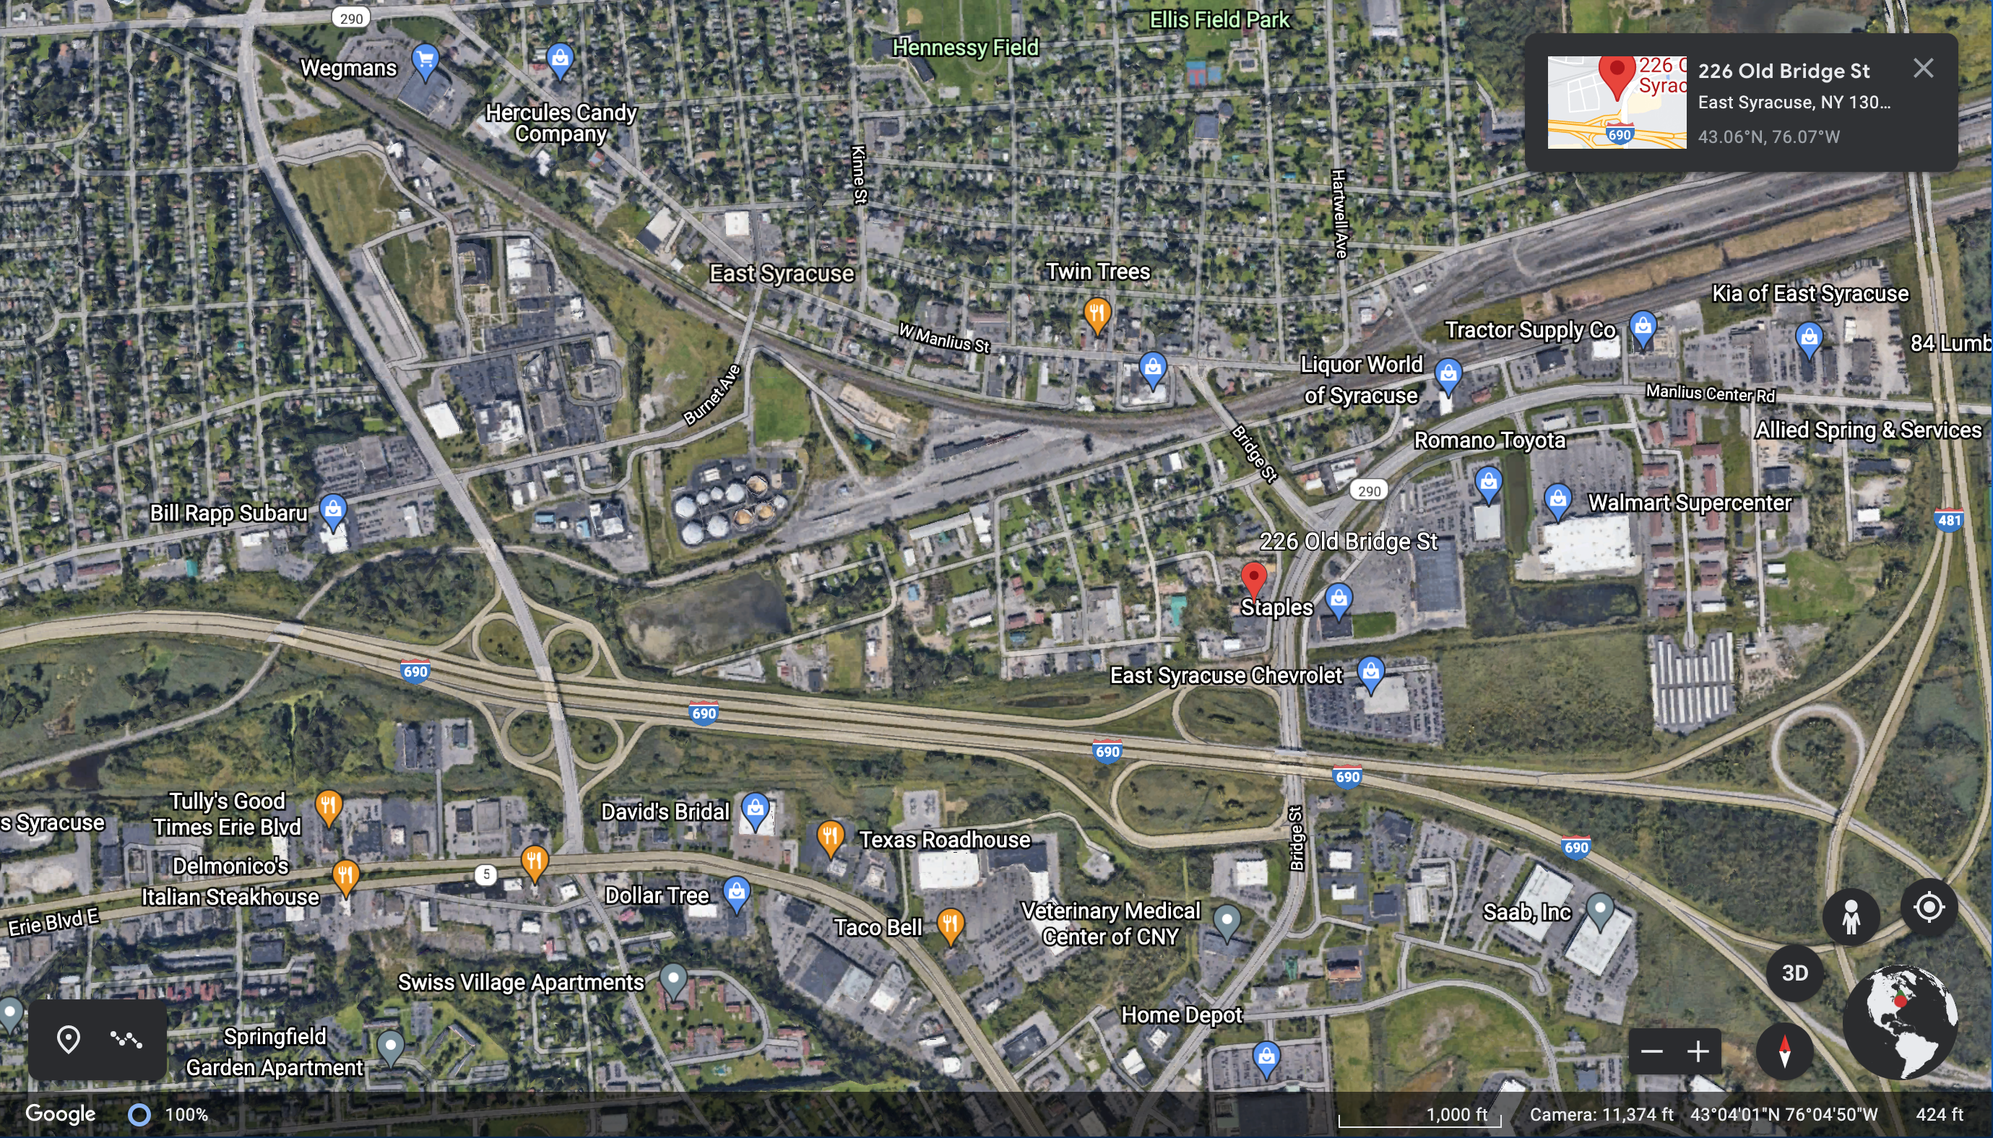
Location and Area Highlights - (Syracuse & Surrounding Areas)

- Superior Location – for Retail/Medical/Office/Professional Uses.
- Visible to over 30,000 cars/day.
- Situated with frontage and exceptional exposure from the heavily traveled Bridge St (Rte. 290)
- Across the street from Dunkin Donuts, Staples, BJ’s Wholesale.
- Easy access for clients and employees.
- Neighbors on Old Bridge St. - Big 4 Tire, K-9 Kamp, 4 Star Auto Detailing, DeWitt Marshall Arts, Cunningham Chiropractic.
- Located just outside Widewaters Office Park, one of the regions premier office parks and the area’s largest Office Park. Glacier Creek Office Park, a newly redeveloped Office Park.
- Immediate access to a high concentration of amenities, including, dining, shopping, banking, post office, groceries, healthcare, daycare and many various other services.
- Located along the New Town of DeWitt bike path to Erie Boulevard.
- Site offers quick and easy access to nearby Interstates 481, 81, 690, and 90 (New York State Thruway).
- Daily commutes are direct and timely. Central access from anywhere in the Greater Syracuse and Central New York Area.

All information furnished, regarding property for sale, rental or financing is from sources deemed reliable, but no warranty or representation is made to the accuracy thereof and same is submitted subject to errors, change of price, rental or conditions prior to sale, lease or financing or withdrawal without notice.

